# **DETERMINANT MACROECONOMIC FACTORS ON THE BANKRUPTCY OF ECONOMIC ENTITIES**

**Drd. Sorin Șomîtcă**

**Scientific Coordinator Prof. Univ. Dr. Elena HLACIUC**

*Ștefan cel Mare University, Suceava, România*

[*sorin.somitca@gmail.co*](mailto:sorin.somitca@gmail.co)*m*

[*elena.hlaciuc@usm.ro*](mailto:elena.hlaciuc@usm.ro)

**Abstract**

*The bankruptcy of economic entities is an extremely important phenomenon in the market economy, especially in the challenging times we live in today. The economy of the countries of the world knows permanent turbulence, a so-called 'polycrisis' in which various, sometimes simultaneous, influences are felt from several sides, which can destabilize and worsen the situation of economic entities. For this reason, a permanent attention is required regarding the evolution of the bankruptcies of the countries of the world in order to prevent or anticipate possible risks and thus to avoid as much as possible the failures of enterprises. The study aims to identify the links, relations and the influence of macroeconomic factors on the bankruptcy of organizations at the level of the European Union, after carrying out a bibliometric analysis to identify what is the current level of knowledge as well as future research directions. Based on econometric modeling, we identified how these macroeconomic factors influence, confirming the fact that they have a decisive impact on the evolution of bankruptcies registered at the level of the European Union.*

**Keywords**: bankruptcy, macroeconomic factors, economic growth, inflation, unemployment rate

**JEL Classification:** E10, G33

**INTRODUCTION**

The failure, decline or bankruptcy of economic organizations represents an extremely important economic phenomenon in the economy of the countries of the world, that is why it is intensively studied over the years, in an attempt to identify the causes and symptoms experienced by companies in difficulty or that are about to fail. exhibit such symptoms. At the same time, it is constantly trying to improve the methods of detecting and predicting bankruptcy, because this situation in which economic enterprises can end up can generate devastating effects for all stakeholders in the immediate ecosystem of the company, but also with effects on the supply or sales chain of them, effects that are often difficult to estimate or quantify. Among the factors that can influence the direction of the companies' evolution towards bankruptcy, in addition to the internal ones, among which poor management stands out, macroeconomic factors play a significant role, acting independently of the company's action or reaction. Included here are economic fluctuations in the sense of economic growth or contraction, reference interest rates that influence the financing cost of companies, the level of inflation, the evolution of the exchange rate, especially influencing companies that carry out import-export operations, but also various legislative regulations or government policies which may have an influence on the stability or performance of a company.

Macroeconomic determinants represent economic variables that generally act on the entire economy of a country, region or even globally and implicitly on economic enterprises, as the basic cell of the economy. The COVID-19 pandemic or the Russian-Ukrainian conflict are examples of phenomena that have left their mark on the world economy, affecting the economy of the countries of the world but also having major influences at the social, political or health level.

The ***purpose*** of our study is to identify the influence of the evolution of the economy, be it economic growth or contraction, of inflation as well as the level of the unemployment rate on the bankruptcy risk of economic entities.

The assumptions underlying our approach are the following:

**H1**: The level of growth or contraction of the economy influences the level of bankruptcies in the economy

**H2**: The inflation rate has a fundamental impact on the bankruptcies of economic entities

**H3**: The level of the unemployment rate recorded in the economy affects the level of bankruptcies.

Developments in the economy that manifest in the form of business cycles are increases or decreases in economic activity between expansion or contraction phases. Recent crises such as the crisis of 2008 or the crisis generated by the COVID-19 pandemic show that rapid economic contractions can lead to the increase of bankruptcies to undesirable levels, this is because during recessions, aggregate demand falls, which has an impact on the reduction of sales of companies and the that do not react quickly or that have not developed and implemented a sustainable activity become vulnerable to shocks and usually follow the path of bankruptcy.

In economic literature, a new concept is gaining more and more attention, namely that of "degrowth" different from the concept of "decrease" or economic contraction, especially following various economic, environmental or social crises, many of them overlapping, acting simultaneously or in concert. The concept of degrowth represents an alternative to the paradigm of permanent economic growth, having as its central theme the idea that, in order to develop a sustainable future, a balancing of consumption and production is required in the sense of their voluntary restriction. All these constraints are imposed by limited resources, ecological limitations but also to achieve climate neutrality goals and a green economy.

High inflation influences the level of bankruptcies in a country on several levels. On the one hand, the decrease in company revenues occurs as a result of the reduction in the purchasing power of final consumers, especially in the case of companies with low profitability margins. At the same time, an inflationary economic environment brings with it a generalized increase in costs which, if they cannot be transferred to final consumers, generates a strong erosion of margins. The mechanisms to control or curb the inflationary situation include, among other things, the increase of reference interest rates, which makes the attraction of foreign capital to be carried out with higher financing costs, which puts even greater pressure and accentuates their vulnerabilities. The recorded level of unemployment in the economy and the level of bankruptcies are two connected indicators because the increase in the level of the unemployment rate influences the increase in the level of bankruptcies as well as their severity.

A high level of unemployment, even a temporary one that manifests itself for a short period of time, generates a reduction in the aggregate demand for goods and services in that consumer incomes decrease and confidence in the economy is thus damaged. In this situation, consumers tend to minimize non-essential expenses being in a situation of struggle for survival, preferring to use the surplus for saving, the future being uncertain. All these create the premises of a contraction in the sales of economic entities, which find themselves forced to restrict their activity and in the worst case to reach the point of starting the legal procedures for insolvency or even bankruptcy.

**LITERATURE REVIEW**

Our research approach starts with querying the WebofScience/Clarivate database for the most pertinent identification of research trends regarding the impact of economic evolution, inflation and the unemployment rate on the bankruptcy of economic entities. The query involved a "boolean" search for the keywords "bankruptcy" AND "economic growth" OR "inflation" OR "unemployment rate" thus obtaining a number of 781 publications, articles, reviews or proceedings from various fields of interest.

The research output is not particularly large, the results being obtained for the period 1975-2024, during which, on average, 8.94 publications were issued per year. The most prolific author is Gallegati Mauro, with a total of 5 publications on the field of interest. The two most cited articles are *Stuck! The Law and Economics of Residential* authored by Schleicher, D., article from 2017 with 301 citations as well as article from 2022 co-authored by Vinod, D., Cherstvy, AG., Metzler, R. and Sokolov, IM. with the title of *Time-averaging and nonergodicity of reset geometric Brownian motion* *with drift* with 290 citations on the WebofScience database in the analyzed period. The production of relevant literature is reduced until 2008, below 20 publications per year, but with the onset of the subprime crisis in 2008-2009, researchers paid more attention to the phenomenon so that the peak is reached in 2019-2022 with over 50 publications per year targeting the impact of macroeconomic variables on company bankruptcy. The most productive journal, with a number of 15 publications related to the studied topic, is Small Business Economics, having a Journal Impact Factor of 6.5 in 2023. Authors from the USA are the most prolific in this field (446 appearances) followed by China with 154 appearances. One aspect worth mentioning is that among the institutions with the greatest impact in the production of scientific research, the second place is the University of Economic Sciences in Bucharest (16 appearances) in close competition with Brno University of Technology in the Czech Republic (17 appearances).

The publication with the most citations is *The Sum of All FEARS Investor Sentiment and Asset Prices* co-authored by Da, Zhi et al from 2015 with an impressive number of citations, 718, being by far the absolute champion among publications that analyze the topic of bankruptcy determined by macroeconomic factors. Essential in the mentioned work is the construction of an index on the Financial and Economic Attitudes Revealed by Search (FEARS) by which investors' sentiment is measured through the internet search behavior of households, having as main themes recession, bankruptcy and unemployment, and through this index predict aggregate market returns.

After establishing the database with the specific publications, in order to graphically capture a bibliometric representation of the research directions, the bibliometric analysis software named Bibliometrix was used, taking into account the keywords plus the research works. Thus, 3 interconnected clusters were obtained that include 49 terms in the form of keywords plus, supporting the effort to identify the directions towards which the research analyzes converge as well as those that need to be deepened for a more faithful projection of the realities economic.

The keyword co-occurrence matrix captures 3 large clusters centered on topics of interest such as bankruptcy, prediction, performance but also growth, financial indicators, determinants, credit, risk or impact, identifying a solid link between economic growth and the evolution of the phenomenon of bankruptcy of economic entities.

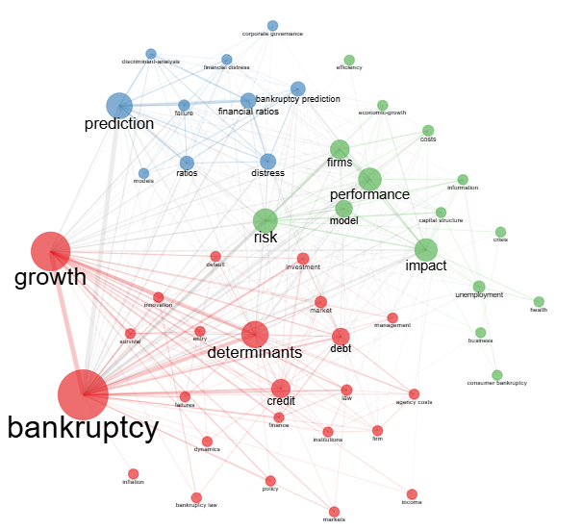

Fig. 1 Map of research directions, nodes and intensity of links between concepts

Source: Own elaboration with the help of Bibliometrix

Tokarski A. et al (2018) uses some of the macroeconomic variables as the number of companies registered in the REGON system, the GDP growth rate, the unemployment rate, the inflation rate in relation to the variable response number of declared bankruptcy.

In another recent study by Situm (2023), the difficult state of micro and small enterprises in Austria is also explained through the lens of the inflation rate and unemployment. These variables have a significant statistical influence, high values ​​of these variables increase the probability of decline, yet there is a 2-year lag on the probability of failure.

Recently, Altman at al (2024) claims in his study, that there is an alarming increase in zombie companies, calling the phenomenon "zombieism" as the survival stage of companies otherwise on the verge of insolvency, all this with the competition the state, financial institutions or investors. The level reached is alarming, 7% in 2020, a level supported by global economic growth or the applied monetary policies. The risks are that this phenomenon does not allow the development of a healthy business environment, as these companies manage to survive on average 5 years before declaring bankruptcy.

In order to prevent the decline of companies with bankruptcy as the maximum peak, the management of companies, regardless of size or geographical location, must adopt strategies by which macroeconomic risks are effectively managed. It is thus recommended to diversify the products and services offered by the company, enter new markets, maintain an adequate level of profitability and generate returns that ensure medium and long-term stability, ensure reserves for unforeseen situations, maintaining a balance in the financing structure of the activity through the efficient use of financing with foreign capital as well as own capital and the list is not exhaustive. To cover the risk of price increases, a trade policy that includes price indexation in case of cost increases, reference interest rate or exchange rate indexation are effective ways to combat macroeconomic risks. Also, the use of financial instruments to cover risks related to interest rates and exchange rates is recommended in the case of companies exposed to currency risk or indebted companies for which an increase in the interest rate may lead to insolvency.

**PAPER CONTENT**

In achieving the goal proposed by this research, we analyze the influence of macroeconomic variables on the level of bankruptcy of companies at the level of the European Union. In order to achieve this goal, we will use as a dependent variable the index published by the European Union, respectively the Business Formation and Bankruptcy Index, with the year 2021 as the base period when the index is 100. The independent macroeconomic variables we will use are economic growth, the inflation rate as well as the unemployment rate, all reported at the level of the European Union, with 27 countries included.

Economic growth comes from the calculation of the evolution of the Gross Domestic Product representing the totality of the goods and services provided by a country, taking into account different methods of calculation, respectively based on production, expenses or revenues obtained.

The inflation rate represents the harmonized index of consumer prices, while the unemployment rate represents the percentage of unemployed among the working age population, aged between 15 and 74.

The analysis period is 2015-2023, the period in which data are available for all the variables included in the research. The data were taken from https://ec.europa.eu/eurostat and processed with the econometric modeling program IBM SPSS Statistics 26, the variables being presented in Table no. 1.

Table no. 1 – The variables used in the analysis

|  |  |  |  |
| --- | --- | --- | --- |
| No. | Indicators | Abbreviation | Variable type |
| 1. | *Business registration and bankruptcy index* | BI | Dependent |
| 2. | *Economic growth* | EG | Independent |
| 3. | *The inflation rate* | I | Independent |
| 4. | *Unemployment rate* | U | Independent |

Source: Own elaboration

Table no. 2 – Variables included or excluded**a**

|  |  |  |  |
| --- | --- | --- | --- |
| Model | Variables Entered | Variables Removed | Method |
| 1 | U, EG, Ib | . | Enter |
| a. Dependent Variable: BI | | | |
| b. All requested variables entered. | | | |

Source: Own processing in SPSS 26

After processing the data, we obtained the correlation matrix in order to build the econometric model based on the 4 variables included in the analysis. Table no. 3 shows the values ​​in matrix form for the analyzed variables.

Table no. 3 – Correlation matrix

|  |  |  |  |  |  |
| --- | --- | --- | --- | --- | --- |
|  | | BI | EG | I | U |
| Pearson Correlation | BI | 1.000 | 0.464 | 0.763 | -0.759 |
| EG | 0.464 | 1.000 | 0.230 | 0.079 |
| I | 0.763 | 0.230 | 1.000 | -0.712 |
| U | -0.759 | 0.079 | -0.712 | 1.000 |
| Sig. (1-tailed) | BI |  | 0.104 | 0.008 | 0.009 |
| EG | 0.104 |  | 0.276 | 0.420 |
| I | 0.008 | 0.276 |  | 0.016 |
| U | 0.009 | 0.420 | 0.016 |  |
| N | BI | 9 | 9 | 9 | 9 |
| EG | 9 | 9 | 9 | 9 |
| I | 9 | 9 | 9 | 9 |
| U | 9 | 9 | 9 | 9 |

Source: Own processing in SPSS 26

There is a strong direct correlation between the bankruptcy index and the inflation rate, meaning that high and long-lasting inflation influences the increase in the risk of bankruptcy, by reducing purchasing power, changing consumer behavior and thus reducing incomes. At the same time, own expenses increase and profitability margins erode, ultimately leading to an inability to pay, culminating even in the bankruptcy of companies. Surprising is the strong but inverse correlation between the unemployment rate and the bankruptcy index.

The theoretical econometric model that we aim to develop has as its objective the establishment of the degree of variation of the dependent variable BI in relation to the variation of the independent variables, namely the macroeconomic variables economic growth, the inflation rate and the unemployment rate. We thus use the multiple linear regression model, and the equation is as follows:

$$BI=α+ β1*EG+ β2*I+ β3*U$$

where:

BI – represents the dependent variable of the model,

EG, I, U – are the independent variables,

β1, β2 și β3 are the regression coefficients

α is error variable.

The developed model must be validated from the point of view of the accuracy of the description of the economic phenomenon under analysis. The necessary information is summarized in the table below.

Table no. 4 – Model Summary**b**

|  |  |  |  |  |  |
| --- | --- | --- | --- | --- | --- |
| Model | R | R Square | Adjusted R Square | Std. Error of the Estimate | Durbin-Watson |
| 1 | ,930a | 0.864 | 0.783 | 2.6467 | 1.988 |
| a. Predictors: Constant, U, EG, I | | | | | |
| b. Dependent Variable: BI | | | | | |

Source: Own processing in SPSS 26

The levels of the multiple correlation ratio R is 0.930 which shows a strong link between the bankruptcy index and the independent macroeconomic variables, being close to the value of 1. At the same time, the determination ratio R Square shows that 86.4% of the variation of the bankruptcy index is explained by the macro-economic variables included in the model. It can be concluded that the model is valid and robust, also confirmed by the value of the adjusted determination ratio, 0.783.

Table no. 5 – ANOVAa Test

|  |  |  |  |  |  |  |
| --- | --- | --- | --- | --- | --- | --- |
|  | | | | | | |
| Model | | Sum of Squares | df | Mean Square | F | Sig. |
| 1 | Regression | 223.223 | 3 | 74.408 | 10.622 | ,013b |
| Residual | 35.026 | 5 | 7.005 |  |  |
| Total | 258.249 | 8 |  |  |  |
| a. Dependent Variable: BI | | | | | | |
| b. Predictors: (Constant), U, EG, I | | | | | | |

Source: Own processing in SPSS 26

The ANOVA test, with Fisher coefficients F = 10.622 and value of Sig. (P-Value) 0.013 which tends to 0, reinforces the fact that the proposed model explains the significant dependence between the bankruptcy index and the macroeconomic variables included in the model, the level of certainty induced is extremely high, being validated in proportion to 95%.

Table no. 6- Coefficientsa of the Model

|  |  |  |  |  |  |  |
| --- | --- | --- | --- | --- | --- | --- |
| Model | | Unstandardized Coefficients | | Standardized Coefficients | t | Sig. |
| B | Std. Error | Beta |
| 1 | (Constant) | 113.780 | 8.679 |  | 13.110 | 0.000 |
| EG | 0.861 | 0.327 | 0.476 | 2.630 | 0.047 |
| I | 0.323 | 0.472 | 0.176 | 0.684 | 0.524 |
| U | -2.744 | 1.027 | -0.671 | -2.673 | 0.044 |
| a. Dependent Variable: BI | | | | | | |

Source: Own processing in SPSS 26

After performing the statistical steps, the regression coefficients were identified, on the basis of which we will build the proposed econometric model.

$$BI=113,78+ 0,861*EG+ 0,323*I-2.744*U$$

Analyzing the obtained situation, we can affirm that economic growth influences the bankruptcy index significantly in a positive way. This translates into the fact that in periods of economic growth and social well-being, entrepreneurial confidence increases, the number of newly established businesses increases, but at the same time weak players or those kept artificially alive are eliminated, as there are no government support programs and thus we can say that the levers of the market economy work effectively. This makes way for those who use the limited resources as efficiently as possible.

A strong but opposite influence is the level of the unemployment rate. A decrease in the unemployment rate suggests that the economy is on an upward slope, the level of flows in the economy is increasing, the level of social welfare is improving and consumption is increasing. Thus, entrepreneurial confidence returns to high levels, the number of newly established companies increases with the number of those that go bankrupt. Also, from another perspective, this situation can be explained by the fact that there can be time lags between economic effects, i.e. a high wave of bankruptcies in an economy can follow a period of high unemployment after a certain time interval, companies managing to last for a period of time but not indefinitely. Also, a high level of unemployment requires the adoption of cost management strategies for businesses to overcome difficult times, but in the long term, a high level of unemployment leads to increased risks of bankruptcy. The stimulus policies adopted by the countries of the world during recessions extend the life of economic enterprises, a fact that may explain the inverse correlation identified.

The analysis of the residual values, shows both in the table and in graphic form, a relatively normal distribution, the residual values ​​which are the extreme values, having a minimum value - 2.3634 while the maximum reached is 4.1496.

Table no. 7 - Residual Statistics

|  |  |  |  |  |  |
| --- | --- | --- | --- | --- | --- |
|  | Minimum | Maximum | Mean | Std. Deviation | N |
| Predicted Value | 87.802 | 102.663 | 95.189 | 5.2823 | 9 |
| Residual | -2.3634 | 4.1496 | 0.0000 | 2.0924 | 9 |
| Std. Predicted Value | -1.398 | 1.415 | 0.000 | 1.000 | 9 |
| Std. Residual | -0.893 | 1.568 | 0.000 | 0.791 | 9 |
| a. Dependent Variable: BI | | | | | | |

Source: Own processing in SPSS 26

The points generally align to the slope of the right with no significant deviations from the slope while the histogram shows a slight asymmetry to the right.

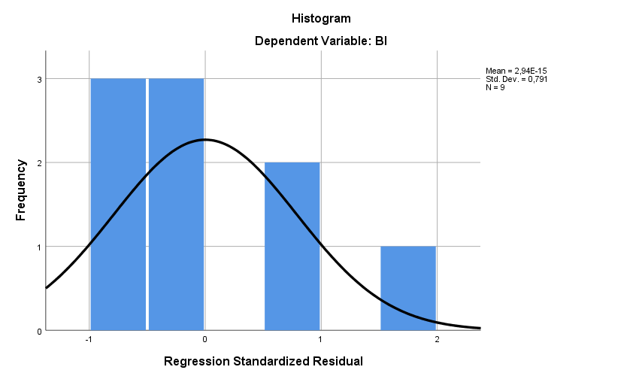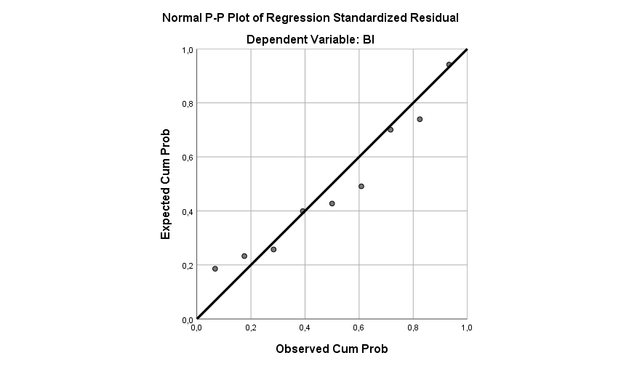

.

*Fig. 2* **–** Histogram and PP Plot Chart of residual values

Source: Own processing in SPSS 26

In conclusion, it can be mentioned that the residual values ​​of the regression model show a normal distribution, the developed model being valid and statistically significant.

**Conclusion**

The economic situation at the level of the entire globe is in an uncertainty after the wave of crises that unexpectedly hit the whole society, starting with the COVID-19 crisis, the energy crisis, the crisis of raw materials, the galloping inflation, the increased level of interest and ending with the military conflicts, especially the Russian-Ukrainian conflict that is still unfolding at the borders of the European Union. For this reason, a deterioration in bankruptcies of economic entities is expected, a fact recently confirmed by a Barameter launched by Allianz, one of the most famous financial groups in the world that also includes the non-payment risk insurance component. The January 2024 study mentions that global insolvencies will increase by 8% this year and 3 out of 5 countries will reach pre-pandemic levels by the end of the year, with the strongest countries in the world having extremely high growth rates, Germany (+ 9%). The Netherlands (+28%) and the US (+5%).

For this reason, a permanent concern for finding the most effective ways to prevent and predict the risks related to the bankruptcy of companies, is at the center of researchers and economists. So, the research study started with a brief bibliometric analysis through which we identified the level of knowledge up to this point as well as the directions towards which future research is headed.

Through the present study, we aim to make a contribution to knowledge by identifying the macroeconomic factors determining the increase in bankruptcy risks. In this sense, we have identified 3 fundamental macro-economic variables in the specialized literature but also the most used in official reports at the level of the European Union, namely the economic growth, the inflation rate and the unemployment rate for the period 2015-2023, following the influence it exerts on the bankruptcy index, index published by the European Union on the website https://ec.europa.eu/eurostat. The econometric model was developed using the statistical software IBM SPSS Statistics 26 which allowed us to achieve the proposed objectives.

The hypotheses initially issued were validated, thus we can state that the external environment influences the bankruptcy risk at the level of the European Union through macroeconomic factors. The level of recorded economic growth significantly influences in a positive sense, in the sense that in periods of economic growth, the number of company creations increases, but at the same time the number of bankruptcies also increases as a result of the exercise of the laws of the economy. The unemployment rate has a strong significant influence, but in the opposite sense, there are premises that the decrease in unemployment should be attributed to economic growth, to the increase in the standard of living of the population that will consume more, new companies are established and what also attracts the bankruptcy of some companies that they were artificially kept alive as a result of the intensification of competition. Also, a lag in the manifestation of symptoms can occur.

In conclusion, macroeconomic factors are relevant when we analyze the trend of the evolution of bankruptcies, which influence economic activity alongside internal factors, among which company management is an essential one.

**Bibliography**

1. Altman, E.I., Dai, R., Wang, W. (2024). Global zombie companies: measurements, determinants, and outcomes, Journal Of International Business Studies
2. Anghel, I., Enache, C., Merino, F. (2020). Macroeconomic determinants of corporate failures. Evidence from Romania and Spain, Journal of Business Economics and Management, Volume 21, Issue 3, pp. 743-759, DOI 10.3846/jbem.2020.12217
3. [https://commercial.allianz.com/news-and-insights/expert-risk-articles/allianz-risk-barometer-2024-macroeconomic developments.html#:~:text=Globally%2C%20Allianz%20Trade%20estimates](https://commercial.allianz.com/news-and-insights/expert-risk-articles/allianz-risk-barometer-2024-macroeconomic%20developments.html#:~:text=Globally%2C%20Allianz%20Trade%20estimates) %20that,the%20US%20(%2B5%25).
4. Erkens, M., Paugam, L., Stolowy, H. (2015). Non-financial information: state of the art and research perspectives based on a bibliometric study. Comptabilité – Contrôle – Audit, 21 (3), 15–9
5. Fuertes-Callén, Y, Cuellar-Fernández, B, Serrano-Cinca, C. (2023), The role of organisational factors and environmental conditions on the success of newly founded firms, Journal Of Management & Organization,  [First View](https://www.cambridge.org/core/journals/journal-of-management-and-organization/firstview), pp. 1 – 34, DOI: <https://doi.org/10.1017/jmo.2023.13>
6. Liu, J. (2004). Macroeconomic determinants of corporate failures: evidence from the UK. Applied Economics, 36(9), pp. 939–945. <https://doi.org/10.1080/0003684042000233168>)
7. Pittiglio, R. (2023). Counterfeiting and firm survival. Do international trade activities matter? International Business Review
8. Situm, M. (2023). Factors affecting micro and small business distress in Austria, International Journal Of Entrepreneurial Venturing
9. Tokarski, A; Tokarski, M. (2018). The Influence Of The Macroeconomic Factors On The Scale And Dynamics Of The Bankruptcy Od Enterprises In The Polish Economy In The Years 2000-2015, Transformations In Business & Economics, 2018
10. Wei, C.Y., McCormack, G., Zhao, J.C. (2023). Bargaining in the shadow of law and finance: the market-oriented debt to equity swap in China, Journal Of Corporate Law Studies
11. Shanmugam, G. (2023). 200 Years of Fossil Fuels and Climate Change (1900-2100), Journal Of The Geological Society Of India
12. Kara, O., Altinay, L., Bagis, M., Kurutkan, M.N., Vatankhah, S. (2024). Institutions and macroeconomic indicators: entrepreneurial activities across the world, Management Decision
13. Valaskova, K., Gajdosikova, D., Lazaroiu, G. (2023). Has the COVID-19 pandemic affected the corporate financial performance? A case study of Slovak enterprises, Equilibrium-Quarterly Journal Of Economics And Economic Policy
14. Faré, L., Audretsch, D.B., Dejardin, M. (2023). Does democracy foster entrepreneurship? Small Business Economics