**AN ANALYSIS OF THE FINANCIAL PEFRORMACE OF THE BANKING SECTOR DURING 2015-2019**

**Abstract:** *The main task of the financial performance’s assessment is directly and completely dependent on the main goal of the bank’s financial management – to maximize the business’s economic value. The management of the financial performance identifies, optimizes and diagnoses the processes that are generating economic value added. The analysis of the bank’s efficiency indicators generates decisions of major importance for the future evolution of the bank and its performance. Due to the fact that it plays a key role in national economies, the bank statistics may produce insights about the economic situation. The impact of the banking activities over monetary statistics, such as monetary base and the domestic private sector crediting.*

Keywords: performance, efficiency, rate of return on assets, return on equity, banks*,*

**JEL Classification**: G21, M40, M48

**INTRODUCTION**

Because the banks are participating in both internal and international financial systems and playing a key role in national economies, the banking financial indicators may offer clues about country’s economical situation. A powerful banking sector is channeling efficiently the funds in order to consolidate the financial and economic system of any country. (Sharma D. Sharma A. K., Barua M.K., 2013)

Banking management is a complex activity carried on depending on the profit maximization and risk minimization goals.

Bank performance reflects the efficiency of capital allocation and mobilization. In order to fulfill this goal, the banks have to invest their funds to support the economic growth, to allocate funds for investments concurring to economic structural changes and to productivity increase, to ease the payments in such a manner that the market could operate with low costs (Nedelescu M., Bunescu P., 2017). The information referring to the bank’s performance and the analysis of the information are very helpful for the investors, for the firms applying for a loan, for the businessmen or deponents which have stable relationships with a banking institution (Niţu, I., 2002).

Manolescu, G. şi Sîrbea Diaconescu, A. (2001) are stating that „the profitability includes the vision referring to covering the investments with own funds at each operational center level, established as profit center”. Rotaru, C. (2001) notes that the performance must regarded mostly in terms of stability, efficiency and less in terms of competition, the latter being rather an outcome of the performance level.

1. **General aspects regarding the banking management concept**

Financial performance management is a set of analytical methods, decision-making models and operational techniques that allow the bank to continuously and systematically strengthen its financial performance by adequately adapting its structures and functions to changes, both incremental and of major magnitude which the business environment receive.

The main components of the performance management are the analysis and evaluation of performance based on the financial situation and strategic planning of banking performance. Banking performance analysis can be performed based on bank income and expenses, and/or with the help of profitability and efficiency indicators, and strategic banking performance planning can be performed either at the level of the entire bank or at each organizational link, following both profitability, as well as bank costs.

The management of banking performance, together with the management of banking assets and liabilities, must contribute to an increasingly efficient activity. There are several concepts regarding the organization of the banking performance management process.

The first one refers to how the banking performance should be pursued: at the level of the entire bank or ensuring it at each organizational link. It is beneficial to organize the performance on each banking unit, and at the central level, on separate departments. The option of organizing a bank in the form of profit centers allows measuring the financial contribution of each business center through appropriate and specific indicators of costs and profitability.

The second concept, refers to the way of setting up the planning, determination, analysis and corrections brought to the bank's performances, by establishing models for expressing the bank's performance. Profitability models include all forms of income - interest, commissions, taxes, other income - and all expenses - interest, wages, equipment, depreciation of assets, provisions for loans and losses - that belong to each profit center. Therefore, an important role of the profitability model is that of solving the cost of resources.

1. **INDICATORS FOR ASSESSING PERFORMANCE IN BANKS**

The financial viability and institutional shortcomings of a bank are also determined by financial assessments, extensive portfolio analysis, an assessment of the bank's overall risk profile. Based on the profit obtained, banks can quantify performance using a system of banking performance indicators. The indicators for assessing the banking performance have a great expressiveness, reflecting a lot of aspects: the degree of profit generation, the operational and managerial efficiency, etc. (Nedelescu M., Bunescu P., 2017). In the literature, banking performance is expressed by indicators of profitability and indicators of financial soundness or risk. (Apătăchioaie A., 2015). The traditional indicators used for bank’s performance analysis are return on assets and return on equity.

The economic rate of return on assets or return on assets indicates the share of net profit in assets at average value and expresses the net result as a performance of asset management, given a given volume of resources. This indicator varies between 0.5% and over 5%. A decreasing evolution shows that the bank has difficulties in generating revenues, so it must be increasing. (Riadi S., 2018).

Financial profitability or return on equity expresses the ratio between net profit and equity at average value, and reflects the efficiency with which management uses the capital invested in the shareholder bank to optimize profit (Apătăchioaie A., 2015), but at the same time measures the time needed for the shareholders to recover the investment. The calculation formula shows that the lower the equity, the higher the ROE, therefore, the bank's shareholders may not want to own too much equity. (Petersen M., Schoeman I., 2008). In the case of banks, a normal margin of this indicator is estimated to be between the significant thresholds of 10% and 30%. A severe disadvantage of this indicator is the ignorance of return risks, because according to modern capital market theory, the rate of return must be adjusted according to the risks taken to facilitate the comparison of different investor options of an investor. (Werner K., Moormann j., 2009). The Basel Accord imposed minimum capital requirements on banks. The restrictive nature of the legal minimum capital could cause banks to change their business strategy in favor of activities and assets that require lower capital requirements. (Greuning H., Brajovic Bratanovic S, 2003)

Each bank carrying out its banking activity aims to cover all expenses incurred for interest paid on the resources attracted to be covered by interest income, commissions, collected for investments made in particular in loans. In order to remain profitable, the difference between them must be greater, in order to be able to cover both the operating expenses and those with the operation of the bank (operational). For good performance management, banks must obtain an optimal relationship in the structure of its expenditures and, first of all, between the costs of resources and the general operating costs of the bank, in order to avoid diminishing profitability through exaggerated costs in this category of expenditures. Niţu I. (2000) considers that "situations in which an expense with the operation of the bank could in itself lead to a decrease in profitability should be avoided and excluded."

In order to prevent such situations, the banks analyze the efficiency of the operating activity in terms of the level of the cost / income indicator (activity cost) determined as a ratio between the total operating expenses and the total operating income. This indicator reflects the degree to which the revenues generated are used to cover the bank's expenses and must be as low as possible to show an efficient banking activity. The literature argues that the lower the ratio of operating expenses to total assets, the more efficient a bank is. (Staikouras C. Mamatzakis E. and Koutsomanoli-Filippaki A. 2008)

1. **Analysis of statistical data on banking performance indicators**

There are many analysis models of banks and other entities. Indicators are a basic tool for financial analysts and are essential for examining the efficiency of the banking management process, but also the risks associated with this activity. Changes over time in indicators provide a dynamic view of the performance of a bank or a banking system. Charts are powerful tools for analyzing trends and structures. They facilitate the comparison of performance and structures over periods of time, offering trend lines, but also the main changes in the evolution of indicators. Many factors can influence the profitability of a bank, but when analyzing banking performance we must take into account the economic environment, but also the regulatory framework in which the bank operates. Pasiouras F. and Kosmidou K (2007) found in their study, that the profitability of banks is affected not only by the specific characteristics of the bank, but also by the structure of the financial market and macroeconomic conditions. An unstable macroeconomic environment, with non-unitary economic performance, exchange rate fluctuations, rising inflation, is the main cause of financial system instability. In some cases, inflation can increase operating costs faster than revenues. The rapid increase in the inflation rate and the deterioration of the inflation outlook have necessitated an increase in the monetary policy rate. Low profitability can be both a consequence and a cause of the weak economic environment, at least for some countries, affecting the ability of banks to finance that country's economy. (KPMG, 2016).

* 1. **Methodology and data**

In order to assess the Romanian banking system and other UE countries banking systems taking into account the banking performance indicators, we have used a set of statistic data collecting methods and we have charted the data. The data is available on European Bank Central site, and for interpretation we have took account of key risc indicators set up by in 2015 the European Banking Authority for the indicators describing the banking profitability. This analysis includes information collected using a sample of 14 UE banks (11 of EU and 3 of non EU member states: Romania, Cyprus and Poland). The average values of the indicators (taken from EBC reports) were compared for the two groups.

The total amount of assets belonging to UE banks increased in 2019 with 3 trillions euro compared with 2018, after a few years of successive decrease. Nevertheless, starting with 2008, the number of UE banks decreased continuously as a results of banking mergers (EFB, 2019).

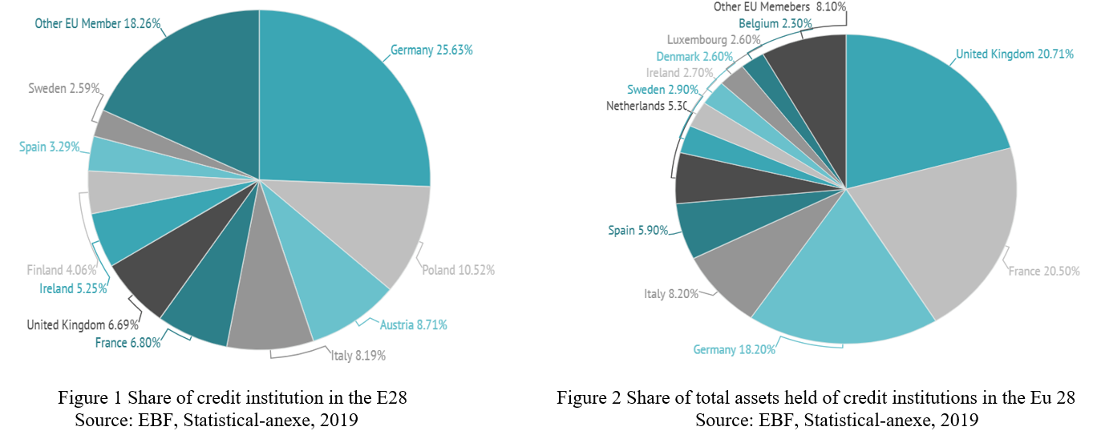

Looking at Figure 1 and figure 2, one can observe that the state with the highest number of banks was Germany (25%), followed by Poland (11%), Austria and Italy (9% each). Performing an addition of the percentages reveals that over half of all UE banks were placed in these four states members of the UE (EBF, 2019).

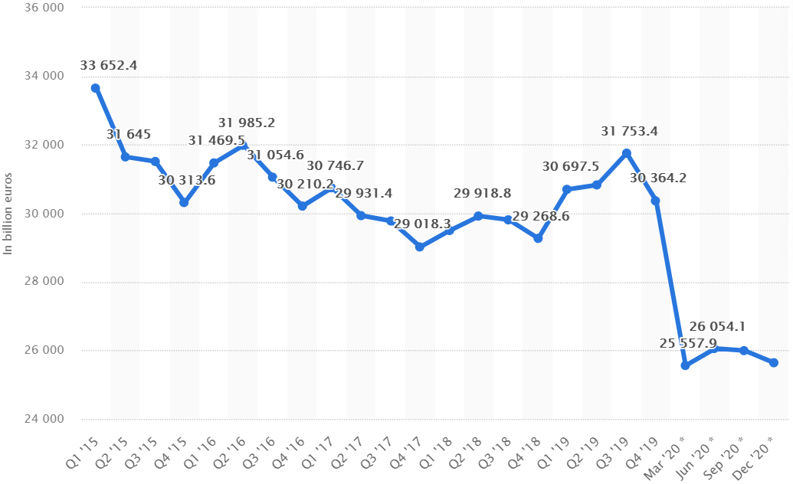

Figure 3 Total assets of banks Europe 2015-2020

Source: <https://www.statista.com/statistics/1124836/europe-bank-total-assets-quarterly/#statisticContainer>

The foreign ownership of the financial intermediates is, in principle, a strong driving force for the financial integrations (Staikouras C. Mamatzakis E. and Koutsomanoli-Filippaki A., 2008). Goddard J., Molyneux P., Wilson JOS, Tavakoli M., (2007) consider that the integration and the liberalization of the European financial markets and of the payment system put a considerable pressure on the traditional bank’s activity directions.

We have analyzed further the evolution of the ability of the European credit institution management to use resources of their disposal in order to maximize the profit. The period we’ve analyzed is during 2015 to 2019, looking at the economic rentability indicator (figure 4).

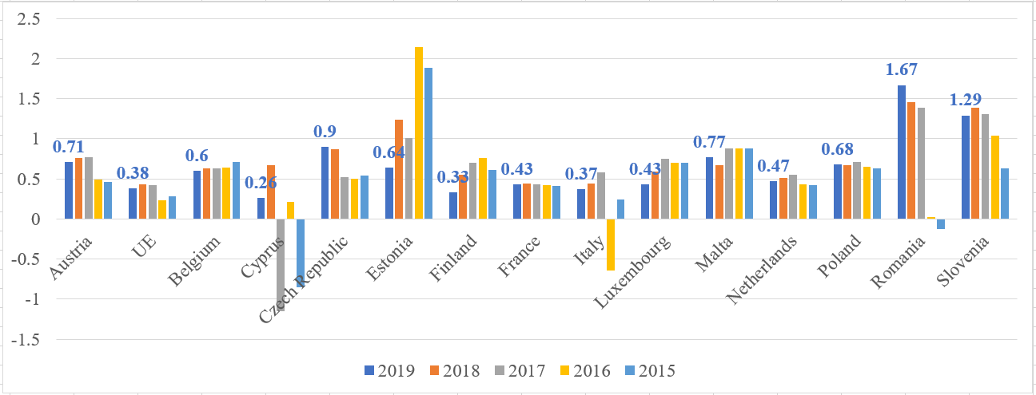

**Figure 4** Evolution of economic profitability, international comparisons

Source: <https://sdw.ecb.europa.eu/>, and authors own elaboration

Profitability is an indicator revealing the bank’s competitive banking position and the quality of the management. Analyzing the international comparison summarized in graph 1, we find that the maintenance of the economic profitability rate for the Romanian banking system is above the average of the EU area (0.38%) due to the low degree of banking intermediation. If we perform a regional analysis, data prior to the COVID 19 period show that, during the analyzed period, the banking sectors in Cyprus, Italy, and Finland recorded low values (0.26 percent, 0.37 percent and 0.39 percent, respectively, December 2019), while those in Romania, Slovenia and the Czech Republic recorded high values, over 1 percent (1.67 percent, 1.29 percent, respectively 0.9 percent, at the end of 2019). The low values of this indicator generally reveal unproductive investments, which cannot bring enough profit to banks. This is also confirmed by the study made by Pessarossi P. and Weill L. (2020), who found that high profitability does not ensure the stability of the bank. Also, the financial structure of the new EU countries has a low level of financial intermediation, with the exception of Cyprus and Malta (Staikouras C. Mamatzakis E. and Koutsomanoli-Filippaki A., 2008).

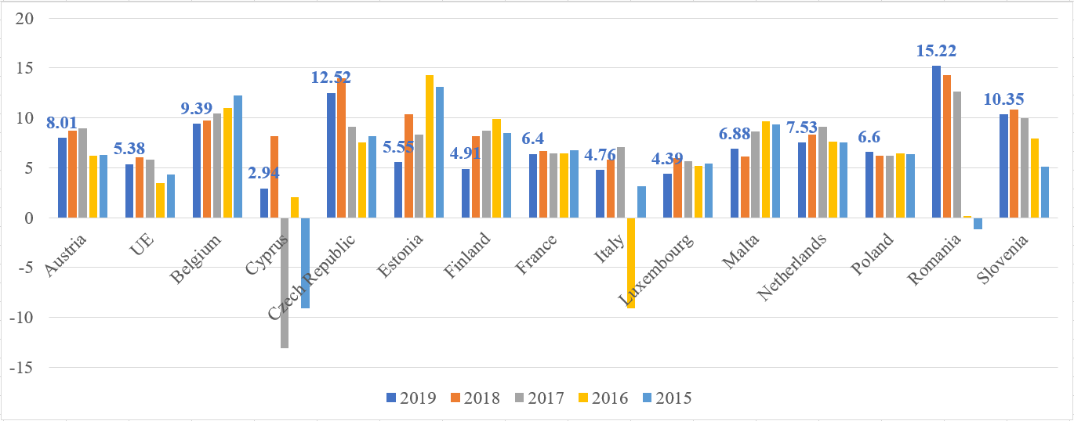

**Figure 5** The evolution of the financial return for different countries.

Source: <https://sdw.ecb.europa.eu/> and authors own elaboration

Based on the data from figure 5 we analyzed the evolution of the efficiency of using the capital invested by shareholders European credit institutions, for the period 2015-2019, with the help of the financial profitability indicator. Between 2015 and 2019, the EU average for ROE was 5.38 percent, but a quarter of banks had a profitability of 4.7 or less. We find that the values of financial profitability obtained by the Romanian banking sector remain above the EBA threshold (10 percent), positioning itself at the top of the indicator in the EU. According to the prudential limits of the European Banking Authority, it is best for banks to have this indicator above 10 percent, with the range between 6 percent and 10 percent indicating an average risk, and below 6 percent a high risk. (EBA, 2015). The regional analysis of the data, for the period 2015-2019, shows that the banking sectors in Cyprus, Luxembourg, Italy and Finland obtained values lower than 6 percent (2.94%, 4.39%, 4.76% and 4.91%, respectively, at end of 2019) and Slovenia, the Czech Republic and Romania values are over 10 percent (10.35 %, 12.52 %, and 15.22 % respectively, at the end of 2019). Moreover, market analysts' forecasts suggest that the ROE level of many euro area banks will most likely remain below 8 percent in the coming years, which will continue to act as a brake on bank share prices. (Elekdag S., Mitra S., 2020). A high return on equity indicates that a small investment of shareholders has been turned into a large profit, and this is very important for a business.

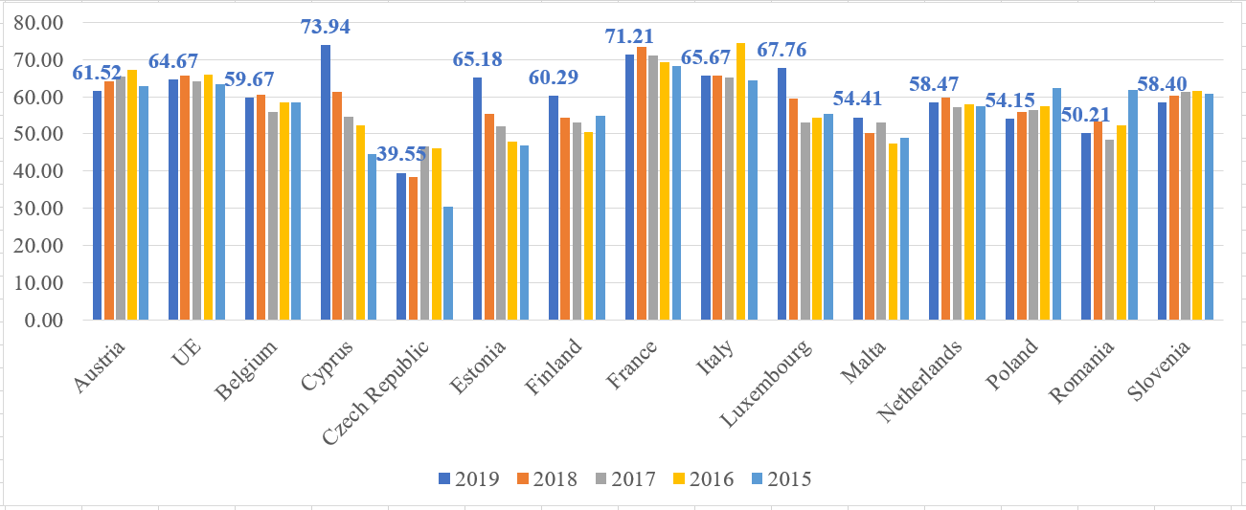

**Figure 6** The analysis of the cost /income ration.

Source: <https://sdw.ecb.europa.eu/>, and authors own elaboration

Based on the data from figure 6, we analyzed the efficiency of the operational activity of European credit institutions, for the period 2015-2019, using the cost / income indicator. From the analyzed data, we find that the efficiency of the operational activity of credit institutions in Romania is positioned in the medium risk range, according to the prudential limits of EBA and below the EU average (64.67%, at the end of 2019). According to the prudential limits of EBA, it is best for the bank for this indicator to be below 50 %, in order to carry out its banking activity efficiently. The range between 50 % and 60 % indicates an average risk of the bank's operating activity. An indicator above 60 % to indicate a high risk of exploitation. Banks can improve operational efficiency both by increasing the degree of intermediation and by continuing consolidation trends. (EBA, 2018)

The operational profitability of Romanian banks, before the COVID 19 pandemic, had a positive dynamic, due to the “improvement of operating revenues, under the influence of accelerating growth of the national currency component of loans to the private sector, partially diminished by the continued upward trend in spending as a consequence of the increase in salary packages.” (BNR, 2019). For a regional analysis, data prior to the COVID 19 period show that the Czech banking sector recorded lower values, below 50 %, achieving efficient operating profitability, while those in Finland, Austria, Estonia, Italy, Luxembourg, France, Cyprus recorded high values, over 60 %, (60.29 %, 61.52 %, 65.18 %, 65.67 %, 67.76 %, 71.21 % and 73.94 %, respectively, at the end of 2019), indicating operational profitability deficient. In order to improve operational profitability, some banks have introduced organizational changes (such as outsourcing), reduced the territorial structure (number of branches), but also the number of employees. (Staikouras C. Mamatzakis E. and Koutsomanoli-Filippaki A. 2008). Elekdag S. si Mitra S. (2020). Elekdag S. si Mitra S. (2020) noted that lower cost / income ratio are associated to a higher return.

1. **CONCLUSION**

A bank's strategy must consider profitability as a precondition that influences its existence, development and future integrity. The final objective of the banking activity is to optimize the contribution of the operations it carries out and the permanent control of the costs in order to ensure the programmed level of profitability. We believe that a framework for evaluating banking performance must include an efficient organization through a clear allocation of income and expenses by business units, in relation to the different business directions and / or products.

A bank's strategy must consider profitability as a precondition that influences the existence, development and future integrity of the bank. The final objective of the banking activity is to optimize the contribution of the operations it carries out and the permanent control of the costs in order to ensure the programmed level of profitability. We believe that a framework for evaluating banking performance must include an efficient organization through a clear allocation of income and expenses by business units, in relation to the different business lines and / or products.

The general profitability of the bank, as a final synthesis indicator of the entire activity, can be a resultant of the profitability derived from the profit centers which, in turn, will reflect the profitability of customers and, further, of the most efficient products and services offered to these customers. Also, the system of banking performance indicators can indicate both a synthetic and a comprehensive image of the bank, but in no case a complete picture of the results of a bank's activity. Therefore, these indicators need to be compared with similar indicators in order to be able to determine the real position of the bank in terms of profitability.

The comparative analysis presented in this paper, prior to the COVID 19 pandemic, shows that Romanian banks are well positioned, if we discuss about of profitability, above the EU average. At the end of 2019, the values of the main indicators of profitability, economic profitability (1.67%), financial profitability (15.22%), cost / income ratio (50.21%) remained high, but the annual average for each indicator obtained in the EU area (0.38%, 5.38% and 64.67%, respectively) positions the Romanian banking sector on the twelfth and eleventh position among the EU states. Based on the results obtained, we consider that the Romanian banking sector has entered the crisis generated by the COVID 19 pandemic with significantly better financial health compared to the financial crisis of 2008, and this feature is valid for most European banking systems.

**REFERENCES**

1. Apătăchioaie A., (2015), *The performance, banking risks and their regulation*, Procedia Economics and Financce 20, International Conference on Globalization and Higher Education in Economics and Business Administration, GEBA, 2013, <https://doi.org/10.1016/S2212-5671(15)00044-1>
2. Elekdag S., Mitra S., (2020), *Breaking the Bank? A probabilistic assement of euro are bank profitability*, Journal of Banking and Finance, vol. 120, nov 2020, <https://doi.org/10.1016/j.jbankfin.2020.105949>
3. ECB (European Central Bank), (2019), *Financial Stability Review*, European Central Bank, Frankfurt 2019
4. EBA (European Bank Autority), (2018), *Raport anual 2018*.
5. EBF (European Federal Bank), (2019), *Banking sectors performance 2019*.
6. Goddard J., Molyneux P., JOS Wilson, (2004), *The profitability of European banks: a cross-sectional and diynamic panel analysis*, The Manchester School, vol.72, no.3, june 2004.
7. Goddard J., Molyneux P., Wilson JOS, Tavakoli M., (2007), European baking: An overview, Journal of Banking and Finance 31, <https://doi.org/10.1016/j.jbankfin.2007.01.002>
8. Greuning HV, Brajovic Bratanovic S., (2003), *Analyzing and Managing Banking Risk: A Framework for Assessing Corporate Governance and Financial Risk Management*, second edition, World Bank Publication, The World Bank.
9. Nedelescu, M., Bunescu P. (2017). *Gestiune bancară*, Editura Pro Universitaria, București.

Niţu, I. (2002), *Principiile profitabilității bancare*, Editura Expert, București.

1. Manolescu, G., Sîrbea Diaconescu, A. (2001)., Management bancar, Editura Fundației de Mâine, București.
2. Rotaru C. (2001) *Managementul performanței bancare*, Editura Expert, București, 2001
3. Riadi S., (2018). *The effect of third parties fund, non performing loan, capital adequacy ratio, loan to deposit ratio, return on assets, net interest margin and operating expenses operating income on lending (Study in regional development bank in Indonesia)*, Proceeding of the International Conference on Industrial Engeneering and Operations Manangement Bandung, Indonesia, March 6-8, 2018.
4. Menicucci E., Paolucci, (2016), *The determinats of bank profitability: empirical evidence from European banking sector*, Journal of financial reporting and accounting, 2016, vol. 14, issue 1.
5. NBR (National Bank of Romania), (2019), *Financial stability report*, december 2019.
6. Pasiouras F., Kosmidou K, (2007), *Factors influencing the profitability of domestic and foreign commercial banks in the European Union*, Research in International Business an Finance, vol. 21, issue 2, june 2007, <https://doi.org/10.1016/j.ribaf.2006.03.007>
7. Petersen M., Schoeman I., (2008), *Modeling of banking profit via return on assets and return on equity*, Proceedings of the World Congress on Engineering 2008, vol II, WCE 2008, jul 2, Londol, U.K.
8. Pessarossi P., Weill L, (2020), *Does high profitability improve stability for European banks?*, Research in International Business and Finance, vol. 53, october 2020, <https://doi.org/10.1016/j.ribaf.2020.101220>
9. Sharma D., Sharma AK, Barua MK, (2013), *Efficiency and productivity of banking sector: a critical analysis of literature and design of conceptual model*, Qualitative Research in Financial Markets, vol. 5, issue 2, 2013 <https://doi.org/10.1108/QRFM-10-2011-0025>
10. Staikouras C. Mamatzakis E. and Koutsomanoli-Filippaki A. (2008), *An empirical investigation of operating performance in the new European baking landscape*, Global Finance Journal, vol.19, issue 1, <https://doi.org/10.1016/j.gfj.2008.01.001>
11. Werner K., Moormann J., (2009), *Efficiency and profitability of European banks: how important is operational efficiency?*, Frankfurt Scool-Working Paper Series, No 111.