**GENDER GAP IN ENTREPRENEURSHIP IN SOME OF OECD COUNTRIES**

**Abstract:**

*The aim of this paper is to study the gender gap in entrepreneurship in some of OECD countries. The research methodology is based on a descriptive analysis and multivariate analysis of the data series collected from the Global Entrepreneurship Monitor website and OECD.Stat. The research included 31 OECD member countries, the data being downloaded from the organization's website and refers to 2019 year. The results show that there is a positive and strong correlation between the share of self employed women and men who are employers. A determining factor that could explain this correlation could be the entrepreneurial culture in each country. In order to eliminate gender disparities in participation and economic opportunities, it is important to find the reasons for this gap. According to the Global Report on Gender Differences, published by World Economic Forum in December 2018, there is a 68% worldwide. At the current rate, the data suggest that it will take 108 years to erase global gender differences. The global disparity index is based on four sub-indices: opportunities and economic participation, education, health and survival, empowerment and political power. In terms of opportunities and economic participation, they can be assessed by looking at: labor market participation ("participation gap"), the ratio of estimated incomes of women and men and equal pay for similar work ("pay gap"); and the relationship between women and men among legislators, senior officials and managers, as well as the ratio between women and men among technical and professional workers ("promotion gap").*

**Key words**: gender gap, entrepreneurship, self employed, clusters, correlation

**JEL classification:** J16, J31, O11, O15

#### INTRODUCTION

The number of women starting new businesses is lower than that of men. That is why one of the important political goals in many countries is to increase women's participation in entrepreneurship

The amplitude of entrepreneurial activity in each country influences the absolute gap between men and women. In order to have a clear picture of the gender gap in entrepreneurship, the ratio of women to men is used, which can be interpreted as the number of women entrepreneurs who started a business that corresponds to each male entrepreneur who started his own business(GEM, 2020).

In general, gender equality refers to a state of affairs in which women and men enjoy the same opportunities in all social categories. It also means the presence of a gender perspective in the decision-making process of all kinds and that women's interests are given the same consideration as men in terms of rights and resource allocation (Johnsson-Latham, 2007).

1. **LITERATURE REVIEW**

Research shows that the gaps between men and women in entrepreneurship stem from women's difficulties in acquiring resources important to the successful operation of a business, but there are also problems of women's self-perception as being able to be entrepreneurs (Thébaud, 2010).

Early career entrepreneurship is influenced by existing entrepreneurship among neighbors, family members and recent school colleagues. Thus while men are influenced by other men, women are influenced by other women (Markussen, S. and Røed, K., 2017).

Bönte and Jarosch (2011) investigated the contribution of personality traits to the gender gap in entrepreneurship. The results showed that a considerably lower level of individual entrepreneurial aptitude among women is mainly due to lower levels of competitiveness and risk tolerance of women and has a significant contribution to the gender gap in entrepreneurship.

Caliendo et al. (2015) investigated the extent to which personality traits, human capital, and employment history influence the launch decision and may explain the gender gap in entrepreneurship. They noted that higher risk aversion among women explains much of the entrepreneurial gender gap. and also found an educational effect that contributes to the gender difference.

Afandi and Kermani (2015) argue that the gender gap tends to be huge when it comes to individual preferences to start a certain entrepreneurial activity. They found the role of individual and country attributes between men and women in the size of the gender entrepreneurial gap.

Guzman and Kacperczyk, (2019) showed that the most significant part of the gap (65%) comes from gender differences in the initial start-up orientation, with women less likely to find companies that signal growth potential for foreign investors.

#### RESEARCH METHODOLOGY

The description and highlighting of certain patterns was performed using descriptive analysis and multivariate cluster analysis. OECD countries have been grouped into clusters according to the share of self-employed who are female and male employers.

The classification of countries in the SPSS program is done from the menu Analysis - Classify using the K-Means algorithm which is the most direct and efficient in terms of volume of calculations. The research included 31 OECD member countries, the data being downloaded from the organization's website and refers to 2019 year.

1. **RESULTS**

According to the Global Entrepreneurship Monitor Report (2020), most countries have higher levels of entrepreneurial activity among men than women, but there are also three economies participating in the survey where the rate of women exceeds the rate of men: Saudi Arabia, Qatar and Madagascar.

The share of women self-employed who are employers in OECD countries varied in 2019 from 0.58% (from 0.5% in 2017) in Japan to 4.69% (from 4.6% in 2017) in Greece and for men the share varied from 2.01% (from 2.08% in 2017) in Japonia to 9.08% (from 8.89% in 2017) in Greece, as can be seen in figure no. 1.

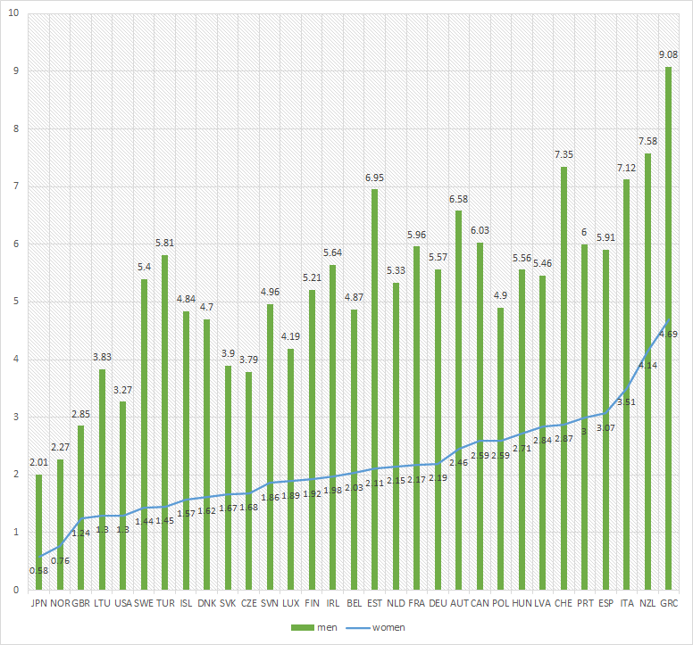

**Figure no. 1 Share of self-employed with employees in 2019**

Thereis a positive and strong correlation between the share of self-employed women who are employers and the share of self-employed men who are employers. The correlation coefficient Spearman is 0,829, value of the sig. is lower than 0,01. This correlation could be explained by the entrepreneurial culture in each country included in the research.

**Tabel no. 1 Spearman correlations**

|  |  |  |  |  |
| --- | --- | --- | --- | --- |
|  | | | share_of_self_employed_women | share_of_self_employed_men |
| Spearman's rho | share_of_self_employed_  women | Correlation Coefficient | 1,000 | 0,829** |
| Sig. (2-tailed) | . | 0,000 |
| N | 31 | 31 |
| share_of_self_employed_  men | Correlation Coefficient | 0,829** | 1,000 |
| Sig. (2-tailed) | 0,000 | . |
| N | 31 | 31 |
| **. Correlation is significant at the 0.01 level (2-tailed). | | | | |

In order to have an overview of, the OECD countries were grouped into 3 clusters using the statistical program SPSS. The member countries of each cluster are presented in table no 2.

**Table no 2. Distribution of OECD countries in clusters according to the share of self employed with employees**

|  |  |  |  |
| --- | --- | --- | --- |
| **Clusters** | **Cluster 1** | **Cluster 2** | **Cluster 3** |
| **Number of Cases in each Cluster** | **4** | **8** | **19** |
| **Members** | New Zealand  Italy  Switzerland  Greece | United States  United Kingdom  Lithuania  Czech Republic  Slovak Republic  Luxembourg  Norway  Japan | Germany  Ireland  Netherlands  France  Finland  Hungary  Canada  Latvia  Slovenia  Belgium  Poland  Sweden  Turkey  Portugal  Spain  Iceland  Denmark  Austria  Estonia |

In the countries included in cluster 1, the share of self employed women who are employers is 3.80%, while the share of self employed men who are employers is 7.78%. In the countries included in cluster 2, 1.30% of the self-employed are women and 3.26% are men. In the countries from cluster 3 only 2.20% of self-employed are women and 5.56% are men, as can be seen in the figure no 2.

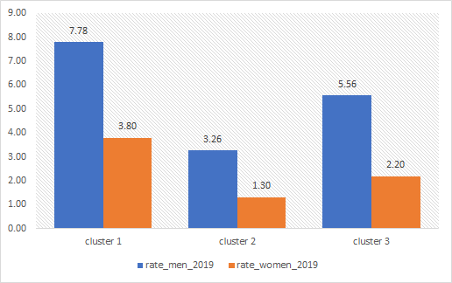

**Figure no.2 Final clusters centers**

The greatest distance is between the countries from cluster 1 and cluster 2. Cluster 2 includes OECD countries where the share of self-employed who are employers, women or men was low in 2019.

**Tabel no. 3 Distances between Final Cluster Centers**

|  |  |  |  |
| --- | --- | --- | --- |
| **Cluster** | **1** | **2** | **3** |
| **1** |  | 5.164 | 2.740 |
| **2** | 5.164 |  | 2.466 |
| **3** | 2.740 | 2.466 |  |

The illustration of the classification, in which it is possible to observe the way of differentiating the classes according to the share of self-employed women and men who are employers, is made by the diagram from figure no. 3.

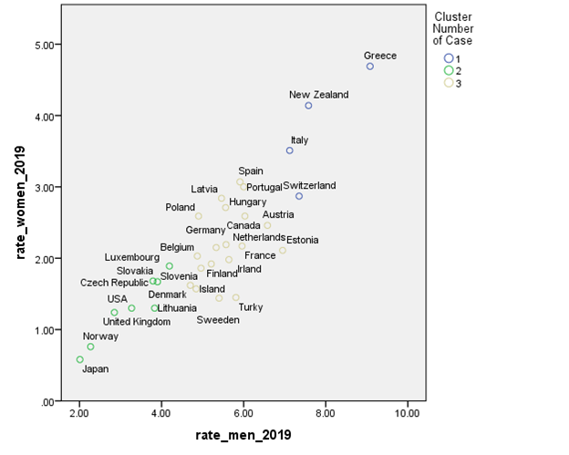

**Figure no 3 Classification of OECD countries in clusters according to the share of self employed who are employers**

From figure no. 3, it can be seen in countries such as Japan, Norway, United Kingdom or the United States, the share of self-employed women and men who are employers is very small compared to countries such as Greece, New Zealand, Italy or Switzerland.

#### CONCLUSIONS

Although the gaps between the share of women who choose an entrepreneurial career and the share of men who start their own business are in the focus of research, information about the factors that determine these gaps is still limited. Factors such as personality traits, access to relevant resources or the existence of family entrepreneurship have an important contribution to the gender gap. Promoting entrepreneurship as a viable career option has social and economic relevance. Statistical analysis performed on 31 OECD countries indicated the existence of a positive and strong correlation between the share of self-employed women and men who are employers. In countries where the share of self-employed women who are employers is low, there is also a small share of self-employed men who are employers. Countries that have a high share of self employed women who are employers, have also a high share of employed men who are employers. A determining factor that could explain this correlation could be the entrepreneurial culture in each country.

#### BIBLIOGRAPHY

1. Afandi, E. and Kermani, M. (2015). *Bridging the gender gap in entrepreneurship: an empirical analysis*, Journal of Developmental EntrepreneurshipVol. 20, No. 02, 1550008, <https://doi.org/10.1142/S1084946715500089>
2. Bönte, W., Jarosch, M. (2011). *Gender differences in competitiveness, risk tolerance, and other personality traits: Do they contribute to the gender gap in entrepreneurship?*, Schumpeter Discussion Papers 2011-012, urn:nbn:de:hbz:468-20110728-152124-2
3. Caliendo, M. Fossen, F. M., Kritikos, A. Wetter, M. (2015). *The Gender Gap in Entrepreneurship: Not just a Matter of Personality*, CESifo Economic Studies, Volume 61, Issue 1, Pages 202–238, <https://doi.org/10.1093/cesifo/ifu023>
4. Global Entrepreneurship Monitor 2019/2020 Global Report, (2020), *Adult Population Survey*, Global Entrepreneurship Research Association, London Business School, Regents Park, London NW1 4SA, UK
5. Guzman, J., Kacperczyk, (Olenka), A., (2019). *Gender gap in entrepreneurship*, Research Policy, Volume 48, Issue 7, Pages 1666-1680, <https://doi.org/10.1016/j.respol.2019.03.012>
6. Howell, S. T., Nanda, R. (2019*). Networking Frictions in Venture Capital, and the Gender Gap in Entrepreneurship,* NBER Working Paper No. 26449,
7. Johnsson-Latham, G. (2007). *A study on gender Equality as a prerequisite for sustainable Development*. Report to the Environment Advisory Council, Sweden. Available at [www.atria.nl/publications](http://www.atria.nl/publications).
8. Markussen, S., Røed, K. (2017). *The gender gap in entrepreneurship – The role of peer effects*, Journal of Economic Behavior & Organization, Volume 134, Pages 356-373, <https://doi.org/10.1016/j.jebo.2016.12.013>
9. Thébaud, S. (2010). *Gender and Entrepreneurship as a Career Choice*: Do Self-assessments of Ability Matter?, <https://doi.org/10.1177/0190272510377882>
10. OECD (2021), "*Gender Equality: Gender equality in entrepreneurship*", OECD Social and Welfare Statistics (database), <https://doi.org/10.1787/data-00723-en> (accessed on 15 November 2021).
11. OECDE.STAT, <https://stats.oecd.org/index.aspx?queryid=74181>