APPLICATION OF PROFESSIONAL JUDGEMENT IN THE RECOGNITION OF PROVISIONS. THE CASE OF BSE LISTED COMPANIES

Maria GROSU
„Alexandru Ioan Cuza“ University of Iaşi, Romania maria.grosu@uaic.ro
Camelia Cătălina MIHALCIUC
“Stefan cel Mare“ University of Suceava, Romania camelia.mihalciuc@usm.ro

Abstract:
The equity of an entity reflects the wealth of its owners, which is, in effect, the residual interest of the shareholders in the assets of the entity after deducting liabilities. In determining shareholders' net assets, all liabilities of the entity must be taken into account, including uncertain or contingent liabilities such as provisions. The nature, opportunity and value of provisions should be disclosed in the explanatory notes to provide full information to interested parties. This work focused in particular on the analysis of provisions, because over time, provisions have been difficult to interpret due to their subjective and cashless nature, and these features describe their vulnerability to manipulation. The research objective of the authors is, on the one hand, to present the aspects concerning the recognition and valuation of provisions, i.e., to detail the main peculiarities of provisions, according to IAS 37, and, on the other hand, to analyse the implementation of the international standard IAS 37 ,,Provisions, contingent liabilities and contingent assets" in entities listed on the Bucharest Stock Exchange, on the regulated market. Thus, the authors aim to analyse the presence of provisions reported by entities listed on the Bucharest Stock Exchange on the regulated market, as well as the areas in which these items are of significant importance.

Key words: provisions, recognition and measurement, IAS 37-Provisions, contingent liabilities and contingent assets, listed entities, Bucharest Stock Exchange .

JEL classification: M41, M48.

INTRODUCTION

Corporate management is directly involved in the preparation and publication of accounting information, which is why managers must act with care and responsibility when presenting accounting data. In many cases the data presented are partly based on estimates, using relevant, objective and calculated reasoning. A thorough understanding of provisions is essential for a user to understand an entity's operating performance and use it as a basis for measurement. This paper has focused in particular on the analysis of provisions, as historically provisions have been difficult to interpret due to their nature as subjective and cashless, and these characteristics describe their vulnerability to manipulation. The subject under analysis is a topical one and is widely analysed, with different views on the importance of these elements in a company both at national and international level. The main objective of the theoretical part of the paper is to describe the theoretical aspects of the recognition and measurement of provisions, and in order to achieve the proposed objective, the authors have detailed the particularities of provisions, i.e. the recognition and measurement of environmental provisions under IAS 37, even though the IASB considers that environmental reports presented outside the financial statements do not fall within the scope of IFRS. The application part is directed towards an analysis over a three-year period, from 2019 to 2021, of entities listed on the Bucharest Stock Exchange, from the point of view of the implementation of IAS 37 "Provisions, Contingent Liabilities and Contingent Assets" by these entities, specifically the presentation of the amounts and reported elements of provisions. In addition, taking into account the information collected, the authors will also use a graphical presentation of the areas, in which the elements that make up the provisions are of significant importance.
The classification of provisions as a liability has severely limited the freedom to create them from an entity's perspective because provisions must meet all the criteria contained in the definition of a liability. The provisions for these items also allow for creative accounting practices and can lead to substantial gains due to these uncertainties. Providing reliable and relevant information to users of financial statements is one of the objectives of financial reporting, but we must also establish that some of the information presented is also based on management judgement. Provisions are one of the main outcomes of these management judgments and intentions, and their recognition and presentation requires interpretation of probabilities, key assumptions and estimation uncertainty (Suer, 2014, 391).
Known as some of the most enigmatic and strategic items in a company's financial statements, this category of liabilities is a major issue in shaping an image and reputation for the company. Thus, some liabilities can only be measured using a substantial degree of estimation, which is why some companies define these liabilities as provisions. Since in some countries the concept of liabilities is narrowly defined to include only amounts that can be determined without estimation, such provisions are not considered liabilities. Even if the amount must be estimated, a provision that involves a present obligation and meets the other requirements of the definition is still considered a liability.

- LITERATURE REVIEW

By creating provisions, entities ensure that all liabilities are included in the financial statements. As provisions are a category that affects both the amount shown in the statement of financial position and in the income statement and other items of profit or loss, they are a category of items that can shape the picture of a financial statement. The inclusion of provisions in the category of liabilities has limited the freedom of companies to create them because a provision must meet all the requirements contained in the definition of a liability (Poniatowska, 2017, 8). It should also be borne in mind that provisions can allow companies to use creative accounting practices and manage earnings due to uncertainty (Suer, 2014, 391). In accounting, verbal probability expressions are widely used for various items such as revenue recognition, tax deferrals and contingent items. In particular, International Accounting Standard 37 ,,Provisions, Contingent Liabilities and Contingent Assets" (IAS 37, iasplus.com), requires a provision to be recognized in the financial statements when it is probable (i.e. more likely than not) that an outflow of resources embodying economic benefits will be required to settle the obligation. It follows that provisions for single events such as restructuring, environmental clean-up, settlement of a lawsuit are valued at the most likely value, while provisions for large populations of events such as guarantees, customer refunds are valued at a probability-weighted expected value (Du et al., 2016, 1). Both valuation methods are done at present value, a method in which a pre-tax discount rate is used to reflect current market assessments of the time value of money and liability-specific risks (Nandakumar et al., 2010).
Provisions meet, despite the inherent risk, the criteria for recognition in the financial statements: there is a present obligation at the end of the reporting period; and the potential outflow of resources required to settle the liability can be reliably estimated. The standard urges that estimates of provisions should be made prudently to avoid deliberate understatement or overstatement of liabilities (Mielcarz et al., 2016). According to the standard, in almost all cases it will be clear when there is an obligation present. The concept of obligation in the standard includes not only a legal obligation (e.g. arising from a contract or legislation) but also an implied obligation (Mielcarz et al., 2016), i.e. when, through a pattern established by its past practices, promoted policy or a sufficiently specific current statement, the entity has indicated to third parties that it will accept certain responsibilities (Feleagă et al., 2010). In this case, a test will be applied to determine whether the present obligation is more likely to occur than not to occur, i.e. whether there is a greater than 50% probability that it will occur (Elliott and Elliott, 2011). IAS 37 excludes obligations and contingencies arising from financial instruments within the scope of IFRS 9 ,,Financial Instruments", insurance contracts with policyholders IFRS 17 ,,Insurance Contracts", even if IAS 37 applies to an insurance company's non-callable liabilities, items covered by another standard such as IFRS 15 ,,Revenue from Contracts with Customers" comprising executory contracts (contracts in which neither party has performed its obligations or in which both parties have only partially and equally performed their obligations; IAS 12 ,'Income Taxes', applies to current and deferred income tax obligations; IFRS 16 ,'Leases', applies to lease obligations; and IAS 19 ,'Employee Benefits', applies to pension and other employee benefit obligations (Nandakumar et al. , 2010).
The recognition of "provisions" and the presentation of "contingent liabilities" have been considered by some authors as sources of creative accounting because of the reasoning used in management estimates. Thus, contingent liabilities are potentially misleading items because, unlike provisions, they are not recognized liabilities. However, they are disclosed and can have a long-term impact on companies' performance (Lopes and Reis, 2019). The recognition and measurement of provisions can have a major impact on how an entity's financial position is viewed by users. IAS 37 addresses provisions for so-called "onerous contracts", which require a company to take into current profit the full cost of fulfilling contracts that continue into the future under defined conditions. This can be a very sensitive issue for a company facing commercial difficulties (Mackenzie et al., 2014, 422). With the entry into force of the standard, the rules on the recognition and measurement of the components of IAS 37 have been codified. Companies preparing financial statements in accordance with IFRS have used these terms strictly on the basis of the definitions given. In addition, the standard has succeeded in clarifying certain misconceptions about the term "provisions", e.g. "provisions" which are required by this standard are now "liabilities" (of uncertain timing or uncertain value). "Provision for impairment" and "provision for doubtful receivables" are not really provisions under this standard, but are adjustments to the carrying amount of assets (Mirza et al., 2008, 317). Before the introduction of IAS 37, companies used provisions, liabilities and contingent assets to smooth earnings because the timing of when a provision was to be established was not well defined and there was little guidance on this and therefore this practice led to potential accounting abuse. This lack of guidance caused problems for many companies that made provisions and then resorted to writing them off to smooth profits. This practice was used in particular by new managers of companies, who made large provisions for restructuring in the first year, with the effect of reducing profits, and then cancelled the provisions made unnecessarily in subsequent years, thereby increasing the company's result. Thus, users of financial statements had difficulty determining the actual profits of companies because of this practice (Okafor et al., 2021).
The use of estimates is a common phenomenon in the preparation of financial statements, according to the standard, and suggests that by using a range of probable outcomes, the entity will usually be able to make an estimate of the obligation that is sufficiently reliable to be used in recognizing a provision. However, no liability is recognized if a reliable estimate cannot be made (Mackenzie et al., 2014, 429). The standard makes it clear that the best estimate of the expenditure required to settle the obligation is the amount that an entity would rationally pay to settle the obligation at the balance sheet date or to transfer it to a third party at that time (Rees, 2010). The amount recognized as a provision should represent the best estimate of the expenditure required to settle the present obligation at the end of the reporting period. The estimates required to settle the obligation are determined by the judgment of the entity's management, supplemented by experience from similar events and, in some cases, determined by independent expert reports. If the provision being valued comprises a large population of items, the obligation is determined by weighting all possible outcomes with their associated probabilities, and this statistical method of estimation is referred to as "expected value" (Feleagă et al., 2010). The standard suggests using expected value as the benchmark for estimating the provision because it allows uncertainty to be incorporated and quantified in the estimation of the obligation (Mielcarz et al., 2016). The discount rate on which the value of the provision is based is a pre-tax rate and reflects current market assessments of the time value of money and the risks specific to the debt. The enterprise has no present obligation for those future expenses if it can avoid incurring them, and in this case is not required to recognize a provision. If the obligation for the amount expected to be reimbursed remains with the enterprise and the enterprise is almost certain to receive the reimbursement if the entity settles the provision, the reimbursement is recognized as a separate asset in the statement of financial position and can be expensed in the statement of comprehensive income, and the amount recognized for the expected reimbursement must not exceed the amount of the provision (Tram-Anh Le, 2019). If the obligation for the amount expected to be repaid remains with the company and the entity settles the provision, the receipt of the amount of the repayment is not almost certain, the expected repayment is not recorded as an asset but is disclosed (CECCAR, 2013).
When making the assessment of a provision, several future events should also be taken into account such as those that may foresee reasonable changes in the application of existing technology, ignoring possible gains from the sale of assets, and possible legislative changes only if it is practically certain that they will be adopted (IAS Plus, IAS 37). IAS 37 has been criticized from the outset for its lack of clarity and the fact that it is difficult to interpret due to both presentation and recognition criteria, which has led to the implementation of different reporting practices. Recent research documents, diversity in the amount and accuracy of disclosures, with discount rate levels being treated, for example, as an absolute accounting choice because IAS 37 contains little explicit guidance and management perceives disclosures that are not explicitly required as optional (Paananen et al., 2021).
In the balance sheet, the provision recorded is presented as a separate item. At the same time the enterprise should disclose for each class of provision a brief description of the nature of the obligation and the timing of any outflow of economic benefits expected by management, a reconciliation between the amounts of the provision at the beginning and the end of the period, respectively, and the additional provision recorded, the amounts used and the amounts unused and reversed during the period under review, as well as the increase in the present value of the provision due to the effect over time and changes in the discount rate, possible indications of the uncertainty of the amount or timing of the outflow of the provision, the main assumptions made about future events and the amount of any expected repayment (Lagrange et al. , 2015). When it is not possible to correctly estimate the value of an obligation, it cannot be recognized and is presented as a contingent obligation (Georgescu, 2005). Thus, a contingent asset is a possible asset that may arise in an entity because of a gain that is influenced by future events and is not within the control of an entity. The treatment of a contingent liability, shows that it should be recorded, when probable, being recognized before the contingent asset, thus preserving the conservative nature of the financial statements (Okafor et al., 2021). Examples of contingent liabilities may include: pending or threatened litigation, claims and assessments, and product warranties and defects (Schiff et al., 2012). A contingent liability is defined as a possible obligation that arises from a past event and whose existence depends on the occurrence or non-occurrence of some event of a probabilistic nature that is beyond the control of the firm (Alibhai et al., 2018, 418-420). The reduced possibility of outflow of resources incorporating the economic benefits to settle the obligations, but also due to the lack of probability of measuring the value of the obligation with sufficient reliability lead entities to the non-recognition in the financial statements of these items (Mielcarz et al., 2016). According to the standard, a contingent liability is not recognized in the statement of financial position. However, unless the possibility of an outflow of economic resources is remote, a contingent liability is disclosed in the notes (IFRS, ifrs.org, IAS 37).
There are many reasons that may justify the establishment of provisions, some of which are explicitly mentioned in IAS 37, while others need to be established in accordance with the general principles of provisioning. According to some studies, provisions are divided into provisions for single events such as restructuring, ground-clearing, lawsuit settlements and provisions for large populations of events such as guarantees and customer refunds (Nandakumar et al., 2010). According to the principle of prudence and accrual accounting, they must also take into account future payments, especially future expenses. Recording a provision will enable a company to comply with the principle of prudence, as regards liabilities and expenditure. In fact, liabilities that exist before the year-end date must be taken into account (Dick, 2010, 101). International Accounting Standard No. 37 lists the most common provisions in the life of a company and includes provisions for litigation, warranty provisions, restructuring provisions, onerous contract provisions, provisions for divestitures and provisions for environmental costs (Dick, 2010, 106).

- PARTICULARS ON THE RECOGNITION AND VALUATION OF PROVISIONS

The IASB considers that environmental reporting outside of financial reporting is outside the scope of IFRS, despite many companies operating in areas of interest where environmental factors have a significant influence on their performance. However, the IASB guides the recognition and measurement of items in financial reporting related to environmental protection, and there are numerous standards and interpretations within IFRS related to topics such as sustainability. The development of sustainability principles with awareness of their impact within the business is becoming increasingly important in accounting and financial reporting, leading to calls for globally recognised sustainability reporting standards and harmonisation of reporting. Building on previous research on IFRS and environmental accounting, there is also corporate hype about the information made available to users, lack of sustainability of reported information, and companies' non-compliance with IFRS requirements on insufficient size of provisions and environmental contingencies (Jose, 2017), thus debating important issues regarding the recognition and measurement of environmental provisions under IAS 37.
The development of environmental or green accounting is a widely analysed topic, and concerns about it have existed for decades, failing to cover many of the environmental challenges (Nicholi, 2022). Large companies had to publish under Directive 2014/95/EU reports on the policies they follow in terms of environmental protection, social responsibility and treatment of employees, respect for human rights, anti-corruption and anti-bribery, objectives that include benefits for companies, investors and society. Better performance, lower financing costs, better relations with consumers and stakeholders, and disclosure of transparent information on social and environmental issues are some of the major benefits for companies, which will have to disclose more transparent information on environmental issues such as: the actual environmental impact of their operations (e.g. greenhouse gas emissions, air pollution and water use) and therefore investors and stakeholders could benefit from more adequate information on environmental performance and provisions made by companies (PWC, 2008). On the other hand, ESG - Environmental, Social and Governance, principles of integrated reporting, principles that refer to environmental, social and governance issues, showing how, social and environmental performance together with good governance contribute to high financial performance (Mihalciuc, 2021). Corporate sustainability reporting improves corporate reputation, leads to increased trust of customers and other stakeholders, improves governance and attractiveness to investors (Directive 2014/95/EU). We are now in the context of a new change, in terms of sustainable reporting, which will take effect from 2024 through a new EU Directive on sustainability, namely The Corporate Sustainability Reporting Directive (CSRD), published in the Official Journal of the European Union on 16 December 2022 and formally adopted by the European Parliament and the Council of the European Union in November 2022 (Directive 2464/2022). The scope of companies required to report is extended under the CSRD to a larger number of European and non-European listed companies operating on EU regulated markets. CSRD will require companies in scope to report sustainability issues in accordance with the detailed set of disclosure standards developed by the European Financial Reporting Advisory Group - EFRAG (whitecase.com).
When we refer to an environmental provision, we are referring to a liability of uncertain timing or value, used to cover risks related to environmental costs, such as clean-up costs, decommissioning or remediation costs that companies will be exposed to in the future. IAS 37 states that the present value of the environmental provision can be calculated using two important elements, namely the estimated future cash flow and the discount rate. Enterprises may use different discount rates to achieve different results for the present value of the environmental provision with the same estimated future cash flow.
Due to its international nature, the oil and gas industry is subject to international regulations and laws that require the decommissioning of assets at the end of their production life. Accounting standards of different countries address the accounting and reporting of provisions for decommissioning costs (Abdo and Mangena, 2018) as there are situations where decommissioning or environmental remediation work at the end-of-life of a plant or other facility may also be required by the terms of operating licences or the entity's stated policy and past practice. An entity that promises to remediate damage, even if there is no legal requirement, may have created a constructive obligation and therefore a liability under IFRS (PWC, 2008).
When the regulations of the International Accounting Standards (IAS) no. 37 regarding contingent assets and liabilities, many oil companies, namely oil and gas operators, have been required to declare current and past liabilities of oil and gas exploitation, their current assets, as well as a plan to phase out these assets once what these elements are considered unprofitable as a result (Sookdeo, 2002). The IAS 37 standard recognizes obligations in the form of penalties or clean-up costs for illegal damage to the environment, which is why businesses should make a provision for decommissioning costs related to an asset that may cause environmental damage (Jose, 2017). Environmental protection, employee safety and social equity are the three major dimensions that a company operating in the oil and gas industry must consider for sustainable development (Fleacă et al., 2014). The oil and natural gas industry is one of the most difficult topics for provisions, as it operates in difficult and remote terrain, and estimating the best value of the current obligation resulting from a past event can be difficult (Lavi, 2016, 35- 86).

RESEARCH METODOLOGY

Businesses today focus on corporate behavior that considers performance, efficiency, growth, financial structure and treatment of shareholders and other stakeholders, as well as normative aspects such as the rules under which they operate, the rules from from sources such as the workforce, legal system and financial markets (Mihail and Micu, 2021). Also, the globalization process has contributed to the need for companies to prepare and disclose financial information as relevant as possible, being used by a wide range of users to make decisions (Răpan et al., 2022). Quality information is an essential element of progress, regardless of the field of activity, especially when it comes to economic activities, and making correct decisions by the enterprise can contribute to solving complex problems that appear in the life of every company (Todea et al., 2014).
In order to attract new users of information and to benefit from financing, many enterprises turn to stock exchange listing. Currently, all listed companies in the European Union are required to prepare consolidated financial statements in accordance with IFRS. Also, about 100 countries require or allow the use of IFRS or have a policy of convergence towards these standards. In Romania, O.M.F.P. no. 1286 of October 1, 2012 approves the Accounting Regulations in accordance with the International Financial Reporting Standards, applicable to commercial companies whose securities are admitted to trading on a regulated market (Vrejoiu, 2022).
The present study aims, on the one hand, to analyze the presence of provisions in companies listed on the regulated market at the Bucharest Stock Exchange, for the analysis years 2019, 2020 and 2021, and on the other hand to identify the areas in which provisions are of significant importance. From the total of 82 companies listed on the Bucharest Stock Exchange, on the regulated market, the financial and banking companies were eliminated and the information presented by the remaining 61 companies was used.
The recognition of provisions as liabilities and their establishment on account of expenses in the annual financial statements affects both the financial position and the performance of the enterprise. Although the recognition of provisions in the annual financial statements is a result of the application of prudence, an asymmetry is created in accounting, i.e. the company cannot record the increase in value associated with assets or the decrease of liabilities, even if they are obvious, but it is required to record all the negative trends of accounting elements, even if they are estimated. Thus, provision accounting makes available to the company the possibility of presenting information on risks and potential losses, with all the negative consequences associated with these elements (Dicu and Mardiros, 2015).
In Romania, the oil and gas industry is an important economic branch because it represents the most significant source of oil production in Central and Eastern Europe and also a key source of importing oil due to the country's geographical position through the accessibility of ports on the Mediterranean Black and the transport systems of the states. The operations of oil and gas companies have a substantial impact on the environment and society, communicating information on decommissioning costs and environmental provisions made available by these companies will help assess society's ability to fulfill its obligation to the environment and the planet, being able help to reduce the concerns of stakeholders, which would lead to the improvement of the company's reputation in the eyes of the public (Abdo et al., 2018). Thus, in addition to investors, other stakeholders of oil and gas companies, such as regulators, environmental activist groups, civil society and the general public are concerned about the decommissioning of oil and gas assets and how it influences the process the environment (Mihalciuc and Grosu, 2021). Taking into account the importance of companies' environmental concerns, the authors also presented some aspects regarding the existence of environmental provisions within the companies under analysis.

RESULTS AND DISCUSSION

Conclusions may review the main points of the paper, do not replicate the abstract as the conclusion. A conclusion might elaborate on the importance of the work or suggest applications and extensions and extensions of the research. From the analysis of the values of the provisions reported by the companies listed on the BVB, the authors observed that the value of the provisions reported by the companies listed on the regulated market of the Bucharest Stock Exchange is significant, thus indicating an important presence of provisions in the structure of these companies. In the conducted study, there are also companies in which provisions have an insignificant value or equal to 0, such as Artego S.A., ElectroArges S.A., Electrocontact S.A., Farmaceutica Remedia S.A., Prefab S.A., UAMT S.A. and Ves S.A.. A visualization of the share of the value of provisions according to the field of activity in total provisions is presented in figure no. 1

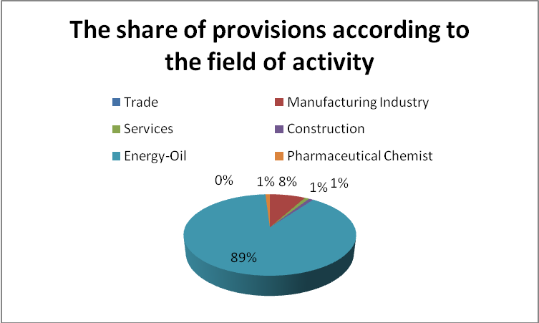
Figure no. 1. The share of provisions according to the field of activity
Source: Own elaboration using data from Bucharest Stock Exchange

According to figure no. 1. in the energy-petroleum field, the largest weight of the provisions reported by the companies is found, respectively 89%, followed by the manufacturing industry with a weight of 8% and services, construction and pharmaceutical chemicals, with a weight of 1%. The percentage of 89% present in the oil energy sector comes mainly from the value of the provisions of the company OMV Petrom, which recorded a value of these elements of 7,789,113,616 lei in 2019, 8,613,730,354 lei in 2020 and 7,244,044,122 in 2021.
The value of 8% registered in the case of companies with the field of activity in the manufacturing industry is due to the significant number of companies that operate in this field and are listed on the Bucharest Stock Exchange, on the regulated market, respectively 38, compared to only 7 companies in the case the oil energy field.
The total value of the provisions is given by the types of provisions established within the enterprises, and their share is presented in figure no. 2.

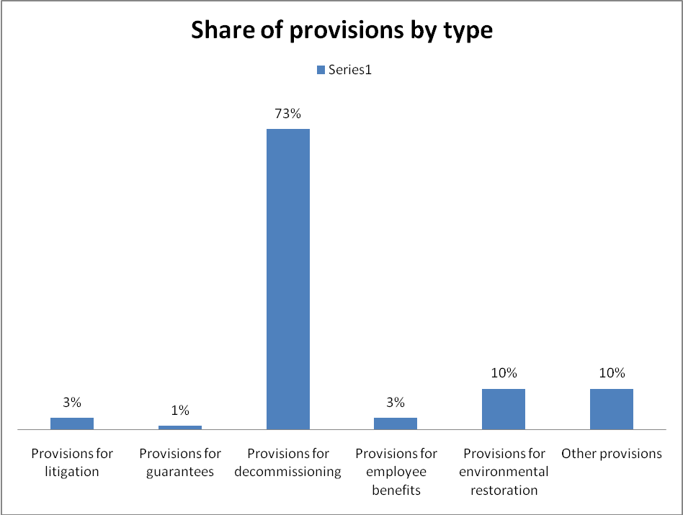
Figure no. 2. Share of provisions by type
Source: Own elaboration using data from Bucharest Stock Exchange

Thus, according to figure no. 2., within the entities listed on the Bucharest Stock Exchange, respectively on the regulated market, provisions for decommissioning have the largest weight of 73%, followed by provisions for restoring the environment with a weight of 10% and other provisions with a weight of total of 10%. Provisions for litigation, provisions for employee benefits and guarantees have an insignificant weight.
Depending on the field of activity, the entities constitute different types of provisions, which is why we have carried out a broader analysis of these elements within the companies in the energy-oil field and in the manufacturing industry presented in figures no. 3. and 4.

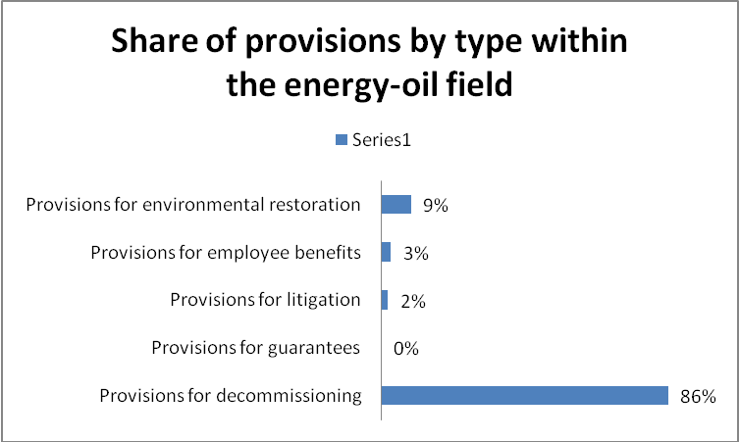
Figura nr. 3: Share of provisions by type within the energy-oil field
Source: Own elaboration using data from Bucharest Stock Exchange

According to figure no. 3, within the entities in the energy-oil field, provisions for decommissioning prevail with a weight of 86%, followed by provisions for environmental restoration and other provisions with a weight of 9%.

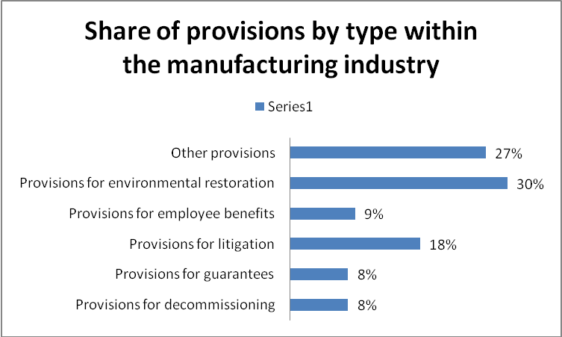
Figure nr. 4. Share of provisions by type within the manufacturing industry
Source: Own elaboration using data from Bucharest Stock Exchange
According to figure no. 4. within the entities in the manufacturing industry, provisions for the environment are most often set up with a weight of 30%, followed by other provisions with a weight of 27% and provisions for litigation with a weight of 18%. The presence of environmental provisions is due to the company Nuclearelectrica S.A. because it constitutes annual provisions for obligations regarding the Intermediate Burned Fuel Depository (DICA), respectively for obligations regarding other low and medium radioactive and non-radioactive waste. To carry out a more thorough analysis of these elements, the authors presented in table no. 1., a ranking by field of activity, of the first companies, with the most significant values.
Table no. 1. Presentation of companies listed on the regulated market of the BSE with significant values among provisions
Field of activity | Company name | Value of provisions 2019 | Value of provisions 2020 | Value of provisions 2021
Energy Oil | OMV Petrom SA/SNP | 7,789,113,616 | 8,613,730,354 | 7,244,044,122
Energy Oil | Romgaz SA/SNG | 527,671,590 | 728,892,947 | 635,608,341
Energy Oil | Rompetrol Rafinare SA/RRC | 342,060,438 | 297,034,901 | 356,577,370
Energy Oil | Transgaz SA/TGN | 72,239,710 | 75,794,781 | 67,446,364
Manufacturing industry | Nuclearelectirca SA/SNN | 324,422,722 | 340,312,211 | 367,124,504
Manufacturing industry | UCM Resita SA/UCM | 233,771,668 | 232,605,508 | 43,177,792
Manufacturing industry | Aerostar SA/ARS | 119,018,703 | 115,641,480 | 131,829,181
Manufacturing industry | IAR SA/IARV | 69,994,375 | 55,584,221 | 53,730,595
Services | Transelectrica SA/TEL | 70,017,850 | 91,564,358 | 51,688,960
Services | Conpet SA/COTE | 14,482,079 | 11,259,657 | 8,769,079
Services | Electrica SA/EL | 9,073,129 | 13,114,674 | 15,891,697
Chemical-pharmaceutical | Zentiva SA/SCD | 17,688,212 | 17,197,603 | 8,384,870
Chemical-pharmaceutical | Antibiotice SA/ATB | 7,149,401 | 13,528,900 | 3,853,530
Construction | Condmag SA/COMI | 12,658,880 | 14,451,128 | 10,294,928
Construction | Cemacon SA/CEON | 11,325,556 | 10,115,976 | 13,877,496

Source: Own elaboration using data from Bucharest Stock Exchange

According to the centralized information in Table 1, the companies with the energy-oil field of activity record the highest values in terms of provisions, respectively OMV Petrom S.A., Romgaz S.A. and Rompetrol Rafinare S.A., followed by the manufacturing industry, Nuclearelectirca S.A., UCM Reșita S.A. and Aerostar S.A. and Chemical-pharmaceutical represented by Zentiva S.A. companies. and Antibiotice S.A. Given that Romania dominates South-Eastern Europe, aspects related to the image of companies operating in this specific industry have become increasingly important in terms of maintaining a relationship with the main stakeholders (Fleacă et al., 2014) . Thus, in the component elements related to provisions for OMV Petrom S.A. there are retirement benefits and other similar obligations in the amount of 170.05 million lei for 2021, provisions for decommissioning and restoration in the amount of 6,253.93 million in 2021 and other provisions in the amount of 888.40 million in 2021. The category of other provisions includes environmental provisions, other personnel-related provisions, litigation provisions and other provisions.
From the analysis of the reports of companies listed on the BSE, within the regulated market only 5 companies present provisions for the environment, namely Cemacon SA, Nuclearelectirca SA, OMV Petrom SA, Rompetrol Rafinare SA and Zentiva SA. Companies present a detailed description of these items in their financial statements, providing important information for potential investors. Cemacon S.A. Company has established provisions for the environment due to the fact that it also carries out mineral resource exploitation activities (clay) and is obliged to carry out environmental restoration expenses related to the exploited perimeters (bvb.ro/infocont/infocont22/CEON). The company Nuclearelectirca S.A. constitutes annual provisions for obligations regarding the Intermediate Burned Fuel Deposit (DICA), respectively for obligations regarding other low and medium radioactive and non-radioactive waste. The environmental provisions related to the company OMV Petrom S.A. are estimated by the management based on the list of environmental projects that the company is obliged to fulfill, representing the best estimate (bvb.ro/infocont/infocont22/SNP). Due to involvement in refinery and petrochemical activities, Rompetrol Rafinare S.A. is obliged to bear environmental restoration costs. The company's environmental policy is in accordance with existing legislation and complies with any obligations resulting from environmental or operating permits. According to the financial statements, the value of the provisions is divided into two elements, namely provisions relating to the Vega Lagoons and provisions relating to the Vadu Boxes (bvb.ro/infocont/infocont22/RRC). Zentiva S.A. Company recognizes an environmental provision when water and soil contamination occurs and there is a legal obligation to decontamination, or it is recognized when there is an implicit obligation, if the company's policy is to carry out decontamination works, even if there is no legal obligation (bvb. ro/infocont/infocont22/SCD).

CONCLUSIONS

In the scientific approach of the present paper, the authors resorted to the presentation of general notions regarding IAS 37 "Provisions, contingent liabilities and contingent assets", paying particular attention to the definition of key concepts, the issues addressed and the scope of applicability of the standard, as well as the description the criteria for recognizing provisions, namely the present obligation, past event, probable outflow of resources incorporating the economic benefits and the reliable estimate of the obligation. From the applied study carried out as part of the work regarding the presence of provisions, in the companies listed on the Bucharest Stock Exchange, a significant presence of these elements was found among Romanian companies, presenting the value of provisions, related to the years 2019, 2020 and 2021 among of the 61 companies found on the regulated market, from which financial and banking companies were eliminated. Following the analysis, it was found that the highest values were recorded by the entities that have an oil or energy field of activity, which results in a significant presence of provisions for guarantees granted to clients, for litigation, provisions for employee benefits, as well as provisions for the environment. The study also registered companies that do not present any elements related to IAS 37, which highlights the still enigmatic nature of these types of liabilities.
Synthesizing all the information, both theoretical and applied, presented in the work, we appreciate that the provision of reliable and relevant information to the users of financial reports regarding the recognized value of provisions, is also based on the reasoning and intentions of the management, their recognition and presentation requiring the interpretation of probabilities, of key assumptions and estimation uncertainty.

BIBLIOGRAPHY

Abdo, H., Mangena, M., Needham, G., Hunt, D., (2018), Disclosure of Provisions for Decommissioning Costs in Annual Reports of Oil and Gas Companies: A Content Analysis and Stakeholder Views, Accounting Forum, Forthcoming, pp. 1-41.

Alibhai, S., Naidoo, E., Bakker, E., Rands, E.,Balasubramanian, T., V., Shah, D., Bharadva, K., Unsworth, C., Chaudhry, A., Merwe, M., Coetsee, D., Varughese, S., Johnstone, C., Yeung, P., Kuria, P., (2013), Interpretation Application of and IFRS Standards, John Wiley & Sons, Inc.

CECCAR, (2013), Standardele Internationale de Raportare Financiară, Editura CECCAR, București.

Dick, W., Missonier-Piera, F., (2010), Financial Reporting under IFRS, John Wiley & Sons, Inc.

Dicu, R.M., Mardiros D.N., (2015), Considerations Regarding the Implications of the Provisions Reporting in the Context of Current Accounting Regulations, Audit Financiar, nr. 131.

DIRECTIVA 2014/95/UE A PARLAMENTULUI EUROPEAN ȘI A CONSILIULUI din 22 octombrie 2014 de modificare a Directivei 2013/34/UE în ceea ce privește prezentarea de informații nefinanciare și de informații privind diversitatea de către anumite întreprinderi și grupuri mari.

Directive (EU) 2022/2464 of the European Parliament and the Council of 14 December 2022 amending Regulation (EU) No 537/2014, Directive 2004/109/EC, Directive 2006/43/EC and Directive 2013/34/EU, as regards corporate sustainability reporting, OJ L 322, 16.12.2022, pp. 15-80,

Du, N., Stevens, K., Ahern, J., Shigaev, A., (2016), Cross-cultural Differences in Interpreting IAS 37 Probability Phrases, International Journal of Financial Research, 7(1).

Elliott B., Elliott, J., (2011), Financial Accounting and Reporting, Prentice Hall, pp. 299-302.
- Feleagă, L., Voicu D. D., Feleagă. N., (2010), National Accounting Culture And The Recognition Of Provisions: An Application Of The Prudence Principle, Conference, Crises et nouvelles problématiques de la Valeur, Nice, France.
- Fleacă, E., Fleacă, B., Dumitrescu, A., (2014), Research Regarding the Reputational Risk of Oil and Gas Companies Operating in Romania Business Market, Bulletin of the University of Agricultural Sciences & Veterinary Medicine Cluj-Napoca.Horticulture, 71(2), pp. 387-394.
- Georgescu, I., (2005), Active si pasive eventuale, Analizele stiințifice ale universității ,,Alexandru Ioan Cuza” din Iași, pp. 115-119.
- Jose, T., (2017), Need for Harmonisation of Sustainability Reporting Standards, Journal of Finance and Economics, 5(6), pp. 253-258.
- Lagrange, B., Viger, C., Anandarajan, A., (2015), Contingency liabilities: The effect of three alternative reporting styles, Research in Accounting Regulation, 27(2), pp. 119-128.
- Lavi, R., M., (2016), The Impact of IFRS on Industry, Ed. John Wiley & Sons, Inc.
- Lopes, A., I., Reis, L., (2019), Are provisions and contingent liabilities priced by the market? An exploratory study in Portugal and the UK, Meditari Accountancy Research, 27(2), pp. 228-257.
- Mackenzie, B., Coetsee, D., Colyvas, B., Njikizana,T., Chamboko, R., Hanekom, B., (2014), Interpretation and Application of International Financial Reporting Standards, John Wiley & Sons, Inc.
- Mielcarz, P., Osiichuk, D., Wnuczak, P., (2016), Actuarial Reserves, Provisions and Contingent Liabilities in DCF Valuation Finanse, Rynki Finansowe, Ubezpieczenia no 1/ (79), pp. 289–298.
- Mihail, B., A., Micu, C., D., (20121), The Influence of the Independent Non-Executive Board Members on the Financial Performance of the Companies Listed in the Bucharest Stock Exchange, Journal of Risk and Financial Management, 14(10), 462.
- Mihalciuc, C. (2021), The contribution of integrated reporting in determining the performance and value of a sustainable organization. Journal of Social Sciences, 4(1), pp. 29-40.
- Mihalciuc, C.C., Grosu, M., (2021), The Concern of Energy Companies in Obtaining and Maintaining their Sustainable Value. In A. Sandu (vol. ed.), Lumen Proceedings: Vol. 17 World Lumen Congress 2021 (pp. 447-464). Iasi, Romania: LUMEN Publishing House.
- Mirza, A., A., Orrell, M., Holt, G., J., (2008), IFRS Practical Implementation Guide and Workbook, Wiles.
- Nandakumar A., Kalpesh J. Mehta, T. P. Ghosh, Yass A. Alkafaji, (2010), Understanding IFRS Fundamentals: International Financial Reporting Standards, John Wiley & Sons, Inc.
- Nicholi, S., (2022), How to resolve audit matters in European Affairs? Introduction to a sustainable management accounting under IAS 37, European Journal of Social Impact and Circular Economy, 3(1), 27-41.
- Okafor, Tochukwu G., Nweke, Fidelis C., (2021), International Accounting Standard 37 (IAS 37) And Creative Accounting Practices By Companies, International Journal of Advanced Academic Research, 7(7).
- Paananen, M., Runesson, E., Samani, N., Time to clean up environmental liabilities reporting: disclosures, media exposure and market implications, (2021), Accounting Forum, 45, (1), 85-116
- Poniatowska, L., (2017), The rules of recognition provisions according to International Financial Reporting Standards, Тернопіль: ТНЕУ, pp. 87-89.
- PWC, (2008), Financial reporting in the oil and gas industry, Energy, Utilities & Mining, available on: https://www.pwc.com/gx/en/energy-utilities-mining/pdf/ifrsog.pdf, [accessed at 28.06.2023]
- Răpan, C. M., Banța, V.-C., Şerban, A., Manea, A., (2022), Analysis of the Net Result and the Comprehensive Income: An Empirical Study of the Listed Companies on the Bucharest Stock Exchange, Oblìk ì fìnansi Issue 2(96), pp. 76-81.
- Rees, H., (2010), The IASB's Proposed Amendments to IAS 37, Accounting in Europe, 3(1), 27-34.
- Schiff, J., Schiff, A., Rozen, H., (2012), Accounting for contingencies: Disclosure of Future Business Risks, Management Accounting Quarterly, 3(3), pp. 1-8.
- Sookdeo, N., (2002), Determination of Environmental Liabilities and Development of a Facility Closure Plan for a State Oil and Gas Company, Paper presented at the SPE Annual Technical Conference and Exhibition, 2002.
- Suer, A., Z., (2014), The Recognition of Provisions: Evidence from BIST100 Non-financial Companies, Procedia Economics and Finance, 9, pp. 391-401.
- Todea, N., Udrea, A., M., Cioca, I., C., (2014), The Effects Of The Adoption Of Ias / Ifrs By Companies Listed On The Regulated Market (Bucharest Stock Exchange - Category Iii) On The Audit Mission, Annales Universitatis Apulensis Series Oeconomica, 16(1), pp. 1-24.
- Tram-Anh Le., P., (2019), Environmental provision under IAS 37: A Review of the Research Literature, Business Administration.

Vrejoiu, A., (2022), The Implementation of the International Financial Reporting Standard (IFRS 16 - “Leases”) by companies listed on the Bucharest Stock Exchange, International Conference on Business Excellence, Walter de Gruyter.
- https://bvb.ro/infocont/infocont22/CEON_20220429120839_Raport-anual-2021.pdf [accessed at 20.06.2023]
- https://bvb.ro/infocont/infocont22/SNP_20220427214045_Rapoarte-anuale-situatii-financiare-si-plati-catre-guverne.pdf [accessed at 20.06.2023]
- https://bvb.ro/infocont/infocont22/RRC_20220429131501_RRC---Raport-anual-2021-RO.pdf [accessed at 20.06.2023]
- https://bvb.ro/infocont/infocont22/SCD_20220428184943_SCD-31-12-2022-Raport-Anual-RO.pdf [accessed at 20.06.2023]
- IAS Plus, avaible at: https://www.iasplus.com/en/standards/ias/ias37 [accessed at 20.06.2023]
- IFRS, avaible at: https://www.ifrs.org/issued-standards/list-of-standards/ias-37-provisions-contingent-liabilities-and-contingent-assets/ [accessed at 20.06.2023]

