NON-FORMAL EDUCATIONAL SERVICES - AS MANAGEMENT ELEMENTS ACTIVATED IN THE EDUCATIONAL SPACE: A CASE STUDY

Abstract:
This article aims to identify through the prism of the management formulas applied in the educational space the area subsumed to non-formal educational services as elements through which to offer to the students a quality education. Thus, based on a quantitative study, the present analysis aims to identify what are the features of non-formal educational services, what is their necessity, what are the means and procedures activated to be used in the educational space, as well as the elements related to the infrastructure so that the educational ideal to be reached.

Key words: management, education, non-formal educational services, non-formal education

JEL classification: I21, L39, O10, R50, P59

THE NON-FORMAL EDUCATIONAL SERVICES – FORMULAS OF THE EDUCATIONAL MANAGEMENT

The non-formal educational services seen as possible solutions for preventing school dropout must be understood starting from the definition of the concept of non-formal education from the objectives it has outlined. Starting from a wider spectrum, the non-formal education is defined as "any educational activity organised outside the existing formal system – whether it is carried out separately or as an important element of a broader activity – which is intended to meet the educational needs of a particular group and which pursues clear learning objectives" (Hunca, 2012: 73).
Guţu (2020) defines the non-formal education "as a less formalized or unformalized reality, but with formative effects" (Gutu, 2020: 129). The author considers that the non-formal education can take on a multitude of forms of activities, characterized by flexibility and which relate mainly to the individual needs of children, taking into account their individual interests and options " (Gutu, 2020: 129).
As an alternative to the formal educational system, the non-formal education appears as a learning option either because of the failure of the formal education system (Andrieş, Clichici, 2020: 8); or of the diversification of the urban life and of the educational needs (Combs, 1973:288); or as a complementary form of development and of the lifelong learning (Havidz et al, 2021:49).
Thus defined, the objectives of the non-formal education, of the non-formal educational services aim at improving the general level of education, increasing the level of training of the children, or of the pupils, or of the teachers, supplementing with a series of complementary knowledge, especially in current areas required on the labor market: knowledge of foreign languages, knowledge in the field of I.T. or in other professional fields that involve a continuous professional training.
In the light of the above, we consider that the non-formal educational services appear as a form of both improvement and complemenarity of the formal education system, much more ingenious, more creative, with less formalized activities, which have the role of improving the school situation of children to help them to go through the school curricula complementary, but also to provide them with the knowledge required on the labor market according to its evolution (new technologies, foreign languages, etc.). They do not depart from the educational ideal delimited by any society or community, but they appear as forms of improvement, completion of the educational requirements arising from the needs of the applicants.
Different from the formal educational system which has a continuous character at least in terms of planning and development, the system of non-formal educational services is based on the degree of the individual interest transformed into the subjective motivation to participate in such forms of education of the children or of the children guided by their parents (especially in grades I-IV). This discontinuity formula of non-formal services is also doubled by the forms of financing and support, in the sense that it is determined by a management of projects that are financed either from public sources or from private sources, but with resources limited in quantity and delimited in time.
Thus, the non-formal education and the non-formal educational services must be analyzed through the prism of project-based educational management.
In order to determine the decisive role of the project-based educational management for the substantiation of the non-formal educational services, a first analytical line starts from the differentiation of the two formal and non-formal areas in the field of education, of the way in which the activities and services for children and pupils are built (see Tabelul no 1).
Table no. 1: Formal education versus nonformal education

Formal education | Nonformal education
Institutional context: schools, colleges, universities; | Institutional context: creative houses and centers, libraries, care centers, non-governmental organizations, youth organizations
Formalized activities: Lessons-Courses, Professional trainings; | Formalized activities: Extracurricular activities (help for homework), personal development, training in the field of children and young people (leadership, moderators, professional training), volunteer services, art schools, sports clubs, summer camps, I.T. courses;
Semi-formalized activities: council of the chidren; social and community activities in the school environment (charity fairs, ecological actions, voluntary actions); Trips; | Semi-formalized activities: Activities within projects managed by non-governmental organizations for children and youth; employment in a youth organisation; visiting museums, theaters, agreement centers; games in groups or individual with the role of training.
Unformalized activities: contacts with colleagues and friends in school; games during the break; informal contacts between teachers/teachers and students. | Unformalized activities: contacts with colleagues and friends within the associative structures; shared living in camps.
Sourse: Adapted after Andrieş, V., Clichici, V. 2020: 21

Thus identified the features of the non-formal services, it can be observed that they can have a discontinuous character, with activities determined in time or integrated in certain projects financed or self-financed or self-sustained, with a structure planned in a flexible manner and determined by the requirements of the clients (parents and children), with activities that incline towards the non-formalized part and centered on the individual needs of the children, based on the learning process and with a creative and attractive character, motivating for children and voluntary, with explanatory-interpretative, applicative tools (diversity of approaches), with a non-formal curriculum that ensures choice possibilities, which takes place in different locations (most of the times outside the school space or in school, but after the compulsory program).
Thus identified the features of non-formal educational services, their practical fulfillment is most often achieved through projects clearly defined as a period of time, with determined goals, with general and specific objectives that – defined SMART – relate to clearly defined target groups of the pupils, with delimited in time goals, which are planned through plans of activities that respect the same temporal determination for which the resources are estimated (human, financial, material, etc.) necessary and implemented taking into account the same temporal determinisms, the finality – the prestart educational service in non-formal regime – being subjected to the analysis process.
Defining an educational project, Iosifescu et. al (2000) identifies the following strategic and tactical conditions that it must meet:
- "Adequacy: to be suitable for achieving the established educational goals and objectives
- Achievability or feasibility: realistic character;
- Economy: derives from achievability – consumption stops resources;
- Simplicity and precision: to encompass those goals and to allocate those necessary and sufficient resources to the realization of intentions. It should be noted that excess precision can be just as harmful as imprecision.
- Operationalization: easy applicability.
- Unity and consistency: not to contain conceptual, principled or actional contradictions.
- Flexibility: adaptability to new situations and achieving flexible dimensions for the service schedule.
- Optimal framing in time: specifying the temporal horizon of each action or complex of actions. The time horizon must be adapted to the level of the project or plan" (Iosifescu et. al, 2000: 38).
- Superimposing those mentioned with the general perspectives of educational management, non-formal educational services correlate with these perspectives and adapt them to the non-formal dimension.
If Tony Bush defines educational management "as a field of study and activity aimed at the functioning and leadership of educational organizations" (Bush, 2016: 13), and Bolam emphasizes that it is "an executive function aimed at the implementation of approved policies" (Bolam, 1999: 194), thus differentiating between management and educational leadership, giving management from responsibility for formulating educational policies, until the ability to modify the entire educational organization, if necessary, non-formal educational services respond to the same type of management that they adapt to the non-formal dimension and management through projects.
In other words, the non-formal education is subject to the same formal educational "dimensions" (Gavrilovici et al, 2002), when the former tries – through projects – to provide non-formal educational services, namely:
- The management of the human resources involved: who are both the members of the project team and the collaborators - who are the trainers who provide the children / students with the necessary knowledge, with a strictly educational role in the non-formal area (they are educational trainers from outside the school or are collaborators with determined activity in projects, other specialists, etc.);
- The process management: both the management of the processes specific to non-formal educational projects, but also of the non-formal educational processes underlying the project (their form, their degree of formalization, creativity, the typology of the training-teaching-learning methods, their location so as to maintain the formal-non-formal-informal lines);
- The financial management: budgeting of the project that subsumes the actual budgeting of non-formal educational activities (extracurricular courses with a help character for homework; skills training courses; training courses for certain professional fields, etc. that are delivered for a fee or are financed through the project that subsumes them);
- The time management: both the delimitation in time of the project and the temporal design of the non-formal educational services (the calendar of extracurricular courses, their frequency so as to adapt to the program of the formal education system; their duration, etc.);
- The curriculum management: what substantiates especially the content at the level of non-formal educational services (what content must have extracurricular educational activities so as to help children / students, in other words, what educational needs must be answered by these non-formal services in order to be attractive);
- Management of the leadership: who leads the project (identification of the project manager), but also who effectively manages the non-formal educational activities offered through projects (if there is a decentralization of the forms of leadership at the level of external specialists or all teachers collaborating in projects that manage their extracurricular courses);
- Communication &marketing management: from the forms of formal communication to the non-formal ones used to promote the project, to promote non-formal educational services, to the forms of communication in the process of non-formal education (trainers / teachers – children – parents, etc.).

analyze the situation from the point of view of access to education, learning, well-being and safety for children

plan the development of activities, relying on the current assets, following the decrease of inequalities in education and the prioritization of families

Evaluation Planning

Verification Action

monitor and evaluate to improve what is not working and to support what is working

implement the activities. capture and document the processes and results

Figure no. 1: The educational project management
Sourse: adapted after Antonowicz, 2020: 10

Analyzing the process of planning non-formal educational services, Antonowicz (2020) identifies the following steps in the management process through projects: Assessing the state of affairs of children through the prism of determining the degree of risk in which they are located; Planning the activities to be taken in order to increase the access of children to the education system; Implementation of programs/plans of activities and strict capture of the results obtained in the project reports and documentations; Verification of the state of affairs, whether the objectives have been achieved, whether the risk situation has been diminished, the state of affairs has improved for children (see Figure no. 1: Management of educational projects) (Antonowicz, 2020: 10).
Determining the way in which formal educational management and project management determine and outline non-formal educational services, this analysis is outlined in terms of the concrete needs to which they must be attentive, which they must form in order to prepare children / students for the next stages of their lives.
From here on, the present study aims to identify what are the specific features of the non-formal educational services seen as specific elements of educational management at the level of the "Bogdan Petriceicu Hasdeu" School in Iasi.

- METHODOLOGY AND SAMPLE

The present analysis aims to present some features of non-formal educational services based on a quantitative, exploratory and predictive research. The present research was carried out between April and June 2022, in the municipality of Iasi, within the School "B. P. Hasdeu" in the Tătăraşi area. The question with a problematizing role, taking the place of the hypothesis of the research refers to: H1: What are the characteristics of the package of services (educational services, social services, psycho-pedagogical services) that parents want for their children?
The dimensions of the research focused on:
- The need for services (why?)
- Actors involved in the provision of services (who?)
- Typology of services (what?)
- Means of service provision (how?)
- Location of the services (where?)
- Timing of service provision (when?).
The tool used is the questionnaire applied during the mentioned period to parents who have at least one child in grades I-VIII, at the School "B. P. Hasdeu" in Iasi. The questionnaire consists of 17 thematic questions (closed, open, semi-open) and 7 questions for collecting socio-demographic data. The questionnaire is distributed online to parents (between May and June 2022), being available on the Google Docs platform.
The sample consists of 376 people, parents who have children in grades I-VIII at the Secondary School "B. P. Hasdeu" in Iasi. The sample is probabilistic and is based on the technique of "simple random sampling", in the sense that it offers the possibility to each responsible (parent who has at least in grades I-VIII) to participate in the research. In this respect, the questionnaire was distributed in the groups of all parents from each class I-VIII from the Secondary School "B. P. Hasdeu" from Iasi, any respondent having equal chances to participate, to be part of the sample. The total population from which the sample was extracted is about 2768 people (parents) who have in the school year 2020-2021, in grades I-VIII, at least one child at this school.
“This procedure ensures that each selected unit has the same probability of being present in the sample and this probability is n/N (where n is the volume of the sample and N the volume of the population, i.e. of the sampling base). For example, if the volume of the sampling base is 2768 and it is desired to select a sample of 376 subjects, the probability of selection is 376/2768=0.13” (Popa, 2016, p. 8).

THE NON-FORMAL EDUCATIONAL SERVICES – TRAITS

The 40% percentage places the necessity of the service in the area of the need to improve the school situation of children. Only 2% of parents consider that their child's school situation has improved in the last year of school, and the correlation with the use of educational services is a positive one, that is, even if the child's school situation is getting better, the parent would still use the educational services analyzed in the questionnaire (see Figure no. 2: The necessity of the educational service).

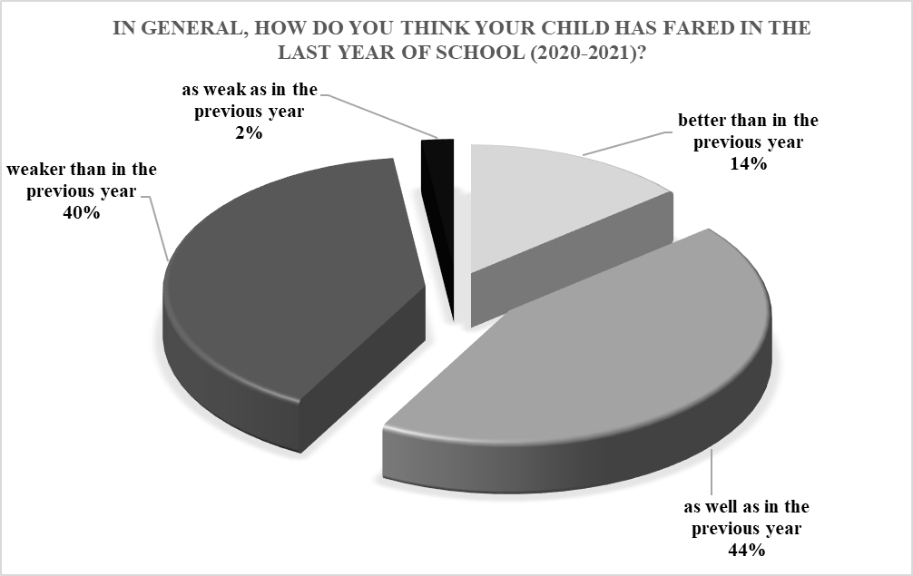

Figure no. 2: The necessity of the educational service

For the second dimension of this analysis, the preference for providing educational services is mainly the classroom teacher (56.9%), as well as the teacher and teachers of children from other disciplines (18.9%) (see Figure no. 3: Actors involved)

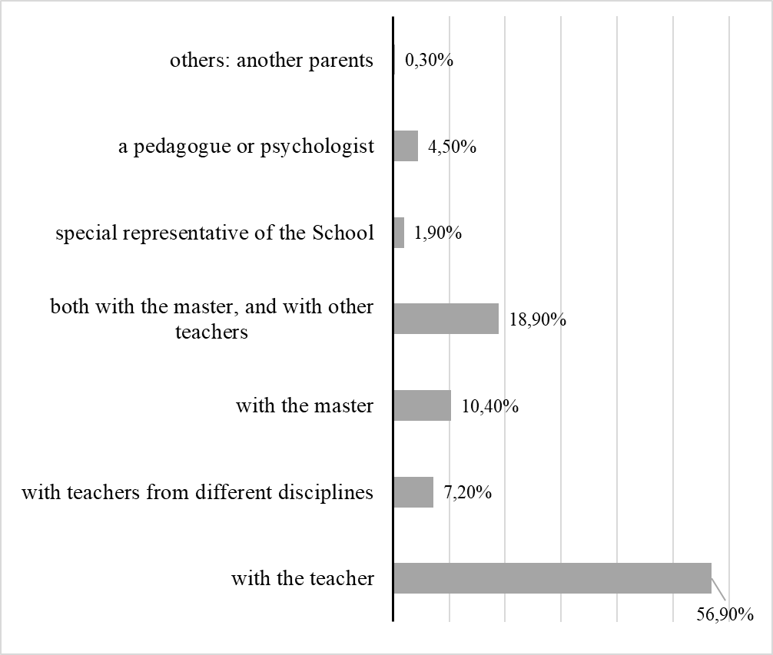

Figure no. 3: The actors involved

It was noted (Figure no. 4) that all eight types of educational services are desirable for the educational package, the most important being the hours for homework help (42.8%), the hours for the preparation of digital skills (48.9%).

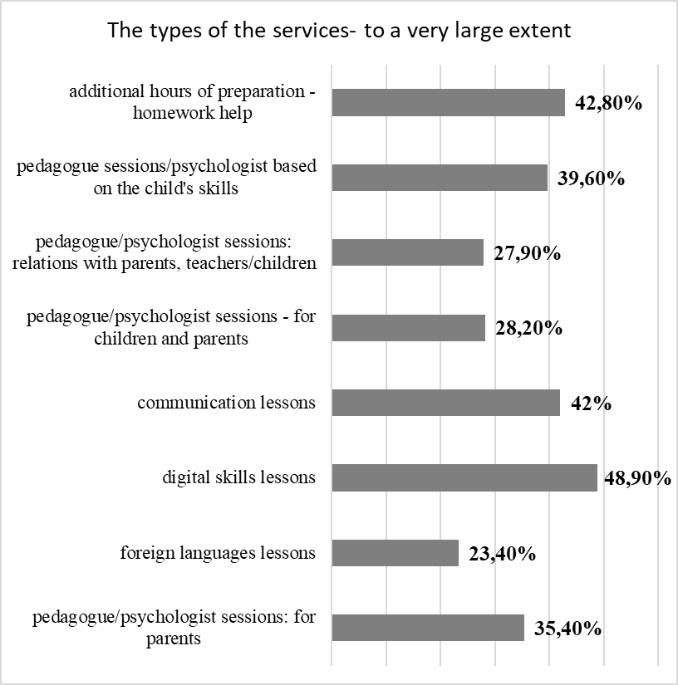

Figure no. 4: The types of the services

In relation to the eight dimensions of the services detailed above, it was tried to identify if there are correlation relations between them. In other words, it has been tried to deteminee if a parent wants as much as possible an educational service, if in relation to the other educational services the parent's desire increases or decreases. Thus, each variable turned one at a time into an independent variable, then a dependent variable (Table no. 2: The correlation of the variables).

Table no. 2: The correlation of the variables

Pearson Correlation | additional hours of preparation - homework help | pedagogue sessions/  psychologist based on  the child's skills | pedagogue/psychologist sessions: relations with parents, teachers/children | pedagogue/psychologist sessions - for children and parents | Communication lessons | digital skills lessons | foreign languages lessons | pedagogue/psychologist sessions: for parents
additional hours of preparation - homework help | 1 | ,349(**) | ,323(**) | ,303(**) | ,440(**) | ,392(**) | ,313(**) | ,421(**)
pedagogue sessions/  psychologist based on  the child's skills | ,349(**) | 1 | ,772(**) | ,738(**) | ,569(**) | ,267(**) | ,597(**) | ,393(**)
pedagogue/psychologist sessions: relations with parents, teachers/children | ,323(**) | ,772(**) | 1 | ,811(**) | ,484(**) | ,324(**) | ,711(**) | ,464(**)
pedagogue/psychologist sessions - for children and parents | ,303(**) | ,738(**) | ,811(**) | 1 | ,534(**) | ,360(**) | ,681(**) | ,453(**)
communication lessons | ,440(**) | ,569(**) | ,484(**) | ,534(**) | 1 | ,599(**) | ,547(**) | ,572(**)
digital skills lessons | ,392(**) | ,267(**) | ,324(**) | ,360(**) | ,599(**) | 1 | ,411(**) | ,523(**)
foreign languages lessons | ,313(**) | ,597(**) | ,711(**) | ,681(**) | ,547(**) | ,411(**) | 1 | ,534(**)
pedagogue/psychologist sessions: for parents | ,421(**) | ,393(**) | ,464(**) | ,453(**) | ,572(**) | ,523(**) | ,534(**) | 1
N | 376 | 376 | 376 | 376 | 376 | 376 | 376 | 376
** Correlation is significant at the 0.01 level (2-tailed).

Summarizing, it can be seen that all the variables establish positive relationships with each other, which means that: the more parents have determined that they want more participation of their children in an educational service, the more they want them to participate in other educational services among those proposed. The main means used to discuss the evolution of the school situation of the child subjected to educational services concern the individual sessions (56,6%), then the online technologies related to communication are appreciated: email (6,6%), online video meetings (5,1%) and Facebook group built for this purpose (4%), but also the classroom meetings (26,1%) (see Table no. 3: Means).

Table no. 3: Means of providing educational services

By what means would you prefer to discuss about the child's school situation? |  | Frequency | Percentage
Valid | in the meetings of the classroom | 98 | 26,1
 | in individual meetings | 213 | 56,6
 | by email | 25 | 6,6
 | Facebook group | 15 | 4,0
 | online video meetings | 19 | 5,1
 | Phone | 4 | 1,1
 | Whatsapp or Google Classroom | 1 | 0,3
 | Including with a psychologist | 1 | 0,3
 | Total | 376 | 100,0

Regarding the location of educational services, the location of the school where the child is already learning has a much higher percentage than the rest of the options identified by respondents (79.5%) (see Figure no. 5). In a pandemic context, only 2.4% support the option of carrying out these online educational services, and 17% of respondents say that the organizers must decide the location of the courses.

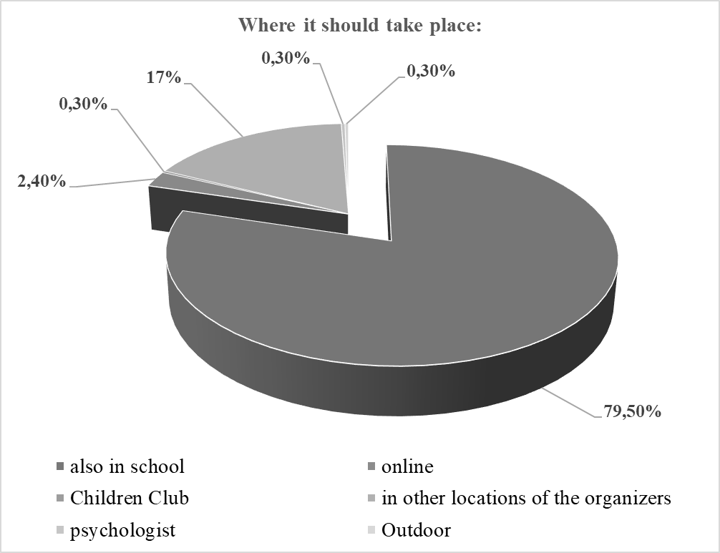

Figure no. 5: The location of educational services

Regarding the respondents' preference for a possible calendar for children, the highest percentages are obtained for: a program established according to the recommendations of the responsible teacher (26,9%) and, on the first place (36,4%) for the program for these services carried out immediately after the classes in class, once every 2-3 days (see Table no. 4).

Table no. 4: The program of service provision
Activities program |  | Frequency | Percentage
Valid | after the program, daily | 79 | 21,0
 | after the program, once every 2-3 days | 137 | 36,4
 | only on Saturdays | 26 | 6,9
 | only on Sundays | 3 | ,8
 | on Saturdays and on Sundays | 27 | 7,2
 | according to recommendations | 101 | 26,9
 | after hours,but not daily | 1 | ,3
 | not at all | 1 | ,3
 | after noon (after 5 p.m.) | 1 | ,3
 | Total | 376 | 100,0

In relation to the number of daily hours, 71% of respondents support a program of 1-2 hours daily, 19.1% support a program of 2-3 hours; 7.4% support a program of 3-4 hours. In terms of children's motivation to participate in such educational services, the following motivations were observed by the respondents (Table no. 5):

Table no. 5: Elements of motivation

What would convince your child to participate in such programs? |  | Frequency | Percentage
Valid | Relationships, socialization, development with other children | 116 | 30,9
 | Competition, prizes, camps, diplomas, new contests | 34 | 9,0
 | Learning new things, curiosity | 45 | 12,0
 | Pleasure/self-confidence/fun/passion & relaxation | 79 | 21,0
 | Specialization, recovery hours otherwise | 56 | 14,9
 | I don't know | 35 | 9,3
 | Digital activities | 1 | 0,3
 | Professionalism and patience from the teachers | 5 | 1,3
 | Sports activities, independent activities | 4 | 1,1
 | To be in school - continuity | 1 | 0,3
 | Total | 376 | 100,0

CONCLUSIONS

Summarizing what has been presented, the package of non-formal educational services should have the following characteristics: it is requested on the basis of improving the school situation of the children, not necessarily of worsening the school situation (but not only); it is desired to be developed in the school and especially with the classroom teachers (but not only: also with a representative of the school appointed for this purpose, with the pedagogue and the psychologist); to have an after-hours schedule (2-3 days a week); the relationship with the parents should be developed in individual sessions both in the classroom, but especially through online means (Facebook group, email, online video sessions); aim at services of the type (in the order of their value by parents): educational services for help with homework, foreign languages, development of communication skills and digital skills, meetings with a pedagogue/psychologist both separately for children and for children and parents, to analyze relationships with parents, with teachers/teachers, other children, and, complementary, meetings with a pedagogue/psychologist just for parents.
Going beyond the motivation for the emergence and development of non-formal education, the importance of these types of services is undeniable. The education and the non-formal services (seen as educational projects) complement the profile activities, increase the quality at this level and aim, on the other hand, to reduce the risks, implicitly the risk of school dropout. Also, the school must support the actors providing non-formal educational services by understanding and applying the common goal: training children, ensuring the best possible quality education, with unrestricted access. Moreover, being the actor who has a first analysis of the actual situation in which the children are, it is necessary to provide information and possible resources to the non-formal educational sector and to correlate with it throughout the educational projects that it implements precisely because at the moment in which children come out of the risk of dropping out of school and re-enroll in the formal educational system, so that the transition should be as smooth as possible. In conclusion, the non-formal educational services acquire a decisive role in the training of students because they do nothing but support the educational ideal established at the level of the formal educational system that they take over and adapt, namely the training of the child prepared to adapt, develop in the society from which he comes from.

BIBLIOGRAPHY:

- Andrieş, V., Clichici, V., (2020), Eduaţia nonformală: aspecte conceptuale şi funcţionale, Institutul de Ştiinţe ale Educaţiei, Chişinău.
- Antonowicz, L., (2020), Crearea unor sisteme de educație reziliente în contextul pandemiei de COVID-19, Unicef Cybermedia.
- Bolam, R., (1999), Educational administration, leadership and management: towards a research agenda, Eduational Management: Redefining Theory, Policy and Practice, Londra: Paul Chapman Publishing.
- Bush, T., (2016), Leadership și management educațional, Editura Polirom, Iași.
- Combs, P. H., (1973), Should one develop nonformal education?, Prospects, vol. 3, nr. 3, pp. 287-306.
- Gavrilovici, O., Dietrich, M., Iosifescu, Ș., Năstase, M, Nicolescu, R. M., (2002), Management educațional, vol. 1-2, Institutul Român de Management educațional, Editura CDRMO, Iași.
- Guțu, V., (2020), Educația formală, nonformală și informală: cadrul comparativ, Științe Sociale, Psihologie, Științe ale Educației, sociologie și asistență socială, online: https://ibn.idsi.md/sites/default/files/imag_file/129-133_17.pdf, [accesat la 03 ianuarie 2023].
- Hafidz, M.A., Elihami, E., Izzatun, H., (2021), Learning the nonformal education through research methodology: A literature review, Jurnal Edukasi Nonformal, vol. 2, nr. 1: 47-55.
- Hunca, M., (2012), O abordare paradigmatică a educaţiei nonformale ca punct de plecare în formarea continuă a cadrelor didactice, Studia Universitatis, nr.9 (59), pp.72-76.
- Iosifescu, Ş. (coord)., (2000), Manual de management educaţional, Editura ProGnosis, Bucureşti.
- Popa, M., (2016), Metodologia cercetării, disponibil la: http://www.apio.ro/upload/mc10_esantionarea.pdf [accesat la 15 decembrie 2022].

