DEVELOPEMENT OF A CROSS-BORDER CULTURAL ROUTE. A QUALITY ASSESSMENT PROPOSAL

Carmen Emilia Chașovschi, associate professor, University Stefan cel Mare from Suceava, Romania, carmenc@usm.ro

Abstract:
The purpose of this paper is to provide some important insights about the development of cultural routes in Romania, and, as well, to propose a framework for the evaluation of the quality delivered, taking into consideration ”on the spot” infrastructure and services that should be available, in order to mediate a positive experiences to the tourists. The items compiled in a pilot-assessment questionnaire were tested on the field, for a cross-border cultural route, that was developed some years ago, in cooperation, by the tourism national authorities from Romania and Republic of Moldova: “Stephen the Great” cultural route.
The paper presents some relevant insights about the cultural routes and their importance for the promotion of the heritage of different European cultures. The literature review covers mainly the impact of the cultural routes for the promotion of the heritage of the regions that are crossed by, and the growing importance that the routes gained in the last years. The undertaken research brings a critical approach to the development of routes in the incipient stage, especially, and reiterate the challenge to create a coherent and positive tourism experience, by combining different tourism objectives in a thematic trail.
The aim was to identify some relevant factors that could be compiled in a quality assessment tool, that could be used for the evaluation of the cultural routes. Similarities with the Index of Destination Attractiveness (IDA) are as well discussed. The paper concludes with recommendations for the tourism stakeholders involved in the process of development the cultural routes. At the same time, the paper opens the field for future research on the quality of the tourism experience on the cultural routes.

Key words: cultural route, attractiveness assessment, destination management, cultural tourism

JEL classification: R11, R58 Regional Development Planning and Policy, Z38, Z32

INTRODUCTION

According to Ramchander (2004) the term „cultural tourism” is sometimes used synonymously with the term ”special-interest” tourism. Since 2004, when this statement was made, we assisted to a constant increase of visitors that are travelling to get familiar with heritage and cultures of other nations. It is almost impossible to separate “culture” or “cultural experiences” from travel, no matter what the main purpose of the travel is. Cultural tourism looks to be omnipresent (Richards, 2007) and for a lot of destinations seems to be a secure path to long term success.
It is no wonder that the initiative of “European cultural routes” was embraced with enthusiasm. Looking back to the evolution of cultural tourism in last 3 decades, an important milestone was the year 1987, when the Declaration from Santiago de Compostela has opened the way for the first Council of Europe Cultural Route, recognizing the importance of the cultural routes as opportunities to promote the diversity of European nations and cultures (European Commission, 2013).
The cultural routes can enhance the value of places, with their cultural identity; can invite tourists to explore sites and cultural resources (local gastronomy, handicraft, folklore, architecture) and to ”re-invent or activate strategies for the appropriate exploitation of the cultural, natural and economic landscape”(Trono, 2022). Moreover, the cultural routes have become for several destinations an alternative way to improve their image and to promote themselves among other destinations. The cultural routes could be considered, as well, an opportunity to present some unique features in a “package”, that otherwise were lost in a multitude of tourism resources.
Previous research for the improvement of the routes management was conducted by the European Commission and the Council of Europe Joint Programme on Cultural Routes in 2011 and optimization proposals were formulated, related to the cultural tourism trends in Europe, the management and governance of the routes, competitiveness of SMEs, branding and marketing of cultural routes, the integration of the CoE Cultural Routes in other initiatives at European and International (Khovanova-Rubicondo, 2012).
In the above mentioned study, were identified two major challenges: “design/implementation of quality and sustainable tourism standards, adjusted to cultural routes environment” and “development of relevant (network and performance) evaluation tools” (European Institute of Cultural Routes & Europarat, 2015). The present paper tries to respond to these challenges, by presenting a quality-evaluation tool for the objectives included in the “Stephen the Great” Route, based on direct site observation and interviews with local stakeholders. The assessment sheet was tested on the field, in research that involved all Romanian objectives registered to the Route “Stephen the Great”.
The analysis was carried out from the perspective of the two approaches identified for the cultural tourism by Bonink in 1992 (apud. Mousavi et al., 2016), ”the sites and monuments approach„ and ”the conceptual approach”. In the research we have taken into consideration the ”sites and monuments approach”. According to this, the culture is described as a ”product”, and assumes cultural tourist as a ”consumer of cultural attractions, the motivation of tourists being restricted to specific attractions and sites”. An assessment tool was developed and applied, in order to analyse the attractiveness of the objectives included in the cultural route “Stephen the Great”.
The results are describing different stages of development of tourism objectives, and are opening doors for future research questions, related to the required level of “maturity” and attractiveness of the objectives included in the cultural routes.

CULTURAL ROUTES IN EUROPE. A GENERAL FRAMEWORK

The routes are a mixture of culture, history, nature and economy (Trono, 2022) and are contributing in the same time at the preservation of local diversity and „enable an intercultural and inter-generational journey”. The Routes become appealing to several countries: being trans-regional tourism paths, a lot of synergies can be activated for joint promotion, for a better visibility for some areas that were not so well known or visited. The promotion of the destinations was enhanced by the Routes, through the themes approached: the tourists were able to connect easier with heritage spots that were attractive to them, with the help of the ”network” of the points approached by the Route.
Launched in 1987 by the Council of Europe, with the Declaration of Santiago de Compostela, the Cultural Routes program was presented as a “cultural, educational heritage and tourism cooperation project aiming at the development and promotion of an itinerary or a series of itineraries based on a historic roue, a cultural concept, figure or phenomenon with a transnational importance and significance for the understanding and respect of common European values” (European Commission/Council of Europe Joint Programme on Cultural Routes, 2013).
Some important milestones in the Routes ‘evolution were the years 2005 and 2008. In 2005 UNESCO identified cultural routes as one of the four heritage categories for the classification of World Heritage Sites and in 2008 ICOMOS published the Charter of Cultural Routes (outlines the evolution of the concept of cultural assets and the values belonging to their setting; set clear foundations for cultural routes; has established codes of conservation and management for cultural routes). The present portfolio includes 48 European routes [1] (https://www.coe.int/en/web/cultural-routes).
The selected themes are quite diverse, covering different periods of the history, from ancient (European Route of Megalithic Culture) to the recent history (ATRIUM route of Architecture of Totalitarian Regimes) (Cultural Routes, 2013). As “particular tourism products” (Xuereb & Avellino, 2020, 2) that are connecting places of European heritage, the Routes have created a travel opportunity for tourists connected by specific cultural themes, related to the history and the culture of Europe.
According to Trono (2022, 9) „contextualizing cultural heritage” in accordance with themes meaningful for the tourists, integrating the experience of culture with the tourism services as accommodation, transport and food-and-wine services, means “making them true attractors of tourist flows”.
The importance of cultural routes was mentioned by a large number of authors, and it is not anymore, a subject of doubts. The advantages are diverse, from the enhancement of cultural tourism (Crivillers et al., 2015) to the promotion of less known cultural sites, relevant for the history and culture of Europe. The routes are associated with the sustainable development (European Commission, 2013), economic development (Timothy & Boyd, 2015). The routes are improving the community competitiveness, are generating new jobs and are creating social wellbeing (Khovanova-Rubicondo, 2012). Additional to these, an extensive list of benefits was compiled by Trono (Trono, 2022): attraction of investors, give rise to a substantial supply chain, employment and economic benefits, preservation and promotion of local diversity, emphasis inland and rural areas, encourage off-season flows, helps the recovery of location s cultural heritage and identity, launch socio-economic development.

- THE “STEPHEN THE GREAT” CULTURAL ROUTE. STUDY SITE DESCRIPTION

The apparition of new cultural routes is associated with the new, different needs of travellers (Trono, 2022). As well, the development of routes is in the interest of public and private stakeholders, both categories considering the cultural routes an opportunity for a growing market. The policymakers, as well, see them as new opportunities for the development of rural, remote and economically disadvantaged areas (Piersanti 2014, apud. Trono 2022).
It is no wonder that, taking into consideration these benefits, a lot of efforts were invested in the last years in the creation of several cultural routes in Romania (Cojocariu, 2015). Through the current Romania's National Recovery and Resilience Plan (PNRR, 2021), twelve new thematic cultural routes will be created: the Route of the castles; the Route of the curias; the Route of the „cule” [2], the Route of the traditional Romanian gastronomy, the Route of the fortified churches, the Route of the wooden churches, the Route of the Moldova monasteries, the route of Saint Ladislaus, the Route of the Roman fortifications, the Route of the fortresses, the Restoration of the cultural landscape of the Danube Delta, the Route of the villages with traditional architecture.
The Route “Stephen the Great and Saint” (RO: "Ruta Voievodului Ştefan cel Mare si Sfânt") was initiated by the national tourism authorities from Romania and Republic of Moldova. The Route is encompassing a chain of tourism objectives and areas, relevant for the history of both countries, that were once one nation and have shared the same history. Stephen III of Moldavia (or Stephen the Great), Prince of Moldavia in medieval age, is a landmark and is seen, after centuries, as a “symbol of stability, consistency, economic development and justice”(stephenthegreat.travel, n.d.). His legendary personality is connecting (both historical and emotional) the communities from both sides of the Prut River, from the formal province of Moldavia.
The route was initiated by National Agency for Investments (Republic of Moldova) and Ministry of Tourism (Romania) and comprises a chain of 29 sites [3]. From these, 20 tourist sites are situated in Romania and 9 are in Republic of Moldavia. The cultural route is crossing the North-East region of Romania (the counties of Suceava, Botoșani, Neamț, Iași, Vaslui and Bacău) and the Republic of Moldova, mixing in a charming way territories and stories from these two countries. It covers about 2000 km and crosses 18 localities in Romania, 11 localities in the Republic of Moldova and 13 wine domains, promoting the monasteries founded by the voivode, the fortified fortresses (Suceava, Soroca, Neamț, Tighina), the old royal vineyards and cellars, museums and other symbolic places related to the history of Stephen the Great (”Voievodul Ștefan Cel Mare Și Sfânt”: Ruta Cultural-Turistică a Moldovei,” 2020).
Additional to the elements of tangible heritage, an important role is played by the intangible resources, that are giving life and content to the tourism experiences offered here (stories, legends, knowledge, crafts and traditions), all linked to the great Prince of Old Moldavia.
The coordination bodies of the cultural route “Stephen the Great” have the ambition to enrol within the next period the route in the prestigious network of the European Cultural Route. A first condition it will be to integrate in the route, sites from three different European countries. Additional to Romania and Republic of Moldavia, Ukraine will be invited to be part of the consortium, and discussions in this direction were conducted (Moldpres. Agenția Informațională de Stat, 2020). A significant contribution to the development of the route is made by North-East Regional Development Agency (NERDA), that is committed to support the future development of the route and is mediating the process by supporting the regional stakeholders in this process.
The Route “Stephen the Great” has a great potential for development, fulfilling the mission of the cultural routes, to build “synergies between national, regional and local authorities and a wide range of associations and socio-economic actors” (European Commission, 2013).
In this particular case, there are met the key elements for ”emergence of identity” in cultural tourism (Richards & Pereiro, 2006), presented in the Figure no. 1 below.

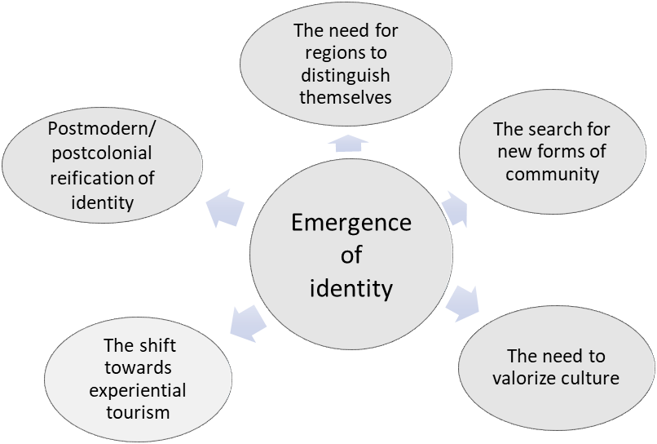

Fig. no. 1. Factors responsible for emergence of identity as a key element in cultural tourism
Source: adapted after Richards and Pereiro (2006)

Richards is describing “identity” as a “process of social construction of meanings that utilizes cultural attributes which occurs in the context of power relations.” (Richards, 2006). In the case of “Stephen the Great” route, all the factors defined (postmodern/postcolonial reification of identity; the need for regions to distinguish themselves; the search of new forms for community; the shift towards experiential tourism and the need to valorise culture) are activated, the route being an appeal to nostalgia after the past Moldova region and after an important historic figures, that incorporated qualities missed in the leading figures of today.
The development of the route has great chances: on trans-national and cross-border level the personality of Stephan the Great is still part of the common imaginary and national spirit of both countries.
The number of thematic trails in Romania is quite limited (nine existing European cultural routes are crossing over Romania) and their benefits for the Romanian tourism was described in previous studies (Cojocariu, 2015). We could assume that exist an important potential for this route, to engage interest and to generate tourist flows over the next years. On international level, with an appropriate promotion and product development efforts, the route can be added to the European Cultural Routes. This is the ambition of both partner countries, to enhance the status of the route, by adding a third country, Ukraine (Moldpres, 2020), with the tourism objectives associated with the theme of the cultural trail. Still, important improvements are required.

- ATTRACTIVENESS OF CULTURAL ROUTES. RESEARCH SETTING AND METHODOLOGY

The present research is associated with tourism attractiveness, described as a key determinant of tourism circulation, that reflects feelings, opinions and perception of tourists about the destination. The attractiveness of a destination is associated with the existing resources (natural and anthropic) of the destination, being dependent on the availability of resources and their perceived value (Ul & Chaudhary, 2021; Formica & Uysal, 2006).
UNWTO has proposed a basic classification of the tourism attractions, in the following categories (Krešić & Prebežac, 2011): (1) Natural tourist-resources; (2) Cultural and historical heritage in tourism; (3) Climate conditions; (4) Infrastructure; (5) Tourist services and facilities.
The destination management studies have approached in the last time the Index of Destination Attractiveness (IDA), that helps in the quantification of the attractiveness. The IDA was developed as a part of composite indicators group, that are combining a number of related measures into one factor (Krešić & Prebežac, 2011), with the purpose to quantify the level of destination attractiveness. Each individual tourism attraction is measured and aggregated. The factors of the IDA developed for Kashmir by Chaudhary (Ul & Chaudhary, 2021) were structured in 11 factors, with several subordinated variables: Hygiene and cleanliness (1), Food attraction (2), Transport facilities (3), Accommodation facilities (4), Site attraction (5), Communication facilities (6), Cost (7) and Cultural attractions (8), Tourism amenities (9), Natural attractions (10) and Tourist activity (11).
The backbone of the theory is the opinion that every individual attraction contributes to the overall attractiveness of the whole destination area, and the competitiveness of a destination rests with each attraction’s performance.
Taking into consideration this theory, we can assume that is available not only for destinations, but for the cultural routes as well, that are a chain of tourism spots (natural or cultural resources) connected by a common subject.
The research objectives were: (1) to develop an index similar to IDA, but adjusted for the assessment of a cultural route; (2) to analyse the quality of tourism experience on the cultural route “Stephen the Great”, with a focus on the “tangible component” of services, taking into consideration the “site and monument approach”, like it was defined by Bonink in 1992 (apud. (Mousavi et al., 2016).
As starting point, we have used the initial questionnaire provided by the representatives of Agency for Investment Moldova and Romanian Tourism Ministry in 2017, for the identification of the objectives worthy to be included in the Route. An observation sheet was developed (see annex no. 1), with 26 items grouped in 5 factors: (I) The quality of access infrastructure; (II) Quality of on-site tourist information and interpretation; (III) Community engagement; (IV) Quality of tourist services / quality of the cultural product; (V) The attractiveness of the destination. In the table no. 1 are listed the items that are subordinated to each factor. The quality of each item was evaluated using a four-value scale: very good, good, satisfactory and poor.

Table 1. List of the research factors and variables. Cultural Routes Assessment.

No. | Factors and evaluation items
I. | The quality of the access infrastructure
1. | Easy accessibility from national roads, with appropriate signage
2. | The access to the tourist attractions is clean, with no waste disposal
3. | The location is easy to find, with the support of the street signs
4. | There is a parking lot in the vicinity where bus access
5. | There are toilets and sanitary facilities
II. | Quality of on-site tourist information and interpretation
1. | There are information boards on site
2. | The panels refer to Stephen the Great
3. | The information displayed is bilingual (at least Romanian-English)
4. | The attractiveness and quality of information panels
5. | There is QR code that allows you to connect to additional online information resources
6. | Static – monitor, LCD, panels, shelves with leaflets available or similar
7. | Information on the move – guides, teachers, archaeologists, actors, volunteers
III. | Community engagement
1. | The locals know the significance of the tourist attraction and the location
IV. | Quality of tourist services / Quality of the cultural product
1. | There are specific facilities and amenities (as for ex. banks nearby or other facilities for tourists)
2. | The operating schedule is displayed
3. | Tourist services offered on the site (if any and what they are)
4. | There is a museum or museum collection that can increase the quality of interpretation (museums, galleries)
5. | General quality for Romanian tourists
6. | Overall quality for foreign tourists
V. | The attractiveness of the destination
1. | There is the possibility for undertaken activities in the area, which lead to an increase of the length of stay
2. | There are accommodation options nearby
3. | Tour guides available
4. | There are annual events connected to the route / theme
5. | There is a tourist information point in the locality or at the location
6. | There is a restaurant in the vicinity, or it exists the possibility to eat nearby, in the community
7. | Accessibility for people with disabilities/ methods of interpretation for people with hearing/vision impairments
Source: author representation

For the field research, the main objectives were: (1) to understand the level of development of the route’s objectives; (2) to identify the need for improvement and the disparities among tourism objectives registered in the route.
The field research for the evaluation of the overall quality of the route “Stephen the Great” was undertaken between May and July 2022. All the tourism objectives were visited and evaluated on spot. For each objectives an observation sheet was completed, for the items presented in the table above. As well, the site was documented with pictures and additional observations for the items were formulated. The observation as research method was used for the “hard”/”tangible” components of tourism services. For the other topics, open interviews were conducted on site. We have submitted to the consideration that the route, as a tourism product, is more complex, being ” a cultural asset” consisting of the tangible and intangible heritage found along them” (Trono, 2022, 15).

RESULTS AND DISCUSSIONS

The results are relevant for the assessment of the quality of the tourism experience on site, mediated by the factors from the table no. 1. As well, they helped and to see in so far, the quality of tourism spots registered in a cultural route suffer from important deviations. The sheet completed for each objective is an important tool for guiding the future actions meant to improve the tourist attractiveness. Additional to this, we have calculated the overall result for the entire route, for each category of factors, as presented in the table no. 2.

Table no. 2. Overall attractiveness of “Stephen the Great” Route

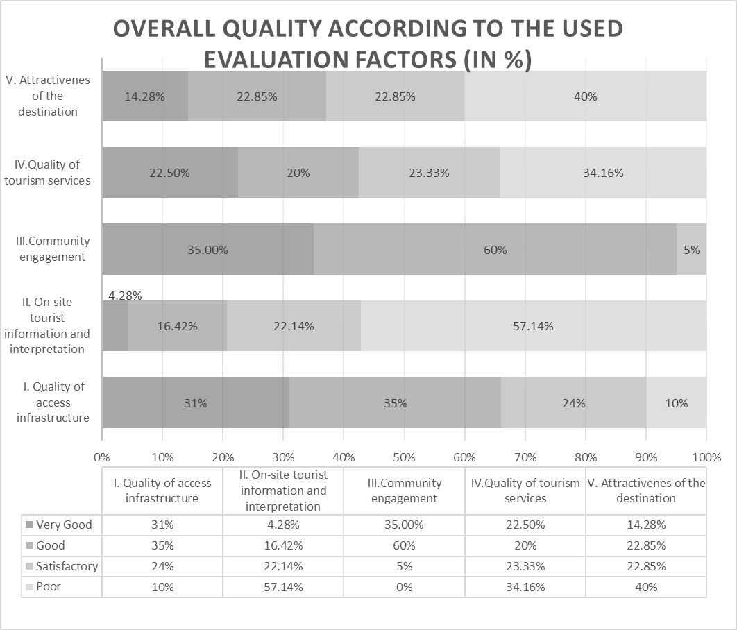Source: author representation

In the discussion we will refer only to the general evaluation of the entire Route, without going in detail regarding the evaluation of each site. From all five assessed factors, quality of access infrastructure and the community engagement have an overall good result. This is a positive aspect, taking into consideration that the poor infrastructure was often brought into discussion by the professionals from tourism industry, being mentioned as a weakness. Still, some objectives were evaluated with a poor score. It was the case of those situated in the remote rural areas. Such disadvantages could be addressed by a proper information/communication policy, and, as well, should become a priority for the future improvements of the route. As well, the good score for “community engagement” is encouraging, if we think that the interaction with the locals is very important for the cultural traveller. At the same time, the item indicates that the locals are aware about the significance of the tourist objective and its significance.
The lowest score was registered for the factor “on-site tourist information and interpretation”. The effort of the route administrators and supporters should be directed to actions meant to increase the attractiveness in-situ through more displays, through information materials available offsite and online. Usually, the information about a tourism objective, that can be accessed on the general pages in internet is limited. It is needed a coherent presentation of the routes’ objectives, with associated stories and valuable scientific information. We should take into consideration that the profile of cultural traveller requires an adequate quality of the content, and that the expectations for this subject could be high.
The results presented in the table no. 2 provides a simple and coherent overview of the points that should be improved, and could be a valuable tool for policy makers, tourism planners and route-administrators. The individual evaluation-sheets, together with the collected pictures are indicating the areas that need improvements. With this support, an action plan can be developed, based on the concrete weaknesses identified on the field. Nevertheless, an action plan should aim to consolidate the strengths, or the functional items from the index.
Future discussions among the stakeholders should bring into attention the fragile connection between the quality of the tourist objectives and the tourism experience, tourist satisfaction and the chances of the route to become a competitive tourist product that could help the communities to prosper. One difficult topic that should be addressed is if there should be an average standard or a minimal admitted quality for the objectives that are part of a cultural route. The new emerging routes are formed from tourism sights that are offering different quality standards (tourism infrastructure, tourism services). This could lead to dissatisfaction and negative image of the route, that later can be hard to be modified. As well, we consider that an external on-the-field evaluation is needed. In most cases, the stakeholders are not realising the needs from an external tourist-perspective, that is so important for matching the offer-demand components.
The constant evaluation of the route objectives is vital. The monitorisation of the route components should be a permanent task of the administration bodies, involved in route management (Crivillers et al., 2015). We are considering that not only the public authorities are responsible, but a proper governance structure should distribute the responsibility among different partners and stakeholdes.

CONCLUSIONS

Cultural routes, as relatively recent category of cultural goods, are generating “an interaction between a monument in need of protection and the cultural or regional context to which it must be linked, in order to be understood and appreciated” (Khovanova-Rubicondo, 2012, 88).
The paper proposes a model that can be employed for assessing the quality of a cultural route, in the perception of tourists, taking into consideration their needs on the site. The subject of cultural routes is relatively new and only limited research was undertaken to analyse all the benefits and challenges associated with the creation and management of such complex programs.
In our particular case all 20 tourism objectives evaluated are connected with the figures of the “Stephen the Great”, but the degree of importance and their maturity as a point of interest for the tourists is different. In the future research we would like to approach the “admitted deviance” from an optimal accepted quality.
The research responds to the needs that were outlined by (Crivillers et al., 2015), regarding the importance of accurate data, that will “allow the Routes to play an effective role in the preservation of heritage and also highlight their capacity to open doors and social and economic development in the territory”. The “analysis of quality standards of the route products and services” should be part of a research methodology of the cultural routes, together with structured interviews of the key stakeholders, with information about how the data was conceived and its strategy, analysis of the types of partnerships, the route management, route governance and synergies among the actors from different layers.
Almost 90% of European cultural routes pass through rural communities, integrating less known areas. They are associated with positive effects on development of sustainable routes, being a model for heritage promotion and protection, a model for slow tourism, and boosters for local economies. The Covid-19 crisis changed the perspective, bringing new challenges (Dominioni, 2021) for the cultural routes: the need to gain the trust and confidence of travellers, the quality of the overall experience, finding ways to recognise and respond to the new tourism demands, to put in place the right tools for sustainability and resilience, the need for training and capacity building, the transition to digital marketing (research and promotion) and to assure the financial support.
The results of the research will serve the planning and development of the route, in the decision-making phase and the formulation of policies, for the consolidation of the exiting partnership and for future improvements. The cooperation between different categories from public and private authorities will be vital, but still, the use of the proposed pilot tool (observation sheet and index of evaluation) could be a start for the formulation of a plan of action, meant to improve the current status. The index will bring clarity and objectivity in the international negotiations and in the process of strategic planning.
Trono (2022, 10) is underlying the same idea, mentioning that the development of partnerships between public and private sectors has a particular importance, in order to strengthen participation and the ability to act on a local level.
The future research should approach some subjects that could be considered limits of the present study: testing the pilot proposed observation sheet with the support of expert focus groups, in order to add other items; some topics related the environment protection and circular / green economy could be included, to respond to the Green Deal Agenda of European Union; to establish an “optimal compulsory quality standard” for the objectives that are part of the route, in order to analyse the deviance and the possible weaknesses that could affect the route overall attractiveness.
To promote a thematic trail could be more challenging that to promote a tourism destination, due the complex and fragile relation of all stakeholders involved in an ecosystem that should work and bring support for the constant quality of the tourism experience delivered on the way.

[1] List of European Cultural Routes: Aeneas Route, Alvar Aalto Route – 20th Century Architecture and Design, ATRIUM - Architecture of Totalitarian Regimes of the 20th Century in Europe, Cluniac Sites in Europe, Cyril and Methodius Route, Destination Napoleon, European Cemeteries Route, European Fairy Tale Route, European Mozart Ways, European Route d’Artagnan, European Route of Ceramics, European Route of Cistercian Abbeys, European Route of Historic Gardens, European Route of Historic Thermal Towns, European Route of Industrial Heritage, European Route of Jewish Heritage, European Route of Megalithic Culture, European Routes of Emperor Charles V, Fortified Towns of the Grande Region, Historic Cafés Route, Huguenot and Waldensian Trail, Impressionisms Routes, In the Footsteps of Robert Louis Stevenson, Iron Age Danube Route, Iron Curtain Trail, Iron Route in the Pyrenees, Iter Vitis Route, Le Corbusier Destinations: Architectural Promenades, Liberation Route Europe, Phoenicians' Route, Prehistoric Rock Art Trails, Réseau Art Nouveau Network, Roman Emperors and Danube Wine Route, Route of Saint Olav Ways, Routes of El legado andalusí, Routes of Reformation, Routes of the Olive Tree, Saint Martin of Tours Route, Santiago de Compostela Pilgrim Routes, The Hansa, TRANSROMANICA – The Romanesque Routes of European Heritage, Via Charlemagne, Via Francigena, Via Habsburg, VIA REGIA, Via Romea Germanica, Viking Route, Women Writers Route.

[2] “A culă (plural: cule; from Turkish kule) is a semi-fortified building found in the southern part of Romania (Oltenia and Muntenia regions). They were originally built as homes for the ruling Boyar class to defend against violent raids by rebels from the south of the Danube during the eighteenth century. Similar constructions exist throughout the Balkans, see Tower houses in the Balkans.” (Source: Wikipedia).

[3] List of tourist objectives registered on the Route “Stephen the Great and Saint”
1. Church of the "Assumption of the Virgin Mary" from Borzești, Bacău district
2. ”Saint Nicolae” Popăuți Monastery, Botoșani district
3. "Saint George" Church from Hârlau, Iași district
4. "Cuvioasa Parascheva" Church and the ruins of the Royal Cellar in Cotnari, Iasi county5. Palace of Culture from Iasi, Iasi district
6. Church dedicated to "Saint Nicholas", Iași district
7. Dobrovăț Monastery Church, dedicated to the "Descent of the Holy Spirit", Iasi district
8. Neamț Citadel, from Târgu Neamt, Neamt district
9. The Royal Court and the Church dedicated to "Saint John the Baptist" in Piatra Neamt, Neamt district
10. Neamț Monastery, Neamț district
11. Războieni Monastery, Neamț district
12. Royal Citadel from Suceava, Suceava district
13. Putna Monastery - Church "Assumption of the Virgin Mary", Suceava district
14. "Holy Cross Church” from Pătrăuți, Suceava district
15. "Saint George" Church of the former Voronet Monastery, Suceava district
16. Church of "Beheading of Saint John the Baptist" in Reuseni, Suceava district
17. Church dedicated to the "Exaltation of the Holy Cross" from Volovaț, Suceava district
18. Church dedicated to "Saint Ilie" from Șcheia Commune, Suceava district
19. ”Podu Înalt” monumental ensemble - Vaslui, Vaslui district
20. Ensemble of the Royal Courts of Vaslui, Vaslui district

This research was funded under the framework of Horizon 2020 research project Be.CULTOUR : “Beyond CULtural TOURism: human centred innovations for sustainable and circular cultural tourism”. This project has received funding from the European Union’s Horizon 2020 research and innovation program under Grant Agreement No 101004627.

BIBLIOGRAPHY
- Cojocariu, S. (2015). The Development of Cultural Routes: A Valuable Asset for Romania. Procedia Economics and Finance, 32, 959–967. https://doi.org/10.1016/S2212-5671(15)01554-3
- Crivillers, M., Gravari-Barbas, M., & Tresserras, J. (2015). The management and the governance of the European Cultural Routes: The case of France and Spain. In Affiliate Members Global Report, Volume 12 – Cultural Routes and Itineraries. https://www.e-unwto.org/doi/book/10.18111/9789284417704
- European Commission/Council of Europe Joint Programme on Cultural Routes. (2013). Cultural Routes management: From theory to practice. https://book.coe.int/en/cultural-heritage/6437-cutural-routes-management-from-theory-to-practice.html
- European Institute of Cultural Routes, & Europarat (Eds.). (2015). Cultural routes management: From theory to practice; step-by-step guide to the Council of Europe Cultural Routes. Council of Europe Publ.
- Formica, S., & Uysal, M. (2006). Destination Attractiveness Based on Supply and Demand Evaluations: An Analytical Framework. Journal of Travel Research, 44(4), 418–430. https://doi.org/10.1177/0047287506286714
- Khovanova-Rubicondo, K. M. (2012). Cultural Routes as a source for new kind of tourism development: Evidence from the Council of Europe’s Programme. In Progress in Cultural Heritage Preservation – EUROMED 2012.
- Krešić, D., & Prebežac, D. (2011). Index of destination attractiveness as a tool for destination attractiveness assessment. Tourism, 59(4), 497–517.
- Moldpres. (2020, December 18). Ruta “Voievodul Stefan cel Mare si Sfant” ar putea deveni un traseu international. https://www.moldpres.md/news/2020/12/18/20010083
- Mousavi, S., Doratli, N., & Moradiahari, F. (2016, December 1). Defining Cultural Tourism. International Conference on Civil, Architecture and Sustainable Development (CASD-2016). International Conference on Civil, Architecture and Sustainable Development (CASD-2016), London. https://doi.org/10.15242/IICBE.DIR1216411
- Ramchamder, P. (2004). Literature Review: Perceptions of Socio-Cultural Impacts and Theoretical Framework, Chapter 3. University of Pretoria.
- Richards, G. (Ed.). (2007). Cultural tourism: Global and local perspectives. Haworth Hospitality Press.
- Richards, G., & Pereiro, X. (2006). Cultural Tourism: Negotiating Identities. Universidade de Trás-Os-Montes e Alto Douro.
- Stephenthegreat.travel. (n.d.).
- Timothy, D. J., & Boyd, S. W. (2015). Tourism and trails: Cultural, ecological and management issues. Channel View Publications.
- Trono, A. (ed. ). (2022). Sustainable Tourism and Cultural Routes in the Ionia and Adriatic Regions. Gruppo editoriale Tab.
- Ul, I., & Chaudhary, M. (2021). Index of destination attractiveness: A quantitative approach for measuring tourism attractiveness. Turizam, 25(1), 31–44. https://doi.org/10.5937/turizam25-27235
- ”Voievodul Ștefan cel Mare și Sfânt”: Ruta cultural-turistică a Moldovei. (2020, December 25). Botosaneanul.Ro. https://www.botosaneanul.ro/stiri/voievodul-tefan-cel-mare-si-sfant-ruta-cultural-turistica-a-moldovei-dar-fara-botosani/
- Xuereb, K., & Avellino, M. (2020). The Phoenician Cultural Route as a Framework for Intercultural Dialogue in Today’s Mediterranean: A Focus on Malta. Almatourism - Journal of Tourism, Culture and Territorial Development, 17-36 Pages. https://doi.org/10.6092/ISSN.2036-5195/9702

https://www.coe.int/en/web/cultural-routes [accessed at 20.08.2022]
- https://mfe.gov.ro/mipe-a-demarat-pregatirea-celor-12-rute-culturale-si-turistice-tematice-finantate-prin-pnrr/ [accessed at 21.08.2022]

Annex 1. Centralized score for the tourism objectives from the “Stephen the Great” Route
No. crt. | Scorecard indicator  (VG=very googd; G=good; S=satisfactory; P=poor) | Total score of the evaluation factors
No. crt. |  | VG | G | S | P
I. | The quality of the access infrastructure
1. | Easy accessibility from national roads, with appropriate signage | 8 | 7 | 5 | 0
2. | The access to the tourist attractions is clean, with no waste disposal | 8 | 7 | 5 | 0
3. | The location is easy to find, with the support of the street signs | 9 | 5 | 4 | 2
4. | There is a parking lot in the vicinity where bus access | 5 | 7 | 6 | 2
5. | There are toilets and sanitary facilities | 1 | 9 | 4 | 6
Total |  | 31 | 35 | 24 | 10
II. | Quality of on-site tourist information and interpretation
1. | There are information boards on site | 1 | 4 | 8 | 7
2. | The panels refer to Stephen the Great | 2 | 5 | 8 | 5
3. | The information displayed is bilingual (at least Romanian-English) | 1 | 5 | 6 | 8
4. | The attractiveness and quality of information panels | 1 | 2 | 3 | 14
5. | There is QR code that allows you to connect to additional online information resources | 0 | 1 | 0 | 19
6. | Static – monitor, LCD, panels, shelves with leaflets available or similar | 0 | 2 | 1 | 17
7. | Information on the move – guides, teachers, archaeologists, actors, volunteers | 1 | 4 | 5 | 10
Total |  | 6 | 23 | 31 | 80
III. | Community engagement
1. | The locals know the significance of the tourist attraction and the location | 7 | 12 | 1 | 0
Total |  | 7 | 12 | 1 | 0
IV. | Quality of tourist services / Quality of the cultural product
1. | There are specific facilities and amenities (as for ex. banks nearby or other facilities for tourists) | 6 | 3 | 4 | 7
2. | The operating schedule is displayed | 7 | 4 | 3 | 6
3. | Tourist services offered on the site (if any and what they are) | 4 | 0 | 4 | 12
4. | There is a museum or museum collection that can increase the quality of interpretation (museums, galleries) | 4 | 2 | 2 | 12
5. | Overall quality for Romanian tourists | 5 | 10 | 5 | 0
6. | Overall quality for foreign tourists | 1 | 5 | 10 | 4
Total |  | 27 | 24 | 28 | 41
V. | The attractiveness of the destination
1. | There is the possibility for undertaken activities in the area, which lead to an increase in the length of stay | 3 | 6 | 3 | 8
2. | There are accommodation options nearby | 5 | 7 | 3 | 5
3. | Tour guides available | 2 | 6 | 5 | 7
4. | There are annual events connected to the route / theme | 0 | 3 | 2 | 15
5. | There is a tourist information point in the locality or at the location | 4 | 3 | 0 | 13
6. | There is a restaurant in the vicinity or it exists the possibility to eat nearby, in the community | 4 | 7 | 4 | 5
7. | Accessibility for people with disabilities/ methods of interpretation for people with hearing/vision impairments | 2 | 0 | 15 | 3
Total |  | 20 | 32 | 32 | 56

https://www.coe.int/en/web/cultural-routes/about

