Media as a tool of promoting innovation in companies

PhD Student Alina-Ramona Butnariu
“Ștefan cel Mare” University of Suceava, Romania
alinaramonabutnariu@gmail.com

PhD Student Andreea NISTOR
“Ștefan cel Mare” University of Suceava, Romania
andreea.nistor03@gmail.com

Abstract:
New media, especially social networks, are a pillar of the innovation process at the company level. Although many studies focus on the negative way in which social networks affect innovation, in the corporate environment, media is an essential tool that can determine a company's business innovation model. The purpose of this paper is to analyze how new media can be used to promote innovation in the corporate landscape. Thus, the paper investigates the connection between integrated marketing communication and the strategy of social networks in the innovation process, based on the agreement of strategies adaptability, as well as the moderating results of the management diversity. In this context, we study both the way in which the media affects the innovation process at the company level, as well as the positive influence of new media in the innovation process. Thus, the conclusion of this study is represented by the fact that social networks support the innovation process when the social factor is integrated into the daily activities of a company. Also, the choice of a communication channel meant to highlight the marketing strategies at the level of a company is essential. In other words, the right social media tools can integrate an organization's goals and strategies in order to capitalize on its target audience.

Key words: innovation, organizational innovation, mass media, strategic management.

JEL classification: L82, L86, O31.

INTRODUCTION

With technology's help, media are advancing rapidly. In the rationality era, media is playing an indispensable role, creating both an entertaining environment and a way to influence society in all respects. The Internet, with new technologies, big data and the cloud has become an essential factor for the development of companies. Social networks offer companies the opportunity to get in direct contact with people in various fields of activity (Chu et. all, 2020). Also, the media, through social networks, have the role of strengthening the branding of companies, which target a specific type of audience, through the use of communication tools, designed to support innovation among companies (Adeola et. all, 2020). Social media innovation needs to be used appropriately in campaigns so that a misguided campaign could damage a company's reputation, and innovation strategies have a significant organizational impact, which could increase the company's value in just a few days (Ahmad et. all, 2019). In order to maintain an advantageous market position, companies focus on technological development in terms of the takeover process. In this context, innovation is a very important pillar in increasing the pace of life of the products or services offered through technology (Jacobides; Billinger, 2006). A coherent and complex approach is needed in order to use system resources and to focus on development and the decision-making process. Thus, organizations, in the process of innovation, share their approach to development and research infrastructure to build their own value chain.
Social media is an important tool in the communication path, especially in the business world (Jones et. all, 2015). However, the virtual space also produced a number of disadvantages, by affecting some aspects of communication and relationships between people, but through social media, companies have experienced new forms of communication. Also, social networks have helped to change the communication strategies within companies, being real sources of information. In addition to creating a useful platform for communication and cooperation between people, the control of information circulating in the media is held by the customers (Mangold; Faulds, 2009). Within an organization, people are more inclined to work directly with the public than through the Internet and, implicitly, social media to convey a message to the public (Wicks et. all, 2014). In this direction, there are a number of scenarios, which attest that the media, through social media can determine both innovation and a lower level of performance at the level of a company. The types of social media platforms are diverse, being intended for each social network, and people tend to form groups, which gives them the opportunity to reflect their own interests. Thus, a group of people on a particular social network, who have common interests, may or may not cause a company manager to make certain decisions, depending on the requirements of the audience on the social networks (Michopoulou; Moisa, 2019). Therefore, managers can adopt a number of innovative methods, designed to satisfy a certain category of audience, but at the same time, a decision considered innovative may prove to be bad for the company's values and image, generating negative performance, which could determine the loss of customers (Zhan et. all, 2020).
When there is no good-developed innovation culture within an organization, this could lead to wrong decisions. Also, many companies tend to focus more on the day-to-day side of production than on technological developments, and in this context, innovation is not a priority for those companies. The rationale of organizations is to speed up the production process, even if the innovation adopted does not maximize profit, then the information obtained from social media about the innovation process could have adverse effects.
Consequently, regarding the role of social media in the innovation process at the level of companies and in increasing their performance, it can be deduced that mixed results can be obtained, and to determine these aspects, this paper aims to identify the role of media in the innovation process and obtaining the performances of Romanian enterprises. In other words, we aim to explore the effect of social media on the capacity of the organizational innovation process. In order to achieve these objectives, we will test a series of hypotheses, through data collected from managers of Romanian companies, starting from the following question: what is the role of the media in the process of innovation and performance of Romanian companies?

- LITERATURE REVIEW

Through the Theory of Social Exchange, individuals tend to make a series of conscious or unconscious decisions about a company's costs, and within these decisions, the goal is to reduce costs and increase rewards. To maximize profits, companies also use social media platforms, through which they can identify customer needs to change the way they meet organizational performance needs (Daft; Lengel, 1986). Social media platforms have diverse capabilities to destroy the information and encourage people to communicate with each other, and compared to traditional media, new media have the ability to empower any entity that can provide information to an audience as much as possible, using the same type of social media. At the same time, the new media have a very good ability to manage the feedback provided, information clues, as well as the use of natural language, accessible to all masses of people, which led companies to adopt these new media to change perspectives and attitudes, customers or potential customers.
With the use of innovation by companies, they can carry out various activities through the accumulation of knowledge and control, and open innovation allows the distribution of knowledge throughout the world (Chesbrough, 2006). In order to benefit from stability, companies need partnerships with external parties to provide expertise, which cannot be developed rapidly internally (Prokesch, 2010). The main pillar of the open innovation process is the identification of ideas and knowledge outside the organization, in order to have easy access to qualitative and quantitative information.
Companies can use social networks to create, through customer groups, different communities that can facilitate interaction with potential customers, facilitating the process of identifying customers and loyalty of existing ones, facilitating brand reputation and interpersonal relationships. (Saura, 2020). On the other hand, there are a number of disadvantages, which could lead to the loss of customers because on social networks such as Facebook or Twitter, customers want to receive quick responses and feedback, and ignoring this expectation can be offensive to the customers (Al-Mansour, 2021).
New products and services are being promoted on social media, and consumers are increasingly using these communication channels to make purchases, obtain information about products and services, as well as to develop relationships with sellers, so, this approach supports consumers to be actively involved in the innovation side of the business. In this context, social networks make it possible to express opinions, propose new ideas and reduce research and development costs (Moy et. all, 2020). Thus, innovative ideas offered by consumers are transformed into technical knowledge, which already has a basis on all that existing knowledge means. These innovative approaches involve maintaining an open mindset towards collaboration, by including consumers in social networks, without relying entirely on qualified staff, meant to generate innovation. Social media also has the ability to gather global consumer feedback on a particular type of product or service, and this approach can significantly improve the process of entrepreneurial innovation (Larson; Vieregger, 2019) by simplifying the flow of knowledge between what are internal and external sources. Social networks have the potential to offer a range of strategies, globally applicable so that companies can grow more and more.
A study (Kandiero et. all, 2014) examined the impact of using social media on the productivity of 140 Zimbabwean employees as well as organizational performance, finding that the role of social media is underestimated due to the risks of use, resistance to change, as well as the fears that are associated with the implementation of social networks in the way of working. Thus, it was concluded that the use of social media has led to an increase in employee productivity as well as more effective communication between employees (Kandiero et. all, 2014). At the same time, another study (Bartosik-Purgat, 2019) conducted in this direction included a number of employees from the USA, Turkey and Poland, which showed that the use of social networks supported communication in the external market, improving the organizational performance.
Social networks support effective organizational communication, even managing to change consumers' perceptions of the determinants of the social landscape. Social media channels should be seen as an extension of traditional communication channels and not their replacements (Mangold; Faulds, 2009). Figure 1 shows a correlation between traditional communication with that of social media, demonstrating the positive influence of technological innovation.
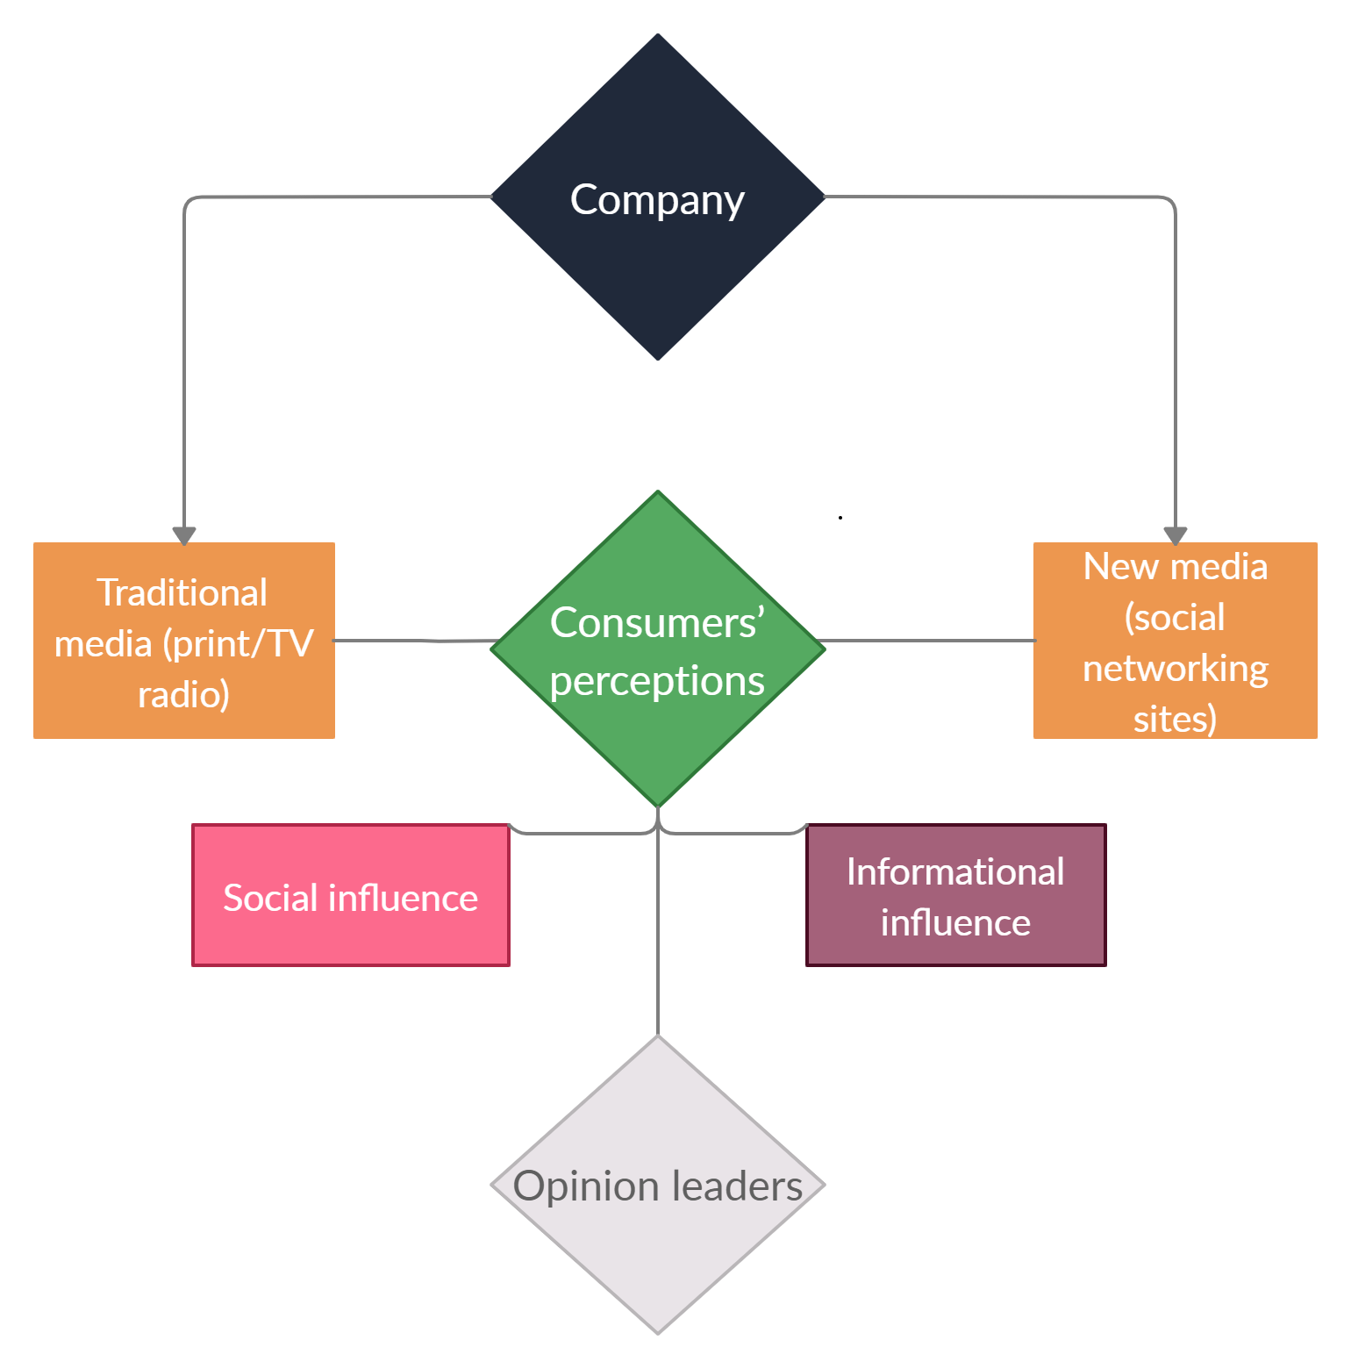
Figure 1. How companies can influence the consumers’ perceptions through the media?
Source: Own elaboration

Social media is extremely useful when it comes to explaining the role of technological innovation to users, and being a quick way to create, so that brands can tell more stories about the usefulness of their own innovations. Another benefit that social media offers is related to the fact that brands can have direct discussions with consumers about the specifications of a product, which leads to resolving any misunderstandings and strengthening the concept of innovation within the company. Opinion leaders also have the opportunity to benefit from a much larger audience than in the offline environment when they share the benefits of innovation. Thus, through the media, more precisely through social networks, there are a number of opportunities and promotions regarding the innovation process. See Figure 2.

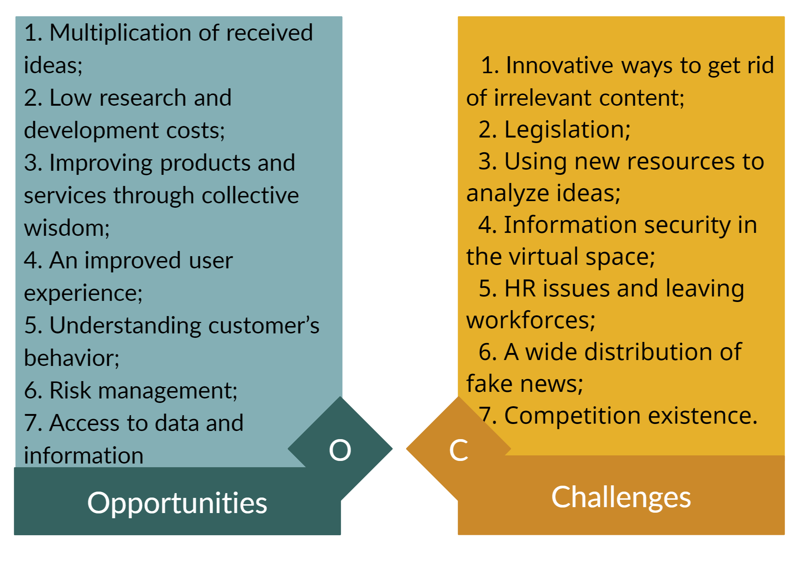
Figure 2. Opportunities and challenges of using social media in the innovation process

Source: Own elaboration
Social networks are a means by which entrepreneurs can analyze their business, suppliers, and distributed content, which are necessary for the process of gathering information. Also, social networks are the most used by entrepreneurs in selecting the best providers, so that managers of organizations can effectively identify what are the advantages and disadvantages of using them.
For social media to generate positive results, companies also need to focus on technological innovation, the investment of which has the role of promoting sustainability and generating new innovative resources (Nelson, 1982). Investment in research and development has accelerated the application of innovative technologies in the production process, and research in this field (Acs; Audretsch, 1989) has shown that patents are one of the most important technical knowledge of a company. These investments are intended to positively influence the outcome of technological innovations, which could lead to an increase in an organization's innovative performance.

METHODOLOGY

This paper aims to identify the role that the media has in the development of innovation at the company level in Romania, and in this context, Figure 3 shows how social networks are used to achieve the performance of Romanian businesses.
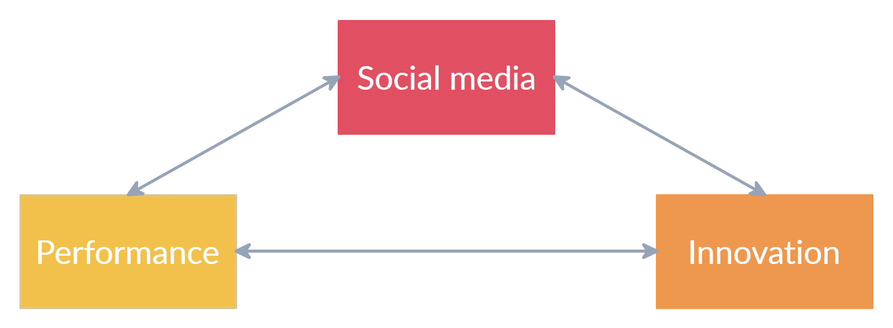
Figure 3. Conceptual framework
Source: Own elaboration

The link between innovation capacity and performance has been studied by several researchers. Each study examined individual aspects of innovation capacity and their association with firm performance. However, few studies have examined the aspects of organizational innovation as a whole in terms of achieving better performance and supporting the competitiveness of organizations, whether private or public. Studies focus only on the factors that are related to innovation capacity and their influence on innovation performance. Instead, the purpose of this research is to investigate the most important aspects of organizational innovation that are significantly and positively related to the performance of organizations when using social media.
The research method selected in this paper is of a qualitative nature, representing an exploratory research meant to confirm the hypotheses formulated by the authors regarding the definition and identification of the main aspects in approaching the models of the innovation process in the targeted organizations in Romania. At the same time, exploratory research will facilitate the obtaining of qualitative primary data on respondents' perceptions of the innovation process. For this purpose, the selected research method is exploratory survey. The questionnaire was used as a communication and data collection tool to respond to the research objectives.

RESULTS OF RESEARCH

In order to transmit the research results in a way that responds effectively to the purpose and objectives of the research, we chose to highlight the current state of organizational innovation models in two regions of Romania by analyzing the answers obtained in the questionnaire and then correlate previously established:
H1. Organizational culture in Romania facilitates the development of organizational innovation through specific practices and methodologies;
H2. Human resources are the most important organizational resource and positively influence the extent to which organizational innovation practices have been adopted in Romanian organizations.
A total of 128 participating organizations from two development regions of Romania (North-East and North West) participated to this research belonging to the following main categories:
- 53 micro-enterprises, representing 41.4% of the total number;
- 24 small enterprises, representing 18.8% of the total number;
- 22 ATUs / town halls, representing 17.2% of the total number;
- 10 higher education and / or research organizations, representing 7.8% of the total number;
- 5 clusters, representing 3.9% of the total number;
- 4 chambers of commerce and industry, representing 3.1% of the total number;
- 4 medium-sized enterprises, representing 3.1% of the total number;
- 3 NGOs, representing 2.3% of the total number.
Among one of the illustrative results of the research is that there is a concern for innovation at the level of vision and strategy, but it is not clear whether this activity remains rather at the level of desire, statement of intent or a reality fact. However, we do not see a contradiction between positioning innovation as a vision and strategic goal and allocating sufficient resources to generate and develop ideas because the vast majority of respondents considered that employees are given sufficient resources (50.8% agree and 23.4 % totally agree). Respondents also considered that the employees of the organization in which they operate are willing to act to meet the organization's goal of innovating to a large extent, with 50% agreeing and 20.3% totally agreeing. We observed that there is a balance between organizational culture, the organization's vision to innovate and the implementation of innovation by existing human resources. Overall, we believe that research organizations are well identified as innovative, at least in terms of vision and strategy in the context of innovation.
Regarding the sources of information and knowledge that are used in the innovation activities of the organization, the respondents had to choose between several options, as follows: communication between the departments of the organization, the parent organization, customers or consumers, suppliers, direct competitors or other organizations in the sector activity of the organization, partners, collaborators and / or consultants, universities and / or research and development institutes, communities of good practice or industry and professional associations, government institutions, participation in scientific and / or technical events (e.g. conferences, exhibitions) and / or access to scientific and / or technical journals and publications and other sources of information and knowledge) and accounted for 61.7% for communication between the organization's departments and 60.9% for partners, collaborators and / or consultants . A third position is represented by the option of customers or consumers with 48.4%. Social media is mentioned as a channel of communication when considering new model of innovation and a reliable source of information when it comes to good practices replication among organizations.
Regarding the cooperation practices within the organizations, social media interactions are the main facilitators to these. Thus the respondents mentioned that the organizations in which they operate use various forms of cooperation, association, partnerships or alliances in order to carry out joint innovation activities, as follows: customers or consumers (50%), other similar organizations in the specific field of activity or in other fields for interdisciplinary cooperation (39.8%), universities and / or research institutes (30.5%) and suppliers (28.1%).
When analyzing the answers regarding the membership in innovation groups / communities, including social media communities, we can see that 35.9% of the respondents indicated that the organization is not a member of any group / community, this proportion confirming the results obtained regarding information sources, where 61.7% among the subjects mentioned the communication between the departments of the organization. In our view, the fact that organizations cooperate mostly internally and not externally with other relevant organizations can be a barrier to organizational innovation. However, the proportions registered for the public-private partnership (32%), industrial and professional associations (30.5%), community of good practices (21.1%) and cluster (20.3%) are worth mentioning.
According to the results of this study, the innovation process is the most important aspect of innovation capacity, and it is significantly and positively associated with overall performance. This finding provides additional evidence to support previous literature indicating that the innovation process has a positive relationship with a firm's performance. Jiménez-Jiménez and Sanz-Valle (2011) showed a significant and positive relationship between the process of organizational innovation and performance. The study by Murat and Baki (2011) showed that the innovation process includes the creation or improvement of a method, as well as the development of processes or systems. While process improvements can diffuse resources, they can facilitate the effects of the learning curve, with a positive impact on the growth of SMEs. Therefore, the innovation process is essential for performance and, in turn, leads to better business performance. The authors showed that there is a direct positive relationship between the innovation process and the overall performance of a firm (Murat and Baki, 2011).
In this study, the finding that some aspects are not directly associated with organizational innovation (aspects like “risk-taking” and “rewards and recognition”) but this does not mean that these aspects have no value or role to play in improving the performance of organizations. In addition, we are aware that the model of organizational innovation that might be replicated via social media is not exhaustive but can be improved with the extension of research to organizations in other regions of Romania.
The ability to innovate is not the only factor that improves the performance of organizations; many different factors can do this and in our opinion social media is a relevant channel of communication of best practices in the field. Innovation has a direct and positive effect on performance, according to many studies (Calantone et al., 2002; Bowen et al., 2010; Jiménez-Jiménez and Sanz-Valle, 2011). However, aspects that support an organization's innovation do not always have a direct impact on improving a company's performance. According to Armbruster et al. (2008), organizational innovation is considered a prerequisite for the efficient development of technical products and the innovation process, and therefore organizational innovations will affect the productivity, quality and flexibility of the company. Therefore, innovation capacity issues could be related to a firm's overall performance through interim measures. In other words, there are many factors that mediate between aspects of innovation capacity to facilitate and achieve strong innovation and performance. This may be due to the fact that the paths from the aspects of the capacity of innovation to the performance of a company are difficult to follow directly.
As a general conclusion to this pilot study, the responses to the questionnaire are positive in terms of human resources in the organizations surveyed: there are concerns about teamwork, companies are able to attract valuable employees, and companies also support employee creativity. Social media is a vital resource of information with employees having access to a wide variety of innovative business models and good practices. Also, the importance of innovation is clearly communicated and the organization implements programs to determine a culture of innovation.

CONCLUSIONS

The world of work is in the midst of many dramatic changes. Relatively recent advances in technology, such as automation, robotics, and artificial intelligence, have not only drastically transformed our daily lives, but also dramatically reshaped entire industries, utilities, and the labor market. The unprecedented development of these technologies has led to widespread changes in business models in all industries, transformed the relationship between employers and employees and affected the organization of work, jobs, tasks and skill sets required in various industries and, but also in the public sector. Some jobs and skills have become obsolete, while completely new occupations require completely different skills. Above all, we can include the crisis caused by COVID-19 as a major change in the economy and the way we think about society and how individuals interact. Success in this time of dramatic change depends largely on the ability of organizations to adapt flexibly and accept change not only by continuing to use the latest technologies, but also by developing and harnessing the potential of their employees to some extent. much bigger than before. Also, use of media and especially social media has been proven to be a catalyst in transferring good practices from one organization to another. Social networks register over 70-80% users out of general population in southern or western Europe and this is why we conclude that this channel of communication has great chances in promoting innovation among organizations as a usual business practice.
However, incorporating innovation into an organization does not happen overnight. It is a long and difficult process characterized by experimentation, learning from failure and persistence. The effort to adopt organizational innovation must be supported and managed as a deliberate act that actively engages a wide range of stakeholders, both internally and externally. In our opinion, media should support all endeavors of an organization to reach to the right information in order to perform and be competitive in an increasingly innovative environment.
As a general conclusion, in Romanian organizations there is a desire to innovate and in most there are many positive premises to do so. Management in organizations is also aware of the importance of innovation and use social media to transfer knowledge and cooperate with stakeholders. It is necessary to provide an intervention model in order to transform this innovation goal into a structured activity, with tangible results, carried out in a sustainable way with maximum use of resources, including social media as information tool.

REFERENCES
- Acs Z. J and Audretsch D. B. (1989), Patents as a measure of innovative activity, Kyklos, vol. 42, no. 2, pp. 171–180.
- Adeola, O.; Hinson, R.E.; Evans, O. (2020), Social media in marketing communications: A synthesis of successful strategies for the digital generation, Digital Transformation Business and Society; Palgrave Macmillan: Cham, Switzerlan d; pp. 61–81.
- Ahmad, S.Z.; Bakar, A.R.A.; Ahmad, N. (2019), Social media adoption and its impact on firm performance: The case of the UAE, Int. J. Entrep. Behav. Res. 25, 84–111.
- Al-Mansour, J. (2021), The interrelationship between strategy as practice and public service innovation and delivery: Academic history and evidence from Kuwait, Int. J. Data Netw. Sci. 5, 151–162.
- Armbruster, H., Bikfalvi, A., Kinkel, S. and Lay, G. (2008), Organizational innovation: the challenge of measuring non-technical innovation in large-scale surveys, Technovation, Vol. 28 No. 10, pp. 644-657.
- Bartosik-Purgat, M. (2019), Digital Marketing Communication from the Perspective of Individual Consumers: A Cross-Country Comparison, Entrep. Bus. Econ. Rev. 3, 205–220.
- Bowen, F.E., Rostami, M. & Steel, P. (2010), Timing is everything: a meta-analysis of the relationships between organizational performance and innovation, Journal of Business Research, Vol. 63 No. 11, pp. 1179-1185.
- Calantone, Roger; Daekwan, Kim; Schmidt, Jeffrey B.; Cavusgil, S. Tamer (2002) The influence of internal and external firm factors on international product adaptation strategy and export performance: A three-country comparison. February 2006Journal of Business Research 59(2):176-185. DOI: 10.1016/j.jbusres.2005.05.001.
- Chesbrough, H. (2006). Open Innovation: A New Paradigm for Understanding Industrial Innovation, In H. Chesbrough, W. Vanhaverbeke, and J. West (Eds.), Open Innovation: Researching a New Paradigm, Oxford university press, Oxford, 1-14.
- Chu, S.C.; Chen, H.T.; Gan, C. (2020), Consumers’ engagement with corporate social responsibility (CSR) communication in social media: Evidence from China and the United States. J. Bus. Res. 110, 260–271.
- Daft, R.L.; Lengel, R.H. (1986), Organizational Information Requirements, Media Richness and Structural Design. Manag. Sci. 32, 554–571.
- Jacobides, M. & Billinger, S., (2006). Designing the boundaries of the firm: From "make, buy, or ally" to the Dynamic Benefits of Vertical Architecture. Organization Science, 17(2):249-261.
- Jimenez-Jimenez, D. & Sanz-Valle, R. (2011), Innovation, organizational learning, and performance, Journal of Business Research, Vol. 64 No. 4, pp. 408-417.
- Jones, N., Borgman, R. & Ulusoy, E. (2015), Impact of social media on small businesses, Journal of Small Business and Enterprise Development, 22 (4): 611–632.
- Kandiero, A.; Perpetua, T.; Jagero, D.N. (2014), Impact of access to social media on employee productivity and organisational performance at Econet Wireless Zimbabwe. Int. J. Knowl. Res. Manag. E Commer, 4, 25–32.
- Larson, E.; Vieregger, C. (2019), Strategic actions in a platform context: What should Facebook do next? J. Inf. Syst. Educ. 30, 97–105.
- Mangold, W. G. & Faulds, D. J. (2009), Social media: The new hybrid element of the promotion mix. Business Horizons, 52(4): 357-365.
- Michopoulou, E.; Moisa, D.G. (2019), Hotel social media metrics: The ROI dilemma. Int. J. Hosp. Manag. 76, 308–315.
- Moy, M.M.; Cahyadi, E.R.; Anggraeni, E. (2020), The Impact of Social Media on Knowledge Creation, Innovation, and Performance in Small and Medium Enterprises. Indones. J. Bus. Entrep. IJBE, 6, 23.
- Murat Ar, I. & Baki, B. 2011, Antecedents and performance impacts of product versus process innovation, European Journal of Innovation Management, vol. 14, no. 2, pp. 172-206.
- Nelson W. (1982), An Evolutionary Theory of Economic Change, Harvard University Press, Cambridge.
- Prokesch, S. (2010). The sustainable supply chain. Harvard Business Review, 88 (10): 70–72.
- Saura, J.R. (2020), Using Data Sciences in Digital Marketing: Framework, methods, and performance metrics. J. Innov. Knowl. 6, 92–102.
- Wicks, R. H., Wicks, J. L., Morimoto, S. A., Maxwell, A. &Schulte, S. R. (2014), Correlates of Political and Civic Engagement among Youth during the Presidential Campaign. American Behavioral Scientist, 7: 173-208.
- Zhan, Y.; Tan, K.H.; Chung, L.; Chen, L.; Xing, X. (2020), Leveraging social media in new product development: Organisational learning processes, mechanisms and evidence from China. Int. J. Oper. Prod. Manag. 40, 671–695.

