ABSORPTION OF EUROPEAN FUNDS AND IMPORTANCE FOR THE SUSTAINABLE DEVELOPMENT

Liliana Sava (Chihaia)
Stefan cel Mare Universty of Suceava, Romania
Email lilianasava74@gmail.com

Carmen Eugenia Nastase
Stefan cel Mare Universty of Suceava, Romania
email carmen.nastase@usm.ro

Mihai Popescu
Stefan cel Mare Universty of Suceava, Romania
email mihai.popescu@usm.ro

Abstract:
The absorption of European funds is representing a phenomenon with strong implications in the European sphere, on the one hand, and within Romania’s capacity to access these funds, on the other hand. The capacity of absorption is “ a variable which is manifesting under different forms in the member states”, thing which determined the need to identify some individual solutions, designed and applied according to the specific needs of each country in regard to the removal of obstacles and of absorption difficulties of European money. The access of European funds results in the implementation of these funds, which contributes to regional development. The objective of this research is to evaluate the capacity of absorption in the area of funds demand, to identify the means of improving the capacity of absorption via the analysis of the identified theoretical aspects and their implementation at a practical level. Another research direction was represented by the analysis of the impact brought by the implementation of the projects conducted from the European funds over the local development, the planning and implementation of available resources, the EU payments towards Romania and the achievements and national level, so that it would be possible to create a strong correlation between the availability of funds and the needs of the public investments. The research’s results demonstrate that the absorption of the European funds is an elemental request posed by the development of the society in the context of European integration and by the development of the local autonomy as an insurance for the success of the local community development.

Key words: absorption of European funds, capacity of absorption, implementation of European projects, regional development, Romania

JEL classification: O2, H43

INTRODUCTION

The adoption of the partnership agreements and of the programs for structural funds and European investments (ESI) represents an important step for the support given by the European Union to the smart growth strategy, which is durable and favourable for inclusion (Europe 2020 Strategy). The programs which are particular for the period 2014-2020 will allow the member states and the regional communities to harness their whole potential, ensuring in the same time a substantial contribution to the specific objectives of the ESI funds, especially those regarding economic, social and territorial cohesion, and ensuring the development of the rural areas and the management of natural resources on the long-term.
During the program period 2014-2020, the European Union is facing the following challenges: the encouragement of recovery from the economic crisis through the creation of jobs and through the settlement of the challenges related to environment protection and climate change, recovery of persistent educational gaps and combating poverty and social exclusion (Strategic Report 2019). The European Union has assumed its commitment to create numerous and better jobs and to create a more favorable society for social inclusion.
Due to the fact that the level of the capacity of absorption from the beneficiaries’ side is difficult to analyze because it implies complex procedures and thorough studies (Dobrescu, 2008), the research intends to evaluate the capacity of absorption from the funds demand’s side. Moreover, at the basis of this choice is the conception according to which any country, in general, and especially in Romania, needs to play a major role in the absorption of European funds (Zaman, 2009). This matter has to be achieved both through the creation of a proper institutional framework for managing the funds received from the European Union and through the awareness of potential beneficiaries (Cace, 2011), over the importance this source of financing represents in what the development process of Romania is concerned, done through information, training and granting support and assistance in all stages of project implementation (Zaman, 2011).

- PROBLEM STATEMENT. THE CAPACITY OF FUNDS ABSORBTION

The capacity of structural funds absorption represents “the degree to which each country is capable to spend effectively and efficient the designated resources from the Structural Funds” (European Structural and Investment Funds, 2015). The importance of the capacity of absorption reside in the necessity of obtaining a maximum contribution to the participation in the process of achieving socio-economic cohesion of the European Union, in order to improve absorption rates, while also focusing more on the efficiency and effectiveness of European cohesion policy (Incaltarau and all, 2020). Therefore, the capacity of absorption reflects the capacity of the future beneficiaries to design acceptable projects so that their implementation to be financed from the European funds. There are two types of absorption capacity (Schweisfurth, 2018):
- the capacity of absorption from funds demand – consists in the creation of an institutional system by the state, necessary for managing European funds.
- the capacity of absorption from funds supply – refers to the beneficiaries’ capacity to absorb the funds which are addressed to them.
According to the Transparency International Romania report (2011), the capacity of absorption from the supply side is influenced by three factors:
- the macroeconomic capacity of absorption – presented and explained in accordance with the GDP; through which the annual amount allocated for a member state from the structural and cohesion funds should not exceed 4% of GDP. Simultaneously, the macroeconomic absorption capacity implies as well the necessity of increasing the budgetary spending as a consequence of the accession to the EU and the capacity to absorb the additional spending which is going to be done.
- the financial capacity of absorption – consists in the capacity of a state to offer co-financing for the projects and programs which benefit from the European Union’s support, the capacity to plan and grant of contributions from the national budget and the capacity to collect the contributions from the partners involved in different projects or programs.
- administrative capacity – consists in the capacity and the competence of the central and local public administration to prepare the projects and programs in time, to finance and monitor them during the implementation period, to comply with the reporting and administrative requirements, to avoid certain irregularities, as well as to ensure and efficient coordination with the involved partners.
The programming period 2014-2020 introduces simplified common norms and an increased emphasis on achievements and results. The budget of €351,8 billions, a third of the EU budget is directed in particular towards the 11 thematically objectives supporting the achievement of the Europe 2020 strategy targets (Europe ESF 2014-2020).
Approximately 50% of the total amount is going to be used for the investments in the less developed areas of the European Union (€182 billion), meaning those areas which have the GDP/cap below 75% of the European Union average, and €54 billion will be allocated for investments in less-developed areas of Europe, areas which show a GDP/cap over 90% of the Union average and in which there live approximately 61% of European Union’s citizens. The regions which are in a phase of transition are going to beneficiate from the amount left (Strategic Report 2019)

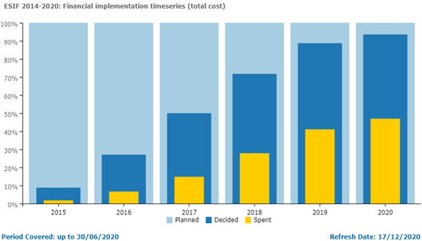

Figure nr. 1. Financial implementation at EU level 2014-2020
Source: Europe 2020 Indicators

The regional discrepancies have visibly increased with the integration of the newest member state. Therefore, 10% of the population of the European Union which coexist in the most dynamic regions produces eight times more income in GDP terms than 10% of the population which lives in less developed areas.
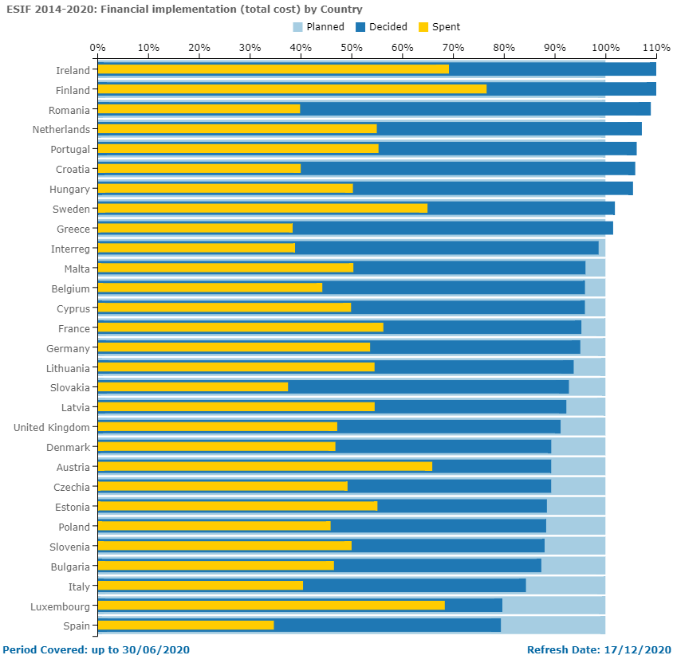
Figure nr. 2. Financial implementation by country 2014-2020
Source: Europe 2020 Indicators

The obvious inequalities between the member states and the other regions is caused by the differences regarding: unemployment and the ability of the work force necessary for development; diversity and size of businesses and infrastructure; quality of the environment; the levels of innovation and usage of technology in businesses (Aivazidou, 2020).
The implementation of the structural funds is based on a series of principles, as it follows:
- Concentrating the measure on the priority objectives for development. The intervention of the Structural Funds is concentrated on those regions or communities where biggest difficulties had been found. Applying this principle led to setting a limited number of areas of intervention.
- The partnership implies a fruitful collaboration between the Commission and the national, regional and local authorities in each member state from the preparatory phase until the implementation of measures.
- The subsidiarity which was established through the Maastricht Treaty. Generally speaking, subsidiarity can be explained: “a superior authority cannot act if an objective is met in a satisfactory way but at an inferior level”. The consequences of applying this principle is that it remains at the discretion of the designated management authorities by the member states to select the projects which are going to be financed and to control their implementation.
- The additionality or the external coherence according to which the structural aid granted by the Union needs to be additional and should not replace the finances already employed by the national, regional and local authorities for the purpose of developing their regions and labour market

RESEARCH QUESTIONS. DIFFICULTIES IN ACCESING EUROPEAN FUNDS

The absorption of European funds for the programming period 2014-2020, at the level of the entire European Union, has been delayed due to the late approval of the budget and of the programmatic documents in the EU Council (member states) and European Parliament.
In measuring the absorption of European funds in the cohesion policy can be used different instrument and methodologies: evaluation based on theory, econometric and macroeconomic models (López-Rodríguez and Faina, 2014). Methodologies and used synthesis in the evaluation of European structural funds’ efficacy, in which there are identified a top-down approach (macro level) and a bottom-up (micro level) in the evaluation of regional economic policy (Batchler and all 2000).
Romania, through 8 national programmes, benefits from ESIF funding of EUR 30.8 billion representing an average of 1 548 euro per person over the period 2014-2020 (Europe 2020 Indicators).

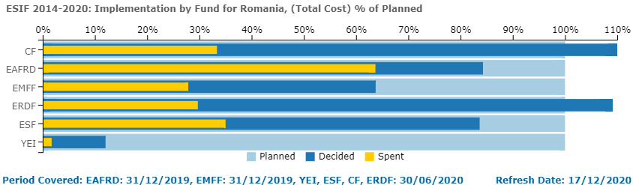
Figure nr. 3. Financial implementation in Romania level 2014-2020
Source: Europe 2020 Indicators

An obstacle was the late accreditation of Romanian management authorities by Brussels. Only in the second half of the year 2017 it was finalised the appointment of the management authorities from the ministries. Without the accreditation of the management authorities, Romania could only launch project calls, carry out and evaluate a project, without being able to get reimbursement for the conducted spending from the European Commission. Another important obstacle was the difficult achievement of the ExAC conditionalities. These sectorial strategies in which Romania is showing on what it wants to spend the European money were late accomplished and, in many cases, the European Commissions has given a warning that without those documents (accreditations) it is not going to make any reimbursements.
A publicized situation was the Romanian Transport General Master Plan. The legislation of public procurement was changed. A series of problems were identified in the electronic system for managing European funds, MYSMIS 2014, made in-house by the Ministry of European Funds in collaboration with the Special Telecommunication Services and the Romanian Intelligence Service. Once these local obstacles are resolved, the absorption of European funds depends highly on beneficiaries. The biggest amounts go to the projects which were done by the public authorities, examples: National Company for Infrastructure (CNAIR), from the Ministry of Transport, through allocated funds for the constructions of highways or Romanian Railways, which coordinate the activity on the railways. Important are also the water and sewer companies from the local authorities’ property. In the same situation there are the research companies, universities which obtain European money for laboratories and research projects.
In the Human Capital Operational Program POCU 2014-2020 (continuation of the POSDRU program), which has the weakest absorption of European funds, currently 0.87%, the main beneficiaries are also the public authorities: Ministry of Labour, Ministry of Education, local authorities, non-governmental organizations, universities, etc. All these entities are carrying out projects with social impact, in the education zone, professional training, medical assistance and entrepreneurship for the community. Many NGOs which have submitted projects in the POCU 2014-2020 have appreciated the difficult pace of the evaluation of the projects at the level of the Ministry of European Funds.

THE CAPACITY OF ABSORBTION OF EUROPEAN FUNDF IN ROMANIA IN THE CONTEXT OF SUSTAINABLE DEVELOPMENT

In the context of growing globalization challenges, including global economic instability, the issue of achieving sustainable development of the state and its regions is becoming particularly important. The concept of sustainable development is based on the idea that the state of society and the quality of life of people are influenced by a combination of economic, social and environmental factors. Awareness of the relationship of these factors allows you to make the right decisions when developing a development strategy for any country, region, and territory. Sustainable development consists of a system of economic, social, environmental measures, which aims to form a system of relationships, based on trust, partnership, solidarity, ethical values, safe environment and national resources of spirituality. An important issue in implementing the concept of sustainable development is the analysis of the absorption of European funds and the identification of how these projects support sustainable development.
The European integration has come with new challenges for the entire Romanian society, especially for the initiators of the investment projects: private companies but also the local, regional and central public authorities. The main opportunities for the companies from the former candidate states are coming from the liberty of operation on the European Community Market and from the possibility to access these European structural funds. Just like in the situation of private companies and local, regional and central public authorities in the other candidate states, the companies and public authorities from Romania had adapted to the new requests posed by the European legislation and to the objective to successfully access the European financing programs created specifically for them (Lucian, 2014).
The European funds which Romania is accessing have a co-financing rate from the national budget depending on the type of investment. For instance, a project for establishing a nursery, financed by the Human Capital Operational Program (POCU), beneficiates of a percentage of 85% of European money. 15% represent the national co-financing, respectively the amounts allocated from the national budget. The European Union grants financing for a large area of projects and programs which cover different domains such as: occupying the work force and social inclusion; policies in the maritime area and fishing; agriculture and rural development; regional and urban development; research and innovation.
The financing is managed having at the core a set of strict rules in order to guarantee that a rigorous control is applied over the way in which the European money are used and to ensure that the funds are used in a responsible and transparent way. The 28 European Commissioners have the final political obligation to guarantee that the European funds are used accordingly. Taking into consideration that the biggest part of the financing is managed by the beneficiary states, the responsibility to execute annual controls and audits is held by the national governments. Over three quarters of the Union’s budget is managed in partnership with the national and regional authorities under the framework of a system of “shared management”, in principle via the five main funds (FSI). These instruments together are contributing to the application of the Europe 2020 Strategy.
A series of funds are directed managed by the Union, being attributed under the form of:
- Grants for projects with activities in the EU policies domains, which, in general, are assigned following the publication of a “proposal request”. The financing comes from the European Union, but also from other sources.
- Contracts concluded between the European institutions for acquiring services, goods and works needed for their own functioning (studies, training, conferences organization, IT equipment). These contracts are assigned via auction.
In the middle of 2019, Romania has registered an absorption rate for the structural funds of 31%, compared to the average of European Union, which is 34%. Other countries in the region have much higher absorption rates: Estonia (46.3%), Poland (43.5%), and Hungary (42.7%). The contracting rate has increased over 15 times, from 5% in 2016 to 87,3% of the allocation, in the present. Approximately €24,8 billion represent the total value of singed financing contracts (Europe 2020 Indicators).

Figure 4: Absorption rate of European funds in Romania compared with EU
Source : Ministry of European Funds

In august 2019, €9,44 billion European money was accessed in Romania through the Cohesion Policy and Agriculture Policy. These amounts are being added another €6,88 billion direct payments towards farmers. Furthermore, €25,68 billion is the total value of open financing lines, value which represents approximately 94% of the total allocation of Romania and €44,5 billion represent the value of the projects submitted for these financing lines.
The absorption rate has remained low despite the significant share the EU funds have held in the total public investments in recent years. The funds earmarked under the 2014-2020 EU budget can be spent by the end of 2023. Given the slow absorption, the risk of not fully capitalizing on the opportunities provided by the EU budget is rising.

CONCLUSIONS

Absorption is a very important aspect of the European integration process and reflecting a phenomenon with strong implications in the European sphere and in the capacity of Romania to access these funds. The purpose of the research is to evaluate the absorption capacity from the supply of funds, to identify ways to improve the absorption capacity through the analysis of identified theoretical aspects, their implementation at a practical level. The accessing of European funds has as a result the implementation of these funds, thing which contributes to the regional development of the country. Regional absorption capacity in the EU depends on territorial economic preconditions for successful absorption of EU funds (Kersan, 2017). The opportunity for accessing the European funds depends on the quality of Member State of Romania in European Union, on the regional profile, on the lower level of development compared to the European one, as well as on the importance of these funds. The capacity of absorption is conditioned evidently by the administrative and managerial capacity of the public authorities, and, as well by the capacity of co-financing and sustaining the projects.

The conclusions of this analysis can represent a landmark in the programming based on the needs of the Cohesion Policy, as well as in the planning of a better absorption of EU funds in the European regions, in the following programming period 2021-2027.

As a Member State of the European Union, Romania needs, on the one hand to increase its efforts for attract more European funds, and on the other hand, to develop its capacity of absorption of these funds, so that a strong correlation between funds availability and the needs for public investments are achieved.

Finally, we appreciate that the absorption of the European funds represents an important and topical approach which needs to be sustained by all the decentralized structures, which function as management authorities. An increased level of absorption of European funds leads to the boosting and diversifying the economic activities, to stimulation of investments in the private sector, to reducing unemployment as well as improving the quality of living.

BIBLIOGRAPHY

Aivazidou, Eirini, Cunico, Givanni, Mollona Edoardo, (2020), Beyond the EU Structural Funds’ Absorption Rate: How Do Regions Really Perform? Economies 2020, 8(3), 55

Bachtler, J., Polverari, L., Taylor, S., Ashcroft, B., & Swales, K. (2000). Methodologies used in the evaluation of the effectiveness of European structural funds: A comparative assessment. Final report to the Scottish executive

Cace, Corina, Sorin Cace, and Victor Nicolăescu, (2011), Absorption of the structural funds in Romania, Romanian Journal of Economic Forecasting 14: 84–105

Dobrescu, Emilian, (2008), Fondurile structural, Editura Eurolobby, Bucureşti (2008)

Incaltarau, Cristian, Gabriela Carmen Pascariu, and Neculai-Cristian Surubaru (2020) Evaluating the Determinants of EU Funds Absorption across Old and New Member States—The Role of Administrative Capacity and Political Governance, Journal of Common Market Studies.

Kersan-Škabić, Ines, Tijanić, Lela (2017), Regional absorption capacity of EU funds, Economic Research-Ekonomska Istraživanja, Volume 30, 2017 - Issue 1sess The European Cohesion Policy, Investigaciones Regionales-Journal of Regional Research, Issue 29, 5-13

Lucian, Paul, (2014), Absorption of European Funds by Romania, Procedia Economics and Finance, Volume 16, Pages 553-556

Schweisfurth Tim, Raasch, Christina, (2018) Absorptive capacity for need knowledge: Antecedents and effects for employee innovativeness, Research Policy, Volume 47, Issue 4, Pages 687-699

Zaman, Gheorghe, and Anca Cristea, (2011), EU structural funds absorption in Romania: Obstacles and issues, Romanian Journal of Economics 1: 60–77

Zaman, Gheorghe, and George Georgescu (2009), Structural Fund Absorption: A New Challenge for Romania, Romanian Journal of Economic Forecasting 6: 136–54.

European Court of Auditors, (2018), Special Report - Commission’s and Member States’ Actions in the Last Years of the 2007–2013 Programmes Tackled Low Absorption but Had Insufficient Focus on Results. Available online: https://www.eca.europa.eu/Lists/ECADocuments/SR18_17/SR_ABSORPTION_EN.pdf

https://ec.europa.eu/eurostat/web/europe-2020-indicators

Transparency International Romania report (2011), https://www.transparency.org/en/publications/national-integrity-system-romania#

Strategic report 2019 on the implementation of the European Structural and Investment Funds, https://ec.europa.eu/regional_policy/en/policy/how/stages-step-by-step/strategic-report/

European Structural and Investment Funds (2015), https://cohesiondata.ec.europa.eu/, https://ec.europa.eu/regional_policy/sources/docgener/guides/blue_book/blueguide_en.pdf

www.fonduri-structurale.ro

www.fonduri-ue.ro

