CONSIDERATIONS ON THE IMPACT OF THE BUDGET DEFICIT ON THE ECONOMY OF ROMANIA

Abstract:
The budget deficit has become a typical phenomenon of the contemporary world. In Romania, as well as in other developing or developed countries, this topic is one of the most difficult issues the economic policy is facing with. Debate on how to address deficits has become a major economic and political issue, both in Romania and in other countries. The present study aims to analyze the budget deficit in Romania as well as the implications of the budget deficit in the economy.

Key words: budget deficit, budget deficit financing; labor market

JEL classification: E62, H6, J21.

INTRODUCTION

The budget deficit has become a common phenomenon in many countries, due to the public spending growth (Apetri et.al., 2014). The issue of budget deficit has been a topic of great interest since the 1980s. As some economists believe, the public financial fluctuation represents the effect of the excessive demand for public financial resources, compared to the funds that can be collected at the national budget (Moşteanu, 2008).
Under the current circumstances of economic activity, where financial needs are greater than available funds, budgeting at all levels represents one of the primary issues, particularly in terms of maintaining the budgetary balance. (Molanescu, 2010).
Among the causes of budget disparities can be identified: high levels of legal tax evasion, high levels of inequality in income and wealth, coercions, demographic fluctuations and government inefficiency (Wynnona, 2016). There have been defined several approaches with regard to the level and implications of budget deficit in the economy.
Thus, according to the neoclassical approach, the increase in the budget deficit leads to higher interest rates, a situation caused by higher loan demand, which discourages private investment, causing higher inflation and eventually slowing the growth rate of the economy (Wynnon, 2016).
According to the Keynesian approach, the budget deficit has greater implications for domestic production, leading to increased aggregate demand and investment. Finally, the central Riccarian argument contends that the deficit only delays current taxes to an upcoming period. This approach suggests that the budget deficit does not affect global demand in an economy. According to this theory, governments either finance spending by taxing taxpayers or by making loans. And these loans must ultimately be paid by raising taxes in the future. Therefore, a choice between later duties and taxes should be made (Fareeha, Ihtsham, 2017).

- THE ARTICLE ANALYSIS OF STATISTICAL DATA ON BUDGET DEFICIT

Methodology and data

Nowadays, study of the budget deficit and preoccupation with its continuing diminution are of great importance for all EU countries, especially as Romania faces great difficulties in the evolution of the economy. In order to analyze the budget deficit, we used a series of statistical methods of collecting and a graphical representing of the data on both the nominal level of the budget deficit and the values resulting from the deficit reporting to GDP available on the website of the European Institute of Statistics. In interpreting the information, we took into consideration the criterion provided by the Maastricht Treaty.

The results of the analysis

The Romanian analysis was based on the execution data on budgetary aggregates, respectively on budget revenues and budget expenditures. Thus, using the data from the General Consolidated Budget of Romania for the 2011-2017 period, we have developed several tables where we can observe the evolution of the mentioned aggregates. In order to calculate the budget deficit indicators as a percentage in GDP, we also used data on GDP evolution in 2011-2017 period, data collected and centralized from the National Institute of Statistics website. Table no. 1 shows the evolution of GDP and of the two budgetary variables related to the time horizon analyzed.

Table no. 1. The evolution of GDP, total revenues and expenditures in the 2011-2017 period - millions Ron

Indicator/Year | 2011 | 2012 | 2013 | 2014 | 2015 | 2016 | 2017
GDP | 578.552 | 585.200 | 625.617 | 674.300 | 704.542 | 758.500 | 816.500
Total Expenditures | 205.819 | 207.922,1 | 215.816,9 | 226.326,8 | 243,915.5 | 242.016,3 | 276.080,4
Total budgetary revenues | 181.920 | 237.512,5 | 200.045,7 | 213.833,6 | 215,401.1 | 223.721,9 | 251.819,7
Source: elaborated by the author based on the data on the website of the Ministry of Public Finance, www.mfinante.ro, www.insse.ro

The analysis of data revealed that Romania registered in 2011 the smallest volume of public revenues with the smallest value quantum. On the other hand, in 2017 there has been recorded the highest income from the analyzed period.

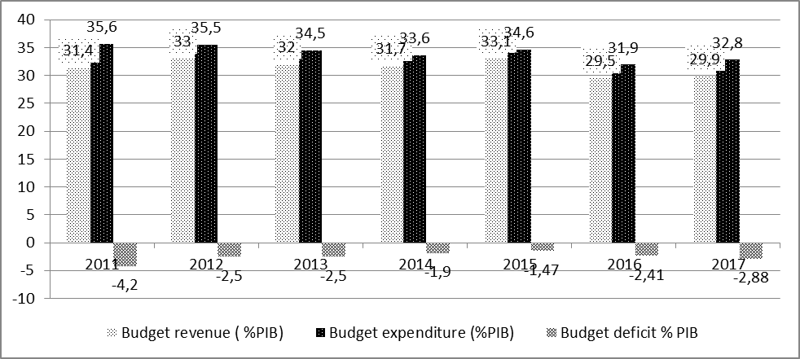
Figura nr. 1. Evolution of the main budgetary indicators in Romania as a percentage of GDP in the 2011-2017 period
Source: Own elaboration using data from www.mfinante.ro, www.insse.ro

Chart no. 1 presents the results of the calculations based on the data mentioned in Table no. 1 on revenue, government expenditure and deficit as a percentage of GDP over the 2011-2017 period.
The graphical representation built on data of the main budgetary indicators, reveals that 2011 registered the largest gap between revenues and expenditures with a direct impact on the budget deficit, accounting for 4.2% of GDP. It is worth noticing that in 2012 revenues increased, without any significant changes of the expenditures, which resulted in reducing the deficit at 2.5% of GDP. Over the next two years, these deficit-reducing trends remain still, due to the fact that expenditures have decreased less in comparison to revenues. In 2015, the smallest cash deficit is recorded for the whole analyzed period. In 2016 and 2017, this trend is changing, revenues are declining to a greater extent than expenses, reaching a budget imbalance of -2.88% of GDP by the end of 2017. This development was driven by the tax relaxation that began in 2015.
According to Romania's fiscal-budgetary strategy on the 2018-2020 period, the budget deficit policy continues to directly support economic growth, within the margin allowed by the Stability and Growth Pact, respectively a European System of Accounts (ESA) budget deficit of 3% of GDP. The budget balance reported to GDP is expected to return to an improving path starting with an adjustment in 2019 and reaching a 1.82% of GDP in 2020.
Between 2011 and 2015, our country implemented large-scale fiscal consolidation measures aimed at reducing both European System of Accounts (ESA) and structural budget deficit, which led to an improvement in the state of public finances. The adjustment made after the economic and financial crisis was mainly on the expenditure section, with structural reforms being promoted especially in the area of the salaries of the public employees, of the public pension system and budgetary programming. Beginning with 2012, the deficit as a percentage of GDP has met the provisions of the Fiscal Treaty (SFB, 2018-2020).

- EFFECTS OF BUDGET DEFICIT IN ECONOMY

Over time, the literature has circulated more currents of opinion according to which it is possible to study the impact of the budget deficit on the economy. First of all, the focus will be on the short-term effects of the budget deficit on consumption and long-term effects of the budget deficit on the national economy, investment and employment.
Secondly, the long-term deficit neutrality hypothesis highlights the financing process on the basis of public debt contracting.
If in the short term, one of the main effects of the deficit is the eviction effect, in the medium and long term, the considerable, long-lasting and with a very low level of sustainability public debt can ultimately lead to major constraints on available internal funds and foreign loans. Thus, a public debt that grows too fast in a certain time, faster than nominal GDP, will constrain an opportunity cost in the future. This cost will involve either a permanently increased tax burden in the future, or a period of inflation, or eventually a period when the state will reduce its expenditures (Hall, R., 2010).
Therefore, there has been noted that the budget deficit is a result of a decreasing economic activity on the one hand, having the effect of reducing the incomes of natural and legal persons, which implies a decrease of the tax base and thus a decrease of the budgetary revenues. On the other hand, the existence of a large budget deficit implies a decline in government investment, with unfavourable consequences for employment as well as budgetary expenditures on employment.

The impact of the budget deficit on the labor market
The methods used to finance the budget deficit, for example: increasing taxation, reducing public spending, increasing public debt, have a major impact on labor market short and long term developments.
Thus, given the short-term implications, the budget deficit causes a reduction in the national economy, it leads to a decrease in the market supply, which implies an increase in interest rates. In this situation, the volume of investment diminishes, consumption decreases, with considerable effects on economic activities and employment.

Table no.2 Evolution of the number of employed and unemployed people in 2011-2017
Indicator/ An | 2011 | 2012 | 2013 | 2014 | 2015 | 2016 | 2017
Average number of employees (thousand of people) | 6153 | 6230 | 6271 | 5850 | 6062 | 6201 | 6390
Unemployed at the end of the year (thousands of people) | 461 | 494,7 | 512,3 | 478,3 | 436,2 | 418,2 | 351,1
Unemployment rate (%) | 5.1 | 5,59 | 5,65 | 5,29 | 4,9 | 4,77 | 4,02
Source: National Institute of Statistics

The analysis of the data presented in Table no. 2 shows that the number of unemployed people in Romania oscillated during the analysis period from 461 thousand in 2011 to 351 thousand in 2017. In 2017 there has been registered the highest percentage of employees and therefore the lowest number of the unemployed people. In 2013, there has been registered an increase in the number of unemployed and a reduction in the number of employees, which shows a decrease of the economic activity, with important consequences also on budget revenues and budget expenditures.

CONCLUSIONS

The deficits that our country faced with had significant impact on the population, but also on the economy of the country. The financing process of these fluctuations was achieved through loans contracted from international bodies, as well as through establishment of austerity measures by the Romanian Government in order to reduce the budget expenditures, especially to those for investments.

The herein analysis reveals that during the recession, budget deficits tend to increase as tax revenues diminish, emphasizing the need for state to intervene through government spending in order to be able to implement social programs. In Romania this has been noticed in increasing number of unemployed people and implicitly decreasing number of employees that led to many riots and social disputes

BIBLIOGRAPHY
- Apetri, Anișoara Niculina, Grosu, Veronica, Mates, Dorel, Bostan, Ion, Socoliuc, Marian, Hlaciuc, Anamaria, (2014), The analysis of evolution and financingh policies of the budget deficit in Romania, in the period 2007-2012, The Annals of the Stefan cel Mare University Suceava, Fascicle of The Faculty of Economics and Public Administration B+, volumul 14, ISSUE 1(19), ISSN 2344 – 3847, Nr. 1(19)/2014, Vol. 14, cod CNCSIS 825, pp.177-187, Available on the Internet http://www.seap.usv.ro/annals/arhiva/USVAEPA_Vol.14,Issue_1%2819%29,2014_content.pdfhttp://www.annal s.seap.usv.ro/index.php/annals http://www.ebscohost.com/titleLists/bsh-journals.htm, http://www.annals.seap.usv.ro/index.php/annals/article/view/684/641
- Fareeha Safdar, Ihtsham Ul Haq Padda, (2017), Impact of Institutions on Budget Deficit: The Case of Pakistan, NUML International Journal of Business & Management, Vol. 12, No: 1. June, 2017. Available on the Internet https://www.researchgate.net/publication/322554655_Impact_of_institutions_on_budget_deficit_the_case_of_Pakistan
- Hall Robert E., Marc Lieberman (2010), Macroeconomics principles and applications, 6th edition, Available on the Internet
https://www.academia.edu/26818353/ISBN_10_1_111_82235_2_Microeconomics_Principles_and_Applications_6th_Edition
- Molănescu, G., Aceleanu, M., I., (2010), Consequences of the Budget Deficit in the Current Crisis in Romania. Implications on the Labor Market, Theoretical and Applied Economics Volume XVIII (2011), No. 2(555), pp. 59-74, [access on 25.04.2019, avaible on] http://store.ectap.ro/articole/556.pdf
- Moșteanu., T., Vuță, M., Câmpanu, E., M., Gyorgy, A., Cataramă, D.F., (2008), Buget și trezorerie publică, Ediția a-III-a, Ed. Universitară, București.
- Wynnona Steyn, (2016), The Budget’s fiscal stance: The non-cyclical element may be a cause for concern, [access on 25.04.2019, avaible on]. (http://www.econ3x3.org/article/budget%E2%80%99s-fiscal-stance-non-cyclical-element-may-be-cause-concern)
- Strategia fiscal bugetară a României pentru anii 2018-2022, [access on 25.04.2019, avaible on]. www.mfinante.ro
- www.mfinanțe.ro [accesat la 25.04.2019]
- www.insse.ro [accesat la 25.04.2019]

