STUDY BASED ON THE IMPORTANCE OF THE INFORMATION PROVIDED BY MANAGEMENT ACCOUNTING ON THE MANAGERIAL PROCESS IN THE JOINT STOCK COMPANIES IN THE NORTH-EAST AREA OF MOLDOVA

Drd. Petronela Vultur
Universitatea Stefan cel Mare, Suceava, Romania

Abstract

Professional accountants have to make choices for recognizing, evaluating and classifying financial transactions to ensure the true image of accounting information. In this study we try to avoid the importance of accounting information in the management process through a questionnaire distributed to 75 joint stock companies in the North-East of Romania.
In the first part we approached the literature at the national level, focusing on the changes in the managerial accounting of the economic entities and the way they have achieved a progress or a regress from the fiscal point of view and the alignment with the international accounting standards.
The first role of management (or managerial) accounting was that of costing. But with the globalization and rhythm of decisions being made, management accounting has adapted to new situations by changing the role and increasing utility for management.

Key words: managerial decisions, accounting information, management tools, economic entity

JEL classification: M41, F61, J53

INTRODUCTION

The economy of a country is made up of all entities operating on its territory, regardless of the field of activity. Research activity in the field of accounting implies the analysis of the economic-financial activity of an entity or several that have something in common, either size, field of activity, legal form. Studies, research in the field of accounting refer both to financial accounting, ie information provided from financial statements, and to managerial accounting, which provides information from costs, prices, produced quantities, internal production reports to information provided to managers, shareholders or other categories of users who have access to managerial accounting information.
Business environment features form business managerial accounting practices. Increasing globalization of markets, international trade, harmonization of financial accounting standards have led to a convergence towards a global set of managerial accounting practices. As developing countries are attractive destinations for foreign investors, it is important to understand how accounting systems work and how to apply these systems. There are relatively few studies on managerial accounting tools in emerging countries, each study bringing a new opportunity to understand the use of these tools correctly

STAGE OF KNOWLEDGE IN THE FIELD

Sorin Briciu şi Sorinel Căpuşneau (2011) argue that cost accounting tools of management have to provide managers with the necessary elements to understand the phenomena and processes taking place within the entity, to provide the operative information on which they can make relevant decisions, being able to anticipate the repercussions of these decisions . In the same way, managerial accounting is meant to provide managers with the tools to perform a permanent and effective control.
Briciu şi Căpuşneau (2011) also considers that the form of organization of managerial accounting, the cost methods used by Romanian companies as well as the applied procedures depend on a number of factors such as the company's activity profile and the increase / complexity of the activity carried out.
Cristina Talpeş in the article "Management accounting: at the boundary between traditional and modern" emphasizes that technical progress requires production technology and implicitly revolutionizing, in addition to how to achieve products, the reorientation towards managerial accounting tools conducive to the entity, of course, based on relevant pertinent analysis.
Albu şi Albu (2012) investigates the use of various categories of managerial accounting tools using a sample of 109 existing entities. The results show the performance and budgeting systems are more widespread than costing. Only 60.6% of the sample entities have implemented a cost calculation system.
In the PhD thesis "Cost Controlling and Profit Management of the Company", Brăescu Madalina has approached in chapter 2 of her thesis "strategies for the electrotechnical industry developed in Romania, studying specifically STAR S.A.". The result that all firms in this area use cost-related information, regardless of their strategy, is another argument for the premise of employing managerial accounting tools.
In the article "Analysis of the use of cost instruments in Romania", under the leadership of prof. Dr Albu Nadia, the analysis and use of managerial accounting tools in Romanian entities has been approached and how these decision-making tools influence these tools.
Another article, "Perspectives on managerial accounting - the case of Romania", written by L., M., Zidaru, Câţă, R., S., Chelaru A., C., Cimpoeru, M., Staicu, E, as the main purpose of presenting a managerial accounting perspective from the point of view of professional accountants in Romania, based on the theoretical and empirical research, to understand how Romanian accounting professionals understand the applicability and use of managerial accounting techniques in the day-to-day life of the entity.
From the national specialty literature, another article entitled "Role and importance in choosing the right concepts of managerial accounting, on the need for information on decision-making in companies", drafted by David, D., Dragoş, D., Puşcaş, A., addresses the question of combining modern practice with managerial accounting, the role, characteristics and importance of these concepts in relation to the process of calculating the accounting entries generated by the cost of production and the object of the entity to obtain profit. What kind of information is required for managers according to the entity's object of business, in the idea of finding the optimal solution for the entity to be cost-effective and efficient.

RESEARCH METHODOLOGY

This study is based on the deductive method, from theory to practice, with similar research and studies to see if the theoretical aspects of the shunt article are valid.
In order to meet the study objectives, the study will be based on methods such as observation, questionnaire, case study and comparative analysis. This study is an empirical one, representing another method of obtaining research results through practice.
The research issues underlying the study were:
1. What is the relationship between the size of the entity, the sector of activity and the instruments used by economic entities in managerial accounting?
2. What is the importance of management in relation to the objectives of the entity?
3. How important are management accounting objectives in managerial decision making?-*95210
The specific objectives of the study are:
- Carrying out an analysis that highlights the importance of sound management in manufacturing enterprises in the northeastern region of Romania;
- Identifying the opinions of the respondents regarding the implementation of the managerial accounting principles, how they perceive this concept;
- Inventory of results and their presentation in a manner that presents the information provided by managerial accounting as well as the role played by managerial accounting;
- Investigating the barriers that impede the implementation of managerial accounting objectives, which can lead to the conservatism of managers in the chosen area as a sample, to the high costs that are needed when choosing a performance management system;
- Measuring the degree of implementation of the information provided by managerial accounting, as well as a hierarchy of the information provided by the respondents.
To answer these questions, we realised an empirical study based on a questionnaire of 14 questions addressed to economic entities with a legal status of a joint stock 58510company. Questions are predominantly with one answer, with a free answer, ranked by opinion, as well as with the grading of the answers with a score of 1 to 5. The questions are explicit, with an important share of specialized terminology.
The investigative field for the present study was made up of a sample of 75 joint stock companies, economic entities from the North - East part of Romania, in order to make an observation on the implementation of the managerial accounting instruments in the sector of production in this area of Romania.

ANALYSIS OF RESEARCH RESULTS

Respondents work in the sample entities within the accounting department. There were responses provided by the managers of those entities who have undergone specialist studies and have knowledge of managerial accounting.
They have a work experience of over 10 years (60%). The field of activity in which they work is mainly in the manufacturing industry, private household activities and the quality of domestic staff; activities of private households producing goods and services for own consumption and construction. Modern managerial accounting methods are used predominantly by large companies.
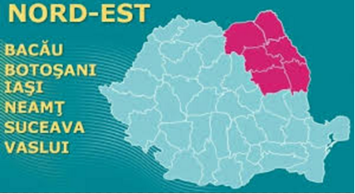
Fig. 1 The North-East Region of Romania chosen as a study sample
Sursa : https://cepu.ro/regiunea-nord-est-cea-mai-mare-rata-de-absorbtie-fondurilor-ue/

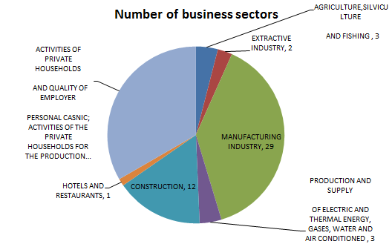
Fig. 2 Structure of the sectors of activity to which the entities part of the study are part

Table 1 The sectors of activity of the respondent entities

Nr. sector | Activity sector | Number of entities | % of total entities
I | Agriculture,Silviculture And Fishing | 2 | 4.44%
II | Extractive Industry | 1 | 2.22%
III | Manufacturing Industry | 17 | 37.78%
IV | Production And Supply Of Electric And Thermal Energy, Gases, Water And Air Conditioned | 2 | 4.44%
V | Construction | 7 | 15.56%
VI | Hotels And Restaurants | 1 | 2.22%
VII | Activities Of Private Households And Quality Of Employer Personal Casnic; Activities Of The Private Households For The Production Of Goods And Services For Their Own Use | 15 | 33.33%
 | TOTAL ACTIVITY SECTOR | 45 | 100%
Sursa:https://lege5.ro/Gratuit/gi4dkmjsga/hotararea-nr-1260-2011-privind-sectoarele-de-activitate-stabilite-conform-legii-nr-62-2011

The reason I chose the North East region is that I live in this area and I am familiar with the entities in this area, which are recognized not only locally, some of them being nationally and internationally renowned.
In addition to information about the respondents (field, work experience, occupational management level, nature and size of the company they work in), we included questions about management functions, managerial accounting tools and techniques used in the company, the role of managerial accounting, the data sources and the accuracy of the information provided.
We have received 48 valid questionnaires, a reason why this number is so small, being the fact that I sent the online questionnaires, not on the spot, and I had to use them for answers virtually.
Another issue addressed in our study is the frequency with which financial reports are drawn up in the sample entities. Much of them, namely 50%, make monthly financial reports, 20% every six months, and another 20% draw up other forms of financial reporting.

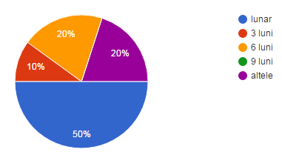
Fig. 3 The share of the frequency with which the financial reporting of the entities under consideration

The results on why management is vital within an economic entity through the information provided by managerial accounting are:

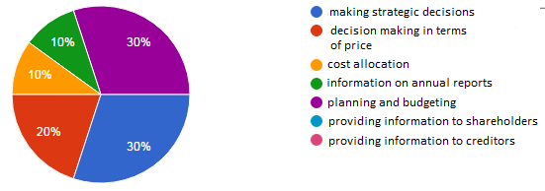
Fig. 4. The structure of information provided by management accounting for management

Of major importance are the managerial accounting information that they must provide to shareholders, 30%, but also the planning and preparation of budgets, 30%. We can still understand the functions of management, evaluation, control, information, decision-making, that management should also provide detailed reports to shareholders, those who have given it credit in the exercise of their profession, but also to plan the entity's activity, to control the budget, through information requested by accountants, by reports that do not have a given structure and do not relate to a certain range, but appear according to their needs.
When asked about the role of managerial accounting in an economic entity, the answer was:

Table 2. The role of managerial accounting in an entity

Importance | Percentage | Number of entities | % of total companies | Accounting role
1 | 40% | 17 | 38% | Performance evaluation
2 | 20% | 8 | 18% | Decision-making process
3 | 10% | 5 | 11% | Cost estimation analysis
4 | 10% | 5 | 11% | Control
5 | 10% | 5 | 11% | Coordination
6 | 10% | 5 | 11% | Forecast
TOTAL | 100% | 45 | 100%

Here is a graph showing the weight of each factor influencing the role of managerial accounting, as shown in the table above:
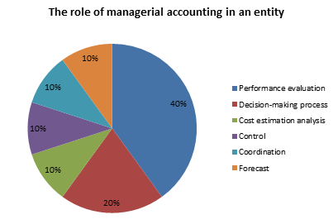
Fig. 5. The role of managerial accounting in an entity

To highlight how many entities responded and what is their share in the total respondent entities, we will graphically represent the following:

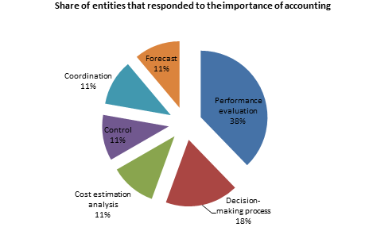
Fig. 6. Share of entities that responded to the importance of accounting

Although in practice the main role of managerial accounting is to help management in making the decision, most respondents have concluded that it is 40% performance evaluation. One reason is that managers still do not make decisions based on information provided by management accounting, but on the basis of intuition, qualitative and not quantitative analysis based on data and information gathered from financial information or production costs. Another reason is the lack of specialized personnel or staff to perform data processing for obtaining information from managerial accounting, or lack of specialist studies from managers to interpret these reports, studies that require deepening in costing methods.
In answer to question 1 to 5, if it is important and which objective of managerial accounting is of greater importance, the responses were structured as follows:

Table 3 Objectives of managerial accounting and their importance

Indicator | Calculation of production costs of products or services | Reduce or optimize costs | Provide cost information to substantiate managerial decision | Drafting, executing and controlling budgets | Control and improvement of internal activities and processes | Formulation of medium and long term strategies | Identify and eliminate activities that do not add value
To a great extent  -5 | 50%  24 | 40%  19 | 40%  19 | 30%  14 | 30%  14 | 30%  14 | 30%  14
Great measure -4 | 40%  19 | 40%  19 | 50%  24 | 70%  34 | 60%  29 | 60%  29 | 70%  34
Little measure -3 | - | 10%  5 | 10%  5 |  | 10%  5 | 10%  5
Very little measure -2 | 10%  5 | 10%  5
Not at all -1
Total | 100%

Accountants and managers use managerial accounting information to conduct an economically efficient activity to calculate and control production costs, managers need to have a medium and long-term budget picture to make the right decisions but also to identify and remove activities that do not add value to the entity, inefficient, through which money amounts are needed elsewhere.
To the question of how managerial accounting evolved over the past 5 years, respondents said that at the level of the entities they worked on, it developed slowly, weakly, is more correct and more relevant to the subject, and has become more useful to the decision-making process, due to the fact that managers have understood the concept of managerial accounting, and quantitative analysis, based on indicators, data converted into valuable information helps them make more accurate decisions and a lower risk of failure.
Another question was what direction should be taken or what should be improved on managerial accounting in the economic entities in which they work, and most of the interviewees responded that they need to improve continuously, take into account the software of managerial accounting, to keep in touch with business partners. Another category responded that managers must keep in mind the information provided by managerial accounting, not to rush when they need to make a strategic decision but to ask for reports and information and then make the right decision. Another reason is the knowledge managers do not have about management accounting, precious information when it comes to managerial decision.

CONCLUSION

The purpose of this study was to analyze whether the accounting information in the joint stock companies in the North-East of Romania is available and used, and what factors influence the development, knowledge and use of this information in the decision-making process.
The research results indicate that the importance of accounting information depends to a large extent on the size of the entity, the familiarization of these instruments by the managers, the sector of activity in which the entity operates. In some sectors, such as construction, consumer goods, household, manufacturing.
In conclusion, we want to show if there were answers to the questions asked at the beginning of the study.
Question 1, which is the relationship between the size of the entity, the sector of activity and the instruments used by economic entities in managerial accounting, the answer is that there is a strong link between the three variables because in the study presented were chosen joint stock companies, with a certain number of employees, with a certain turnover and total assets, meaning some thresholds that make the difference between the joint stock companies and the other economic entities. The managerial accounting tools used are differentiated according to the sector of activity targeted, precisely from the cause of costing methods, especially when dealing with processing or extractive industries, the methods of calculation are different from those in construction or agriculture, forestry, fishing. Equally different are the costing tools in the hotels and restaurants sector compared to the other sectors.
For question 2, what does management mean in relation to the entity's goals, we can say that managers are the main factors of influence that decide the fate of a company. Either they are directed to meet the requirements of stakeholders, managerial accounting information they must provide to shareholders, but also planning and preparing budgets. We can still understand the functions of management, assessment, control, information, decision-making, that management should also report in detail to shareholders, those who have given credit in the exercise of their profession, but also to plan the entity's activity, either are focused on their own gain, thus not taking into account the interests of shareholders or other stakeholders.
For the 3th question how important the management accounting objectives are in managing management decisions, we can say that these elements are interdependent, because management accounting through its tools seeks to make the best decisions regarding costs, prices, distribution channels, payroll, staff restructuring.
To see if your article has reached your goal of providing interested people with information about the area of ​​interest, we must reach each specific goal:
- An analysis has been made that highlights the importance of well-founded management in manufacturing enterprises in the northeastern region of Romania, namely that the key importance is the information provided by management accounting to investors, shareholders, more precisely
- The respondents' opinions on the implementation of the managerial accounting principles, the way they perceive this notion, and the fact that the evolution of managerial accounting in the sample entities was made slowly, precisely because the managers did not understand the importance of knowing as much information as possible for making the best decisions;
- The results were inventoried and presented in a manner in which strategic decision-making and price-making take the largest share of the information that managerial accounting provides, as well as the role of accounting management;
- We have investigated the barriers that prevent the implementation of managerial accounting objectives, which are related to the conservatism of managers in the area chosen as a sample, by the high costs that are necessary when choosing a performance management system;
- The degree of implementation of managerial accounting information, as well as a hierarchy of the information from the respondents' point of view, has been measured and the assessment of the entity's performance has a greater share in the overall characteristics that determine the role of managerial accounting.
The literature has intensively debated and voiced doubts about the use of classical costing methods, since these methods are no longer beneficial in so far as they are based on information provided by a system designed for a technological age characterized by local competition rather than one globally.
In conclusion, the use of accounting information in the form of instruments, reports, is imposed on the one hand by a constantly developing market, by partners, both clients, suppliers, shareholders, who will perform when it comes to manufactured products, and on the other hand the requirements of shareholders that are directly related to the managerial decisions of the person who directs the entity.
The analysis has shown that the main purpose of managerial accounting is to provide accounting information to managers and other employees of the company. These results clearly indicated that the main role of managerial accounting in a company is to analyze costs and estimate them.

BIBLIOGRAPHY

- Albu N., Albu C.N., (2012), Factors Associate With The Adoption And Use Of Management Accounting Techiques In Developing Countries: The Case Of Romania, Journal Of International Financial Management & Accounting, 23:3;
- Brăescu, M., Teza De Doctorat ”Cost Controlling And Profitable Management Of The Company”, (2013), Universitatea Al. I. Cuza , Iași;
- Briciu S., Căpuşneanu S., (2011), Analysis of Possibility to Organize Accounting by the Target Costing (Tc) Method in the Entity Framework of Romania, Economie Teoretică Şi Aplicată, Volum 18,Nr. 9;
- David, D., Dragoș, D., Pușcaș, A, (2013),” The role and importance in choosing the right concepts of managerial accounting with regard to the need for information on decision-making in companies”;
- Diaconu P., Albu N., Stere M., Albu C., Guinea F. (2003), In-depth managerial accounting, Editura Economică, Bucureşti;
- Dobre M.,A, Lică Ş., N., Lupu C., M., Mateiaş C., M., Niţă E., (2015), Analysis of the Use of Costing Tools in Romania, Journal Of International Financial Management & Accounting, 23:3;
- Hilton, R.W. (2005) Managerial Accounting. Creating Value In A Dynamic Business Environment, 6th Edition, Boston: Mc Graw Hill;
- https://cepu.ro/regiunea-nord-est-cea-mai-mare-rata-de-absorbtie-fondurilor-ue/;
- https://lege5.ro/Gratuit/gi4dkmjsga/hotararea-nr-1260-2011-privind-sectoarele-de-activitate-stabilite-conform-legii-nr-62-2011;
- Kober R., Paul B.J. (2007), The interrelationship between management control mechanism and strategy, Management Accounting Research, 18(4);
- Talpeş, C., G., (2014), Management Accounting: At the Limit of Traditional and Modern.

Albu N., Albu C.N., Factors Associate with the Adoption and Use Of management Accounting Techiques in Developing Countries: The Case of Romania, Journal of International Financial Management & Accounting, 23:3, 2012, pag 2-3.

